# React.js

Contents

React.js 1

Section 1: Getting Started 2

2. What is React.js? 2

3. Why React Instead of "Just JavaScript"? 2

4. Building Single-Page Applications (SPAs) with React 2

5. Exploring React.js Alternatives (Angular/Vue) 2

7. About This Course & Course Outline 2

8. The Two Ways (Paths) Of Taking This Course 2

9. Getting the Most Out Of The Course 2

10. Setting Up The Course Dev Environment (Code Editor) 2

Section 2. JavaScript Refresher 2

12. Understanding "let" and "const" 2

13. Arrow Functions 2

14. Exports & Imports 2

15. Understanding Classes 2

16. Classes, Properties, and Methods 2

17. The Spread & Rest Operator 2

18. Destructuring 2

19. Reference Types and Primitive Types Refresher 2

20. Refreshing Array Functions 2

Section 3: React Basics & Working With Components 2

24. Module Introduction 2

25. What are Components? And Why Is React All About Them? 2

26. React Code is Written In A "Declarative Way"! 2

28. Creating a new React Project 2

30. Analyzing a Standard React Project 2

31. Introducing JSX 2

32. How React Works 2

33. Building a First Custom Component 2

34. Writing More Complex JSX Code 2

35. Adding Basic CSS Styling 2

36. Outputting Dynamic Data & Working with Expressions in JSX 2

37. Passing Data via "Props" 2

38. Adding "normal" JavaScript Logic to Components 2

39. Splitting Components Into Multiple Components 2

Assignment 1: Time to Practice: React & Component Basics 2

40. The Concept of "Composition" ("children props") 2

41. A First Summary 2

42. A Closer Look At JSX 2

43. Organizing Component Files 2

44. An Alternative Function Syntax 2

Section 4: React State & Working with Events 2

46. Module Introduction 2

47. Listening to Events & Working with Event Handlers 2

48. How Component Functions Are Executed 2

49. Working with "State" 2

50. A Closer Look at the "useState" Hook 2

51. State can be updated in many ways! 2

52. Adding Form Inputs 2

## Section 1: Getting Started

### 2. What is React.js?

React is a JavaScript library for building user interfaces. React.js is a client-side JavaScript library that helps us with writing that client-side JavaScript code. React is all about building modern reactive user interfaces for the web.

### 3. Why React Instead of "Just JavaScript"?

With just JavaScript, you must write every single step that should be taken. This is called an imperative approach, as you must write every action step by step and have to handle the nitty-gritty details. React is all about splitting your application into small building blocks, small components, where every building block, every component has a clear task and therefore your code stays maintainable and manageable.

### 4. Building Single-Page Applications (SPAs) with React

With React we often build so-called Single-Page Applications.

### 5. Exploring React.js Alternatives (Angular/Vue)

React.js is one of the most popular libraries you can learn. It's a lean and focused component-based UI library. It really focuses on this component thing, and it doesn't have a lot of other features built in. If you need other features like routing, you will need to install an extra third-party library.

Angular is an alternative to React. Angular is a complete component-based UI framework. Angular has more build in features than React. Angular also embraces TypeScript right from the start. It can be overkill for smaller projects.

Vue.js is another popular alternative to React. Vue.js is kind of like a mixture between Angular and React. Vue.js is a complete component-based UI framework, includes most core features. It is a bit less popular than React & Angular.

### 7. About This Course & Course Outline

Course is organized into 3 categories. The first section is about the basics of React. The second category of the course is about more advanced React concepts, which covers concepts that you need for a lot of real applications that you push to production. The last part of the course will be sections that contain summaries or refreshers on certain concepts to make sure that we're all on all same page.

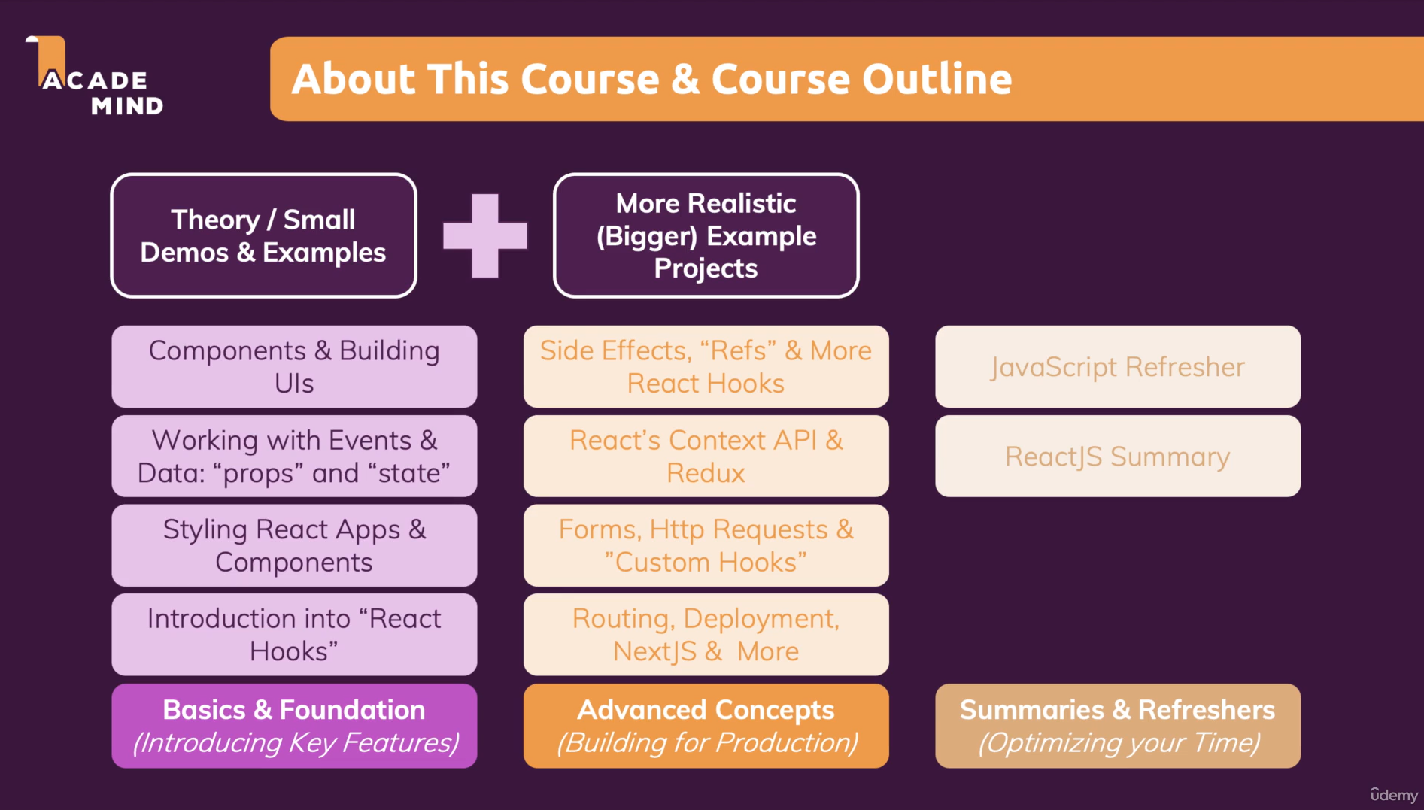

### 8. The Two Ways (Paths) Of Taking This Course

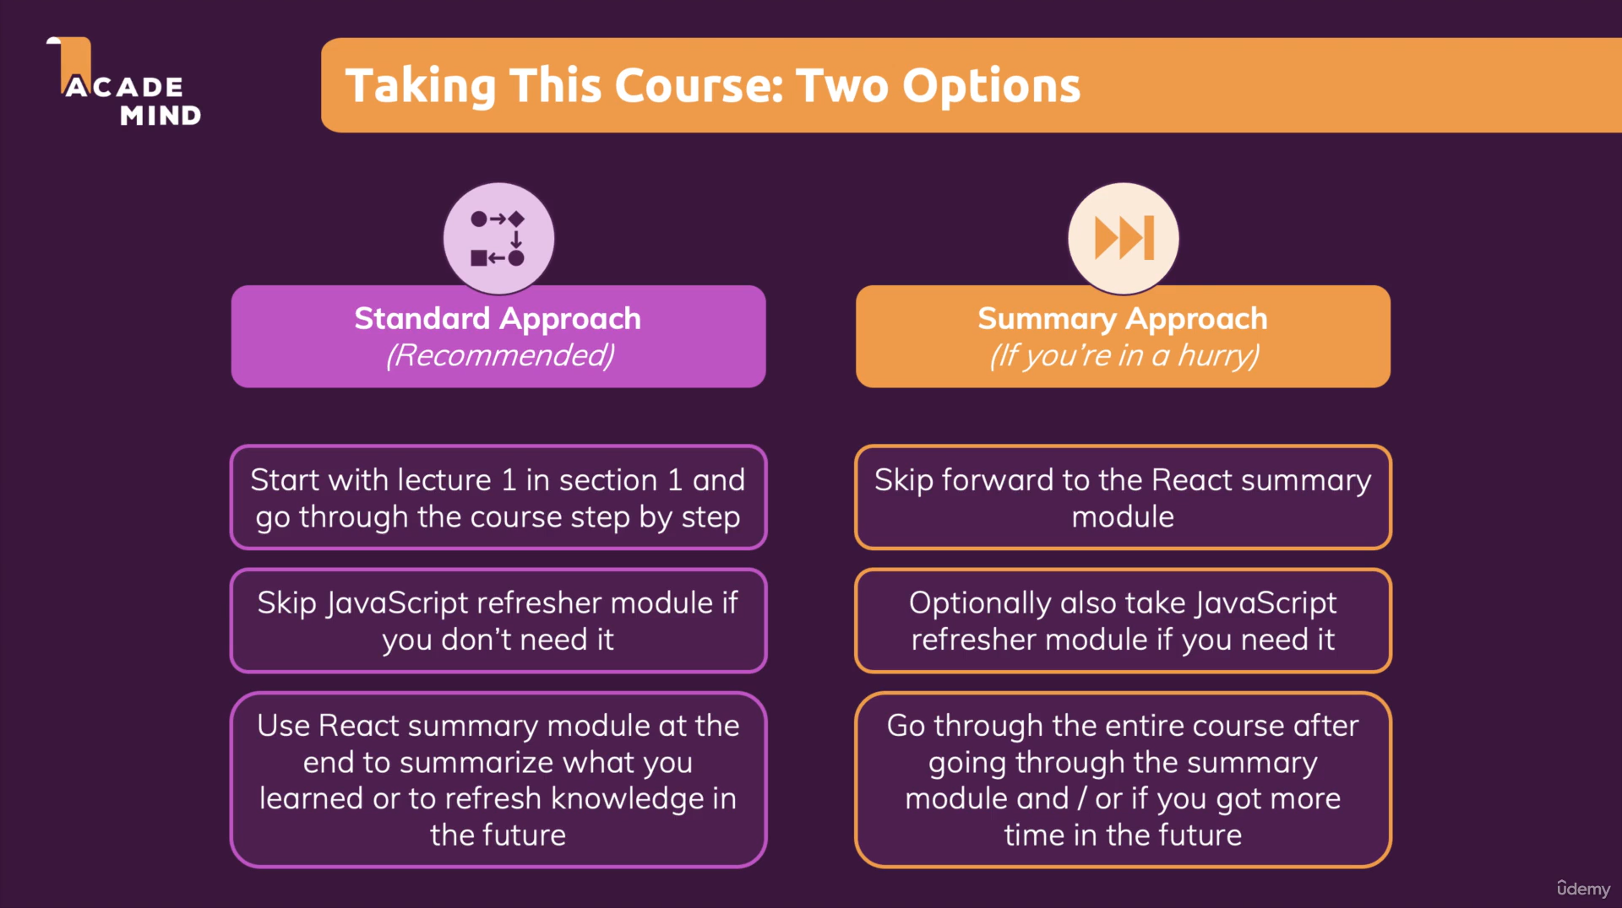

### 9. Getting the Most Out Of The Course



### 10. Setting Up The Course Dev Environment (Code Editor)

Max will be using VSCode throughout this course. I should install Prettier.js to help with code formatting. The other extension is the Material Icon Theme extension.

## Section 2. JavaScript Refresher

### 12. Understanding "let" and "const"

"let" and "const" are different ways of creating variables. With ES6, "let" and "const" were introduced to JavaScript. "let" is considered the new "var".

You use "let" for variable values. "let" and "const" are also changing something behind the scenes about the scope of the variable.

Use "let" if you want to create a variable that really is variable. Use "const" if you plan on creating a constant value, so something which you only ever assign once and never change.

If you try to re-assign a "const" variable, you will get an error because you can only assign a value to a const variable once.

### 13. Arrow Functions

A normal JavaScript function looks like this:

function myFnc(){

…

}

You may also have a function with syntax that looks like this:

let myFunc = function(){

…

}

An arrow function looks like this:

const myFunc = () => {

…

}

The arrow function solves a lot of problems that occur with the this keyword. The this keyword does not always refer to what you might expect it to refer to when writing your code. When you use this inside of an arrow function, it will always keep its context and not change it surprisingly on runtime.

Some example code:

//A function declaration

function printMyName(name){

console.log(name);

}

printMyName('Max');

//An arrow function

const printMyNameArrow =(name) =>{

console.log(name);

}

printMyNameArrow('Max');

If you only have one argument to an arrow function, you can omit the parentheses as shown below:

const printMyNameArrow = name =>{

console.log(name);

}

printMyNameArrow('Max');

You cannot omit the parenthesis in an arrow function if you have 0 parameters or two or more parameters. You can only omit the parentheses for an arrow function if you have exactly one parameter.

With 0 parameters, the correct function is:

const printMyName = () => {

console.log("Max");

}

With 2 or more parameters, the correct function is:

const printMyName = (name, age) => {

console.log(name, age);

}

printMyName('Jeremy', 25);

If you have a case where all you do in your function body is return and you have no other code in the function body, you can omit the curly braces and write it in one line and then you also have to omit the return.

All you do in the function body is return:

const multiply = number => {

return number * 2;

}

console.log(multiply(2))

Omitting the curly braces and the return:

const multiply = number => number * 2;

console.log(multiply(2));

### 14. Exports & Imports

Another feature which next generation JavaScript offers is about writing modular code. With JavaScript code, you can split up code over multiple files. The idea behind export and import statements and so-called modules is that inside of a JavaScript file we can import content from another file so that the JavaScript files themselves know their dependencies.

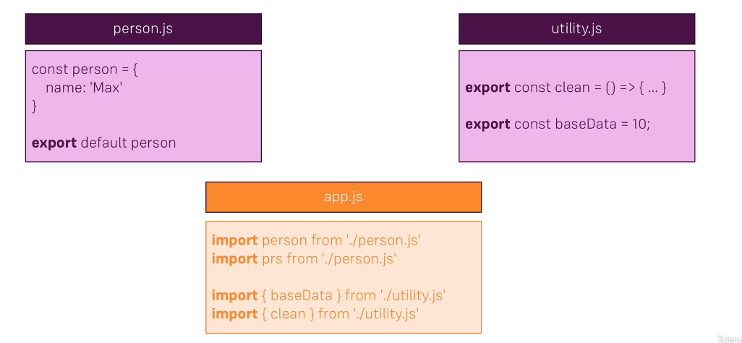

The file "person.js" uses the default keyword. The default keyword simply means that if we just import something from that file, it will always be our default export. So in this case, the file "person.js" has a constant called "person". Therefore, when importing the constant "person" from "person.js" we can name "person" whatever we want.

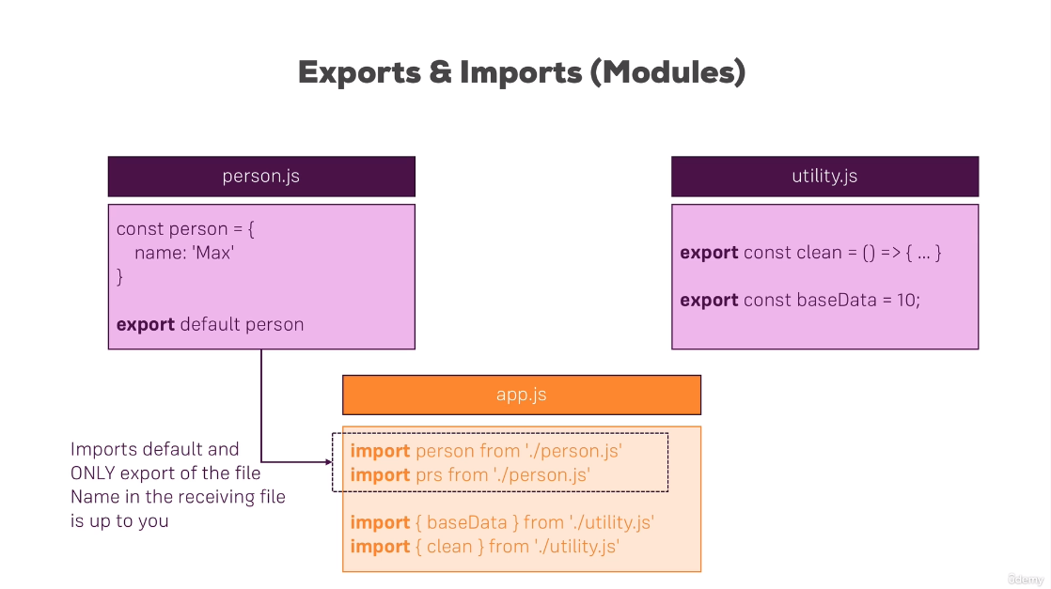

For the file "utility.js" it is a bit different since we import from two different constants, and therefore, the import syntax uses the curly braces to explicitly target specific things from that file. We target specific things from the "utility.js" file by using their specific names.

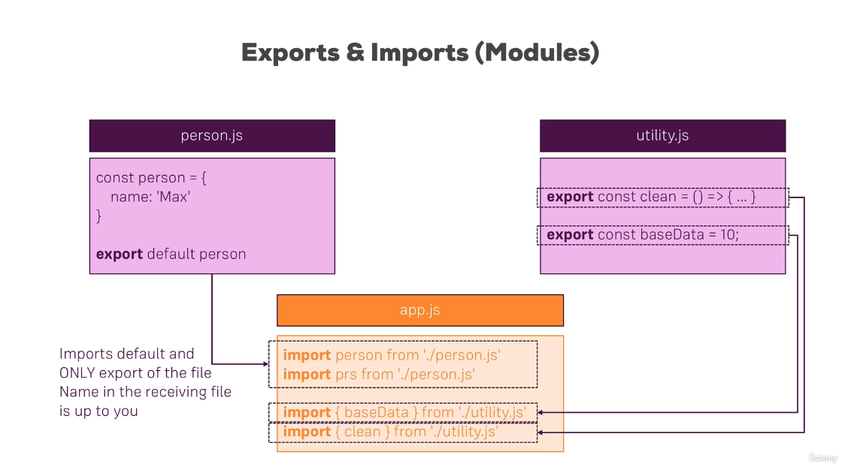

Instead of writing

import {baseData} from './utility.js'

import {clean} from './utility.js'

You could write

import {baseData, clean} from './utility.js'

Or

import {clean, baseData} from './utility.js'

If you have a named export, you have to use the exact name defined in the file with the export keyword; however, you can assign an alias which you can then again freely choose in the file you are importing it with the as keyword or if you have multiple named exports in a file, you can import everything with this * special character and then assign an alias. In this case, bundled would be a JavaScript object which exposes all constants and whatever you export in the other file as properties so that you simply have bundled.baseData, bundled.clean to access the export of things.

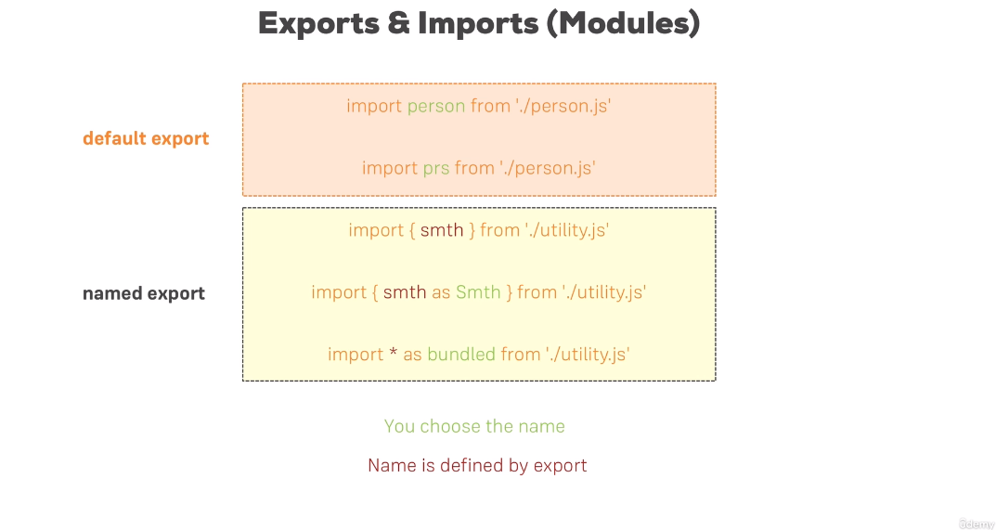

### 15. Understanding Classes

Another feature of next generation JavaScript is classes. Classes are essentially blueprints for objects.

A class is created with the class keyword and can have both properties and methods.

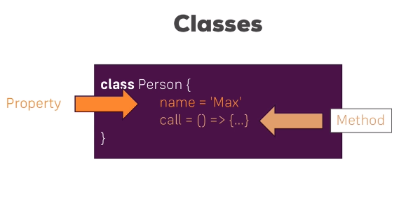

Methods are simply functions attached to classes where properties are variables attached to classes. A class is instantiated or used using the new keyword as shown in the screenshot below.

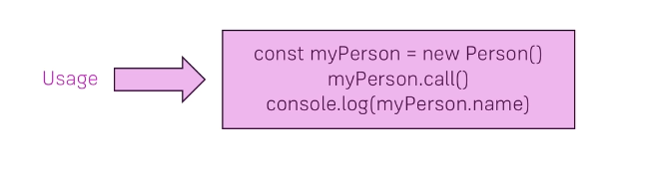

Classes are a more convenient way of creating constructor functions, so you create JavaScript objects with classes as blueprints.

Classes all support inheritance, which means that you have another class which you inherit from taking all its properties and methods and potentially adding new properties and methods.

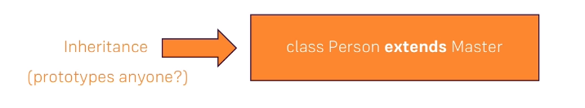

An example of creating and using a class:

class Person {

constructor() {

this.name = 'Max';

}

printMyName () {

console.log(this.name);

}

}

const person = new Person();

person.printMyName();

Classes can also inherit. Here is an example of inheritance:

class Human {

constructor(){

this.gender = 'male';

}

printGender(){

console.log(this.gender);

}

}

class Person extends Human {

constructor() {

super();

this.name = 'Max';

}

printMyName () {

console.log(this.name);

}

}

const person = new Person();

person.printMyName();

person.printGender();

Classes are used by React.js to create components. At least this is one of the two ways of creating components in React.

Classes are just blueprints for JavaScript objects and are very comparable to constructor functions where inheritance is comparable to prototypes.

### 16. Classes, Properties, and Methods

Next generation JavaScript offers a more modern syntax for initializing properties and methods.

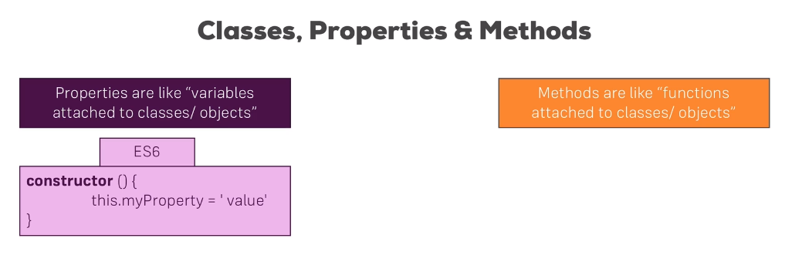

There is a more modern syntax which spares us using this constructor function. With next generation JavaScript, you can assign a property directly inside your class.

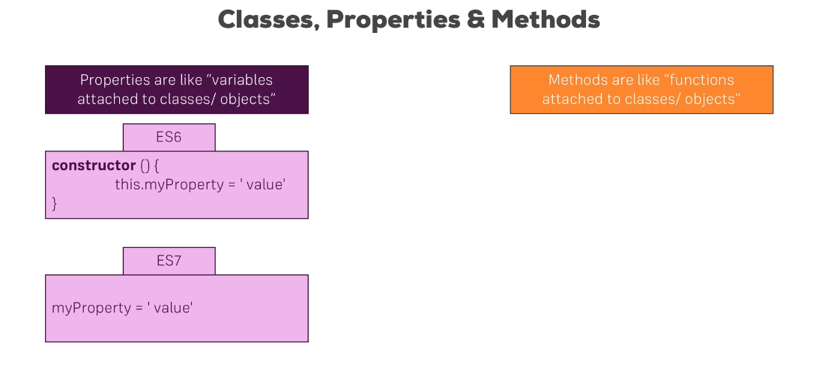

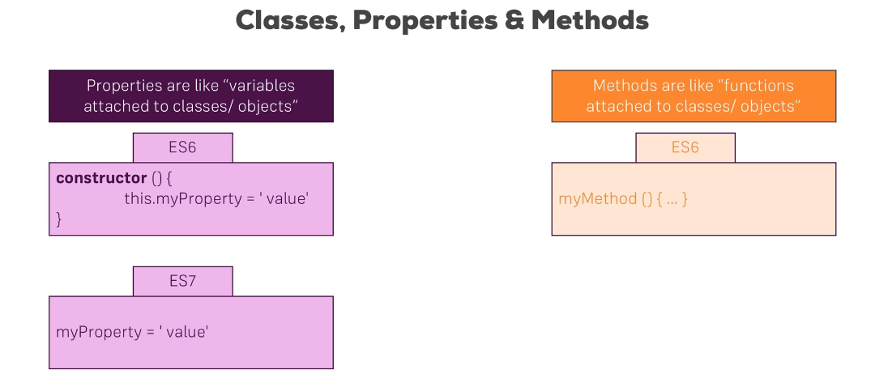

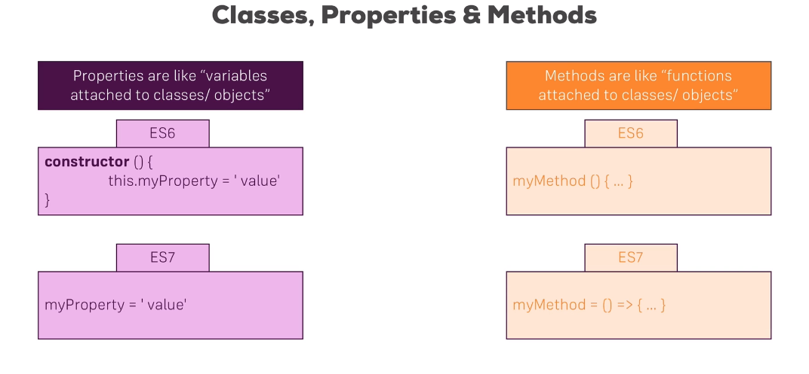

Using a more modern syntax for initializing properties and methods:

class Human {

gender = 'male';

printGender = () => {

console.log(this.gender);

}

}

class Person extends Human {

name = 'Max';

gender = 'female';

printMyName = () => {

console.log(this.name);

}

}

const person = new Person();

person.printMyName();

person.printGender();

### 17. The Spread & Rest Operator

It is only one operator – three dots: "…".

Spread operator – Used to split up array elements OR object properties.

If we have an old array, and we want to add all of the elements from the old array to the new array and additionally add a 1 and a 2 element, the first syntax would be what we use. Three dots in front of oldArray will simply pull out all of the elements and add it to the new array that we create with the square brackets.

For the object, we create a new object with curly braces and newProp, but then we also have …oldObject to pull out all of the properties of the old object and their values and add them as key-value pairs to the new object. If oldObject also had newProp, the property newProp in new object would override the property newProp in oldObject.

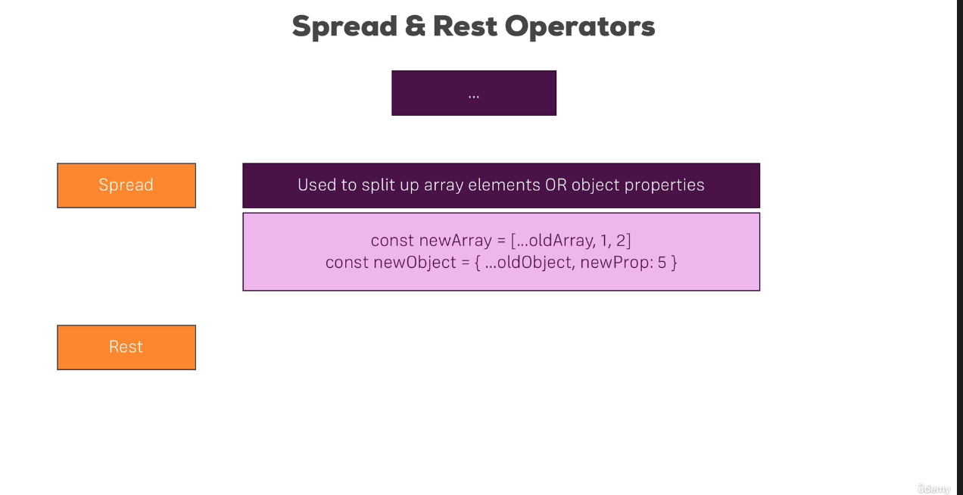

The Rest Operator is used in a function argument list.

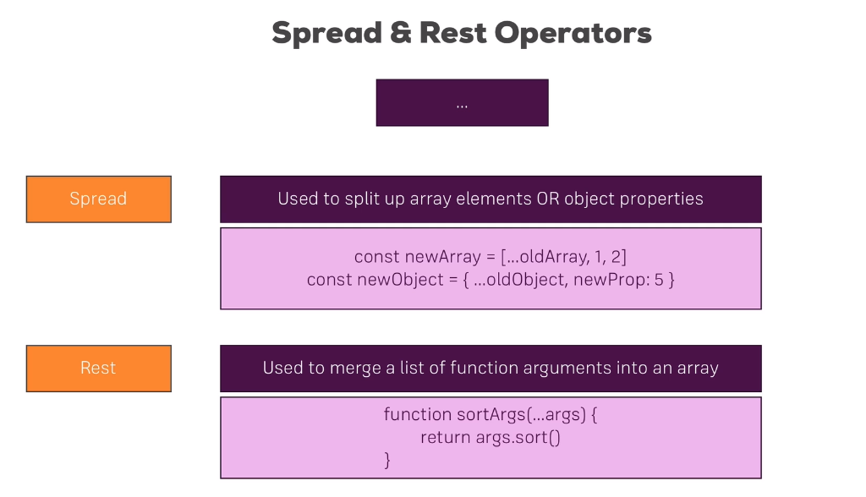

#### Example Using Spread

const numbers = [1, 2, 3];

const newNumbers = [...numbers, 4];

console.log(newNumbers);

We would get as output:

[1, 2, 3, 4]

If we did something like:

const numbers = [1, 2, 3];

const newNumbers = [numbers, 4];

console.log(newNumbers);

We would get as output:

[[1, 2, 3], 4]

Example with Object:

const person = {

name: 'Max'

};

const newPerson = {

...person,

age: 28

};

console.log(newPerson);

The output will be:

[object Object] {

age: 28,

name: "Max"

}

#### Rest Operator Example

The dots in the below example are used as a rest operator, which merges the arguments into an array.

const filter = (...args) => {

return args.filter(el => el === 1);

}

console.log(filter(1, 2, 3));

The output will be:

[1]

### 18. Destructuring

Destructuring allows you to easily extract array elements or object properties and store them in varaiables. It may sounds like spread, but it is different from spread. Spread takes out all elements, all properties and distrubtes them in a new array, new object, or wherever you're using it. Destructuring allows you to pull out single elements or properties and store them in variables for arrays.

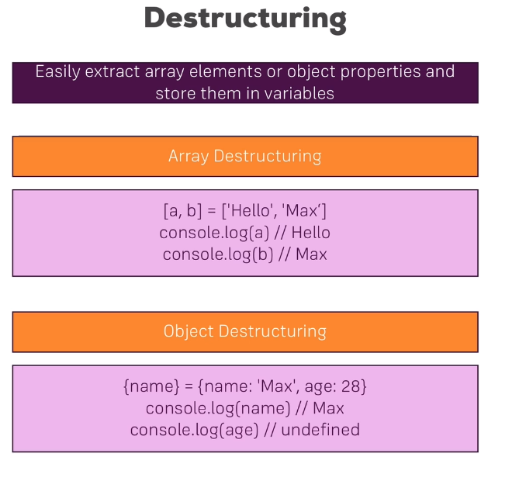

The syntax on the left side of the equals sign in the array looks like we are creating an array, but we are not. In array destructuring the order defines which property we take. For object destructuring, it's the property name. So curly brace name curly brace on the left side targets the name property of the object6 on the right side and pulls out the value, which is why logging age would be undefined, since we are not pulling out this value.

An example of destructuring would be the following:

const numbers = [1, 2, 3];

[num1, num2] = numbers;

console.log(num1, num2);

Which would output the following:

1 2

If we wanted to get num 3, we could do the following:

const numbers = [1, 2, 3];

[num1, , num3] = numbers;

console.log(num1, num3);

Which would output the following:

1, 3

Object destructuring is also supported. We could do the following:

const hero = {

name: 'Batman',

realName: 'Bruce Wayne'

};

const {name, realName} = hero;

console.log(name);

console.log(realName);

The code will output the following:

Batman

Bruce Wayne

### 19. Reference Types and Primitive Types Refresher

Remember that you have reference and primitive types in JavaScript.

const number = 1;

const num2 = number;

console.log(num2);

This is creating a real copy of number. The output will be:

1

but it will also have copied that value 1 into num2. Numbers, strings, and Booleans are so-called primitive types because whenever you reassign or store a variable in another variable it will copy the value.

Objects and arrays are reference types, though.

For example, if we create a person object

const person = {

name: 'Max'

};

const secondPerson = person;

console.log(secondPerson);

The above code example will print the same value as the first person but will not actually have copied the person object. Instead, person, the object is stored in memory and in the constant person, we store a pointer to that place in memory. If we then assign person to secondPerson, that pointer will be copied.

We can see that this is the case if we changed person.name after having it copied:

const person = {

name: 'Max'

};

const secondPerson = person;

person.name = 'Manu';

console.log(firstPerson);

console.log(secondPerson);

We get the output:

[object Object] {

name: "Manu"

}

[object Object] {

name: "Manu"

}

For secondPerson, the name also changed. The reason for this is that it just copied the pointer and points to the exact same object in memory as person does. So if we change name on person, we automatically change it for secondPerson.

For arrays, if you copy an array, and you change an array element, it will change in the so called copied array. It can lead to unexpected behaviors if you copy objects or arrays like this because you then may manipulate one object in one place in the application, and accidentally manipulate another usage of the same object in another place of the application.

Therefore, we will learn techniques to copy reference types in immutable ways, which means we copy that by really copying the object, and not just a pointer. We can do this using the spread operator.

We can create a newPerson object and spread the person properties.

const person = {

name: 'Max'

};

const secondPerson = {

...person

};

person.name = 'Manu';

console.log(person);

console.log(secondPerson);

We get the output:

[object Object] {

name: "Manu"

}

[object Object] {

name: "Max"

}

It's important to keep in mind that objects and arrays are reference types. If you reassign them, you're copying the pointer, not the value. Therefore, if you want to do this in a real copy way. You will have to create a new object and just copy the properties and not the entire object.

### 20. Refreshing Array Functions

There are several built-in array methods including filter, sort, map and so on.

The built-in array methods are not next-generation JavaScript; they are regular JavaScript. All these methods work in the same way, though. They take a function as an input and this function is then executed on each element in the array. A new array is produced as a result of each of the built-in methods.

An example using the map method is:

const numbers = [1, 2, 3];

const doubleNumArray = numbers.map((num) => {

return num * 2

});

console.log(numbers);

console.log(doubleNumArray);

The above code produces the output:

[1, 2, 3]

[2, 4, 6]

## Section 3: React Basics & Working With Components

### 24. Module Introduction

We're going to learn the following:

* React Core Syntax & JSX
* Working with Components
* Working with Data

We're going to be building an expense tracker.

### 25. What are Components? And Why Is React All About Them?

React is a JavaScript library for building user interfaces. React makes building complex, interactive and reactive user interfaces simpler.

React embraces a concept called components. React is all about "Components."

All user interfaces in the end are made up of components.

Components are reusable building blocks in your user interface. Components are just in the end just a combination of HTML code, CSS code for styling, and possibly JavaScript code for some logic.

Components can be nested.

You build these individual components, and then you tell React how to compose them together into a final user interface.

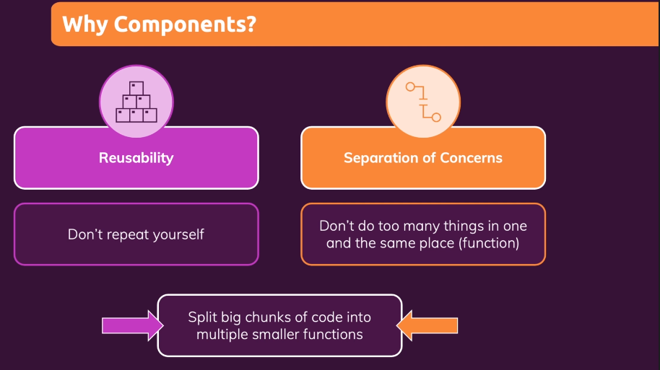

### 26. React Code is Written In A "Declarative Way"!

#### How is a Component Built?

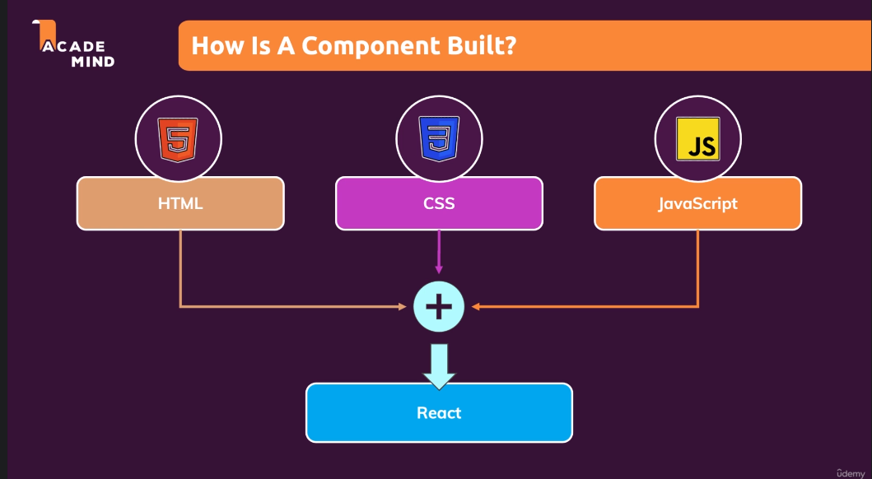

When we work with React, we combine HTML, CSS, and JavaScript in all these components and then we combine all these components together to build the entire user interface. Mostly React components are about combining HTML and JavaScript. You can add CSS but that's not the focus of React.

React uses a Declarative Approach for building these components, which means that with React, you will not tell react that a certain HTML element should be created and inserted in a specific place on the user interface as you would be doing with Vanilla JavaScript. With React, you will always define the desired end state, the target state or possibly also different target states depending on different conditions and its then React's job to figure out which elements on the actual webpage might need to be added, removed, or updated. You don't write these concrete dom updating instructions on your own as you would be doing with Vanilla JavaScript. With React and React components, you just define these end states and under which conditions which states should we use, and then React will do the rest under the hood.

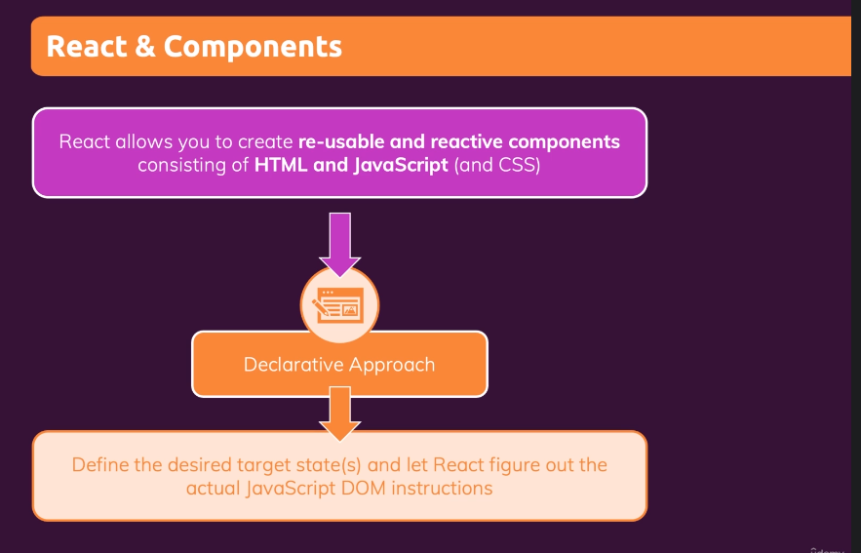

You build your own, custom HTML Elements and combine them together to build a user interface.

### 28. Creating a new React Project

We start creating a React project by using the repo create-react-app. Install Node.js. Run the command to create the repository for create-react-app. Go into the directory in the terminal and then run npm start, which will start the development server on localhost:3000.

In the folder, the package.json file holds all of the dependencies for this project as well as development dependencies. The src folder holds the actual source that we will be working with. Run npm install in the terminal in the folder that contains the package.json that has the dependencies that you want to install.

As long as npm start is running, it will automatically watch your code files, so that whenever you change something in code, it will automatically update the loaded page in the browser.

### 30. Analyzing a Standard React Project

React code is just JavaScript code. The npm start process which started this development server, which is watching our code. This process will not just watch our code and then take it and deliver it to the browser; but before it delivers it, it will transform it, so that certain extra features work in the browser, even though they wouldn't work if just regular JavaScript code was used.

The dependencies "react" and "react-dom" make up the react library.

The package ReactDom is exporting some React DOM object, and we're importing it into index.js, so that we can call the createRoot method on it, which creates the main entry point, the main hook of the overall user interface you are about to build with React. The method createRoot tells React where this React Application, this user interface which you build with React, should be placed in the web page that is loaded.

The index.html file in the public folder. The public folder we will rarely work in, but it holds the index.html file that is loaded in the browser. It is basically the only HTML file that is being used by this overall React Application because it is a single-page application. The HTML file is the entry point, the place where the React-driven user interface should be rendered into so to say. The div with id="root" in the HTML file does not hold any content, but is the place where we want to attach or inject our React-driven user interface.

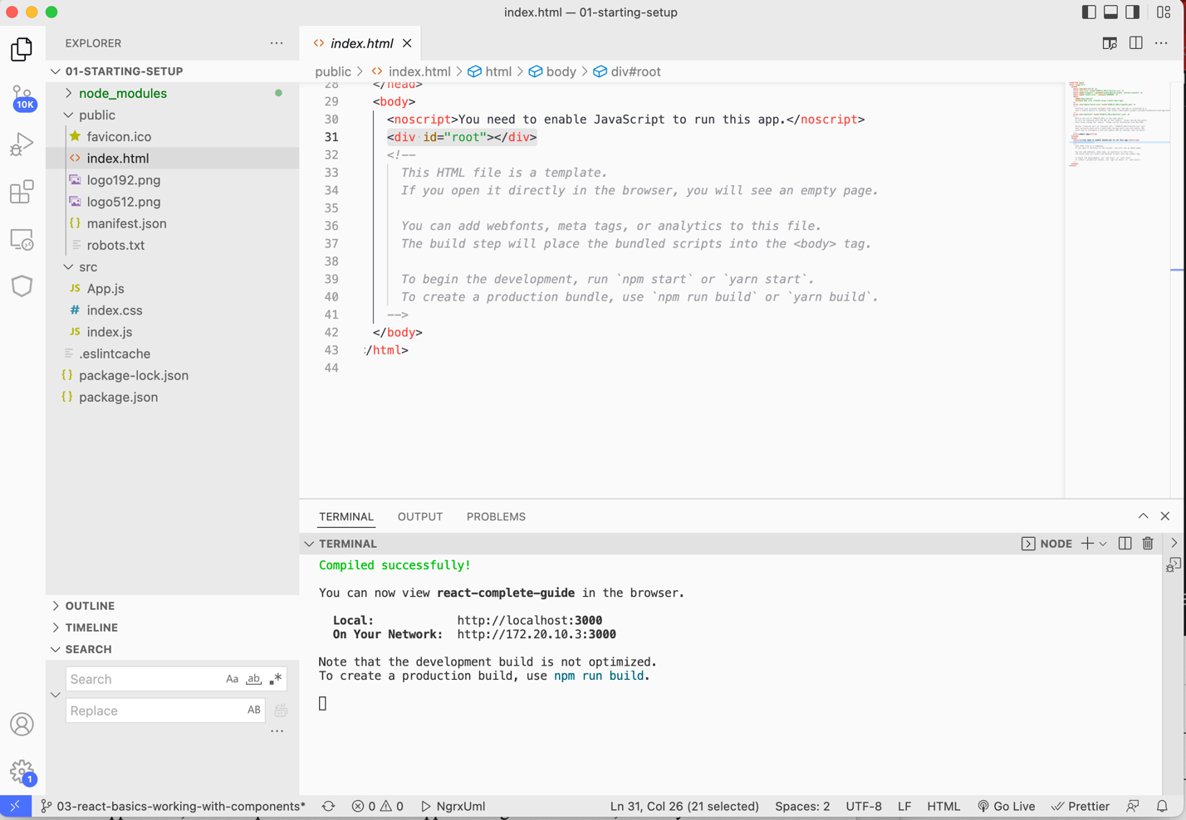

In index.js it is the div with id="root", that we select using some regular JavaScript code and then we use a method from the react-dom library to tell React that this should be the root of our React application, the main place where the React application gets rendered to, so to say. That's what createRoot does. We then store the root object in a constant.

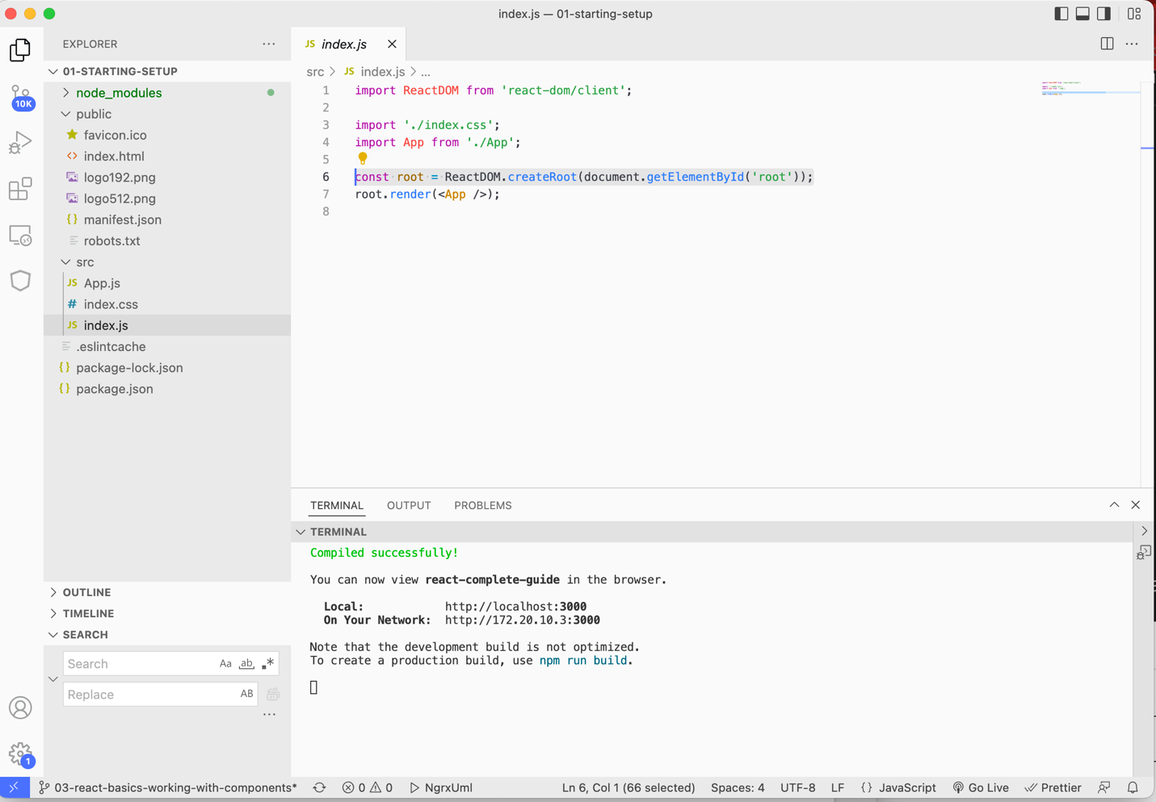

On that root object, we call the render method to tell React what should be rendered in that div that we selected. What is inside of the div should be replaced with what is inside App.

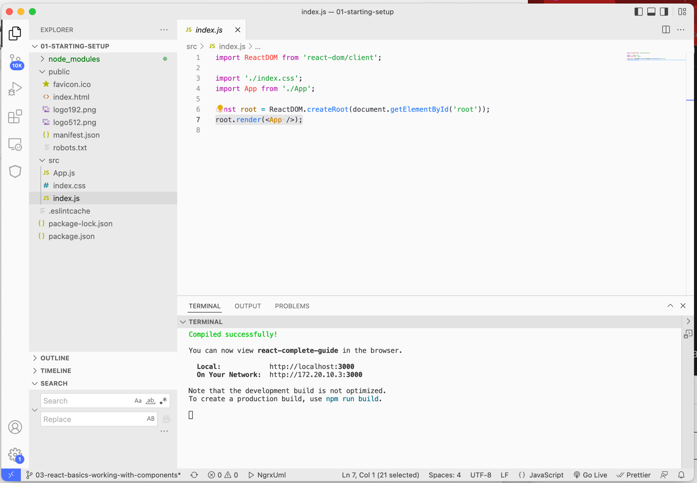

You could select other elements such as spans, paragraphs, etc, but a div is the most common root element that is selected.

What is App?



We're importing App from the App file. The App file we're referring to is the file inside of the src folder called App.js. You just omit the ".js" file in the import. However, if you are importing another type of file, such as a CSS file, you need to add the extension. If it is a third-party library or one of your JS files, you omit the ".js".

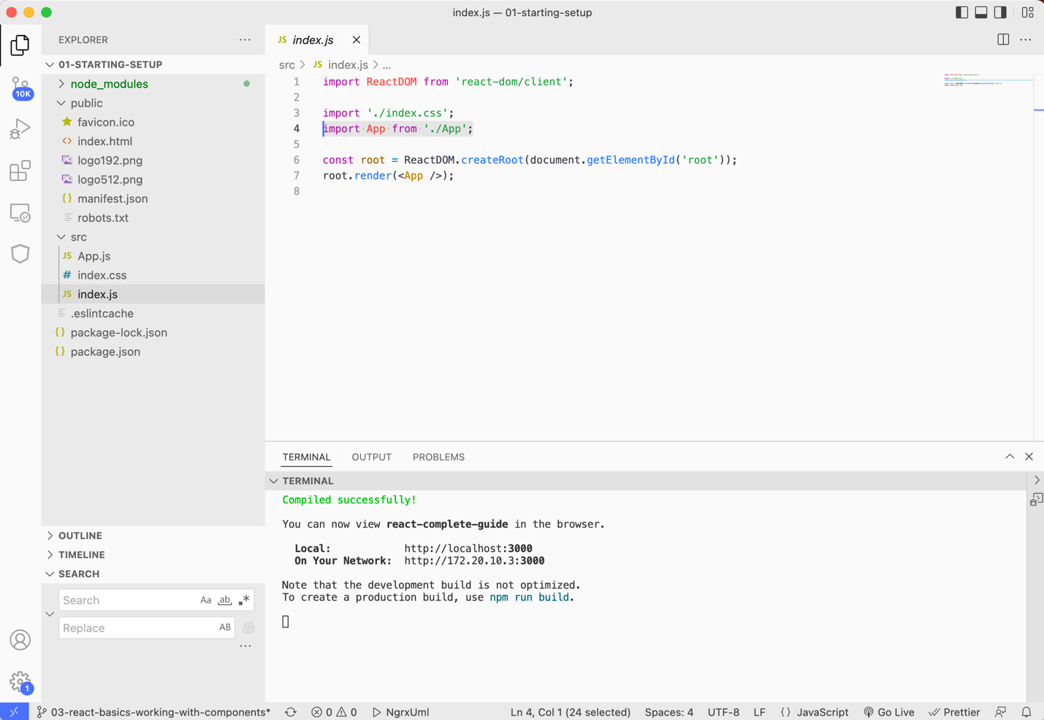

App is a component. It is the App component which we, in the end, render in place of that element with an id of "root", so inside of that div to be precise.

The App.js file has a function called App() and we then export this function.

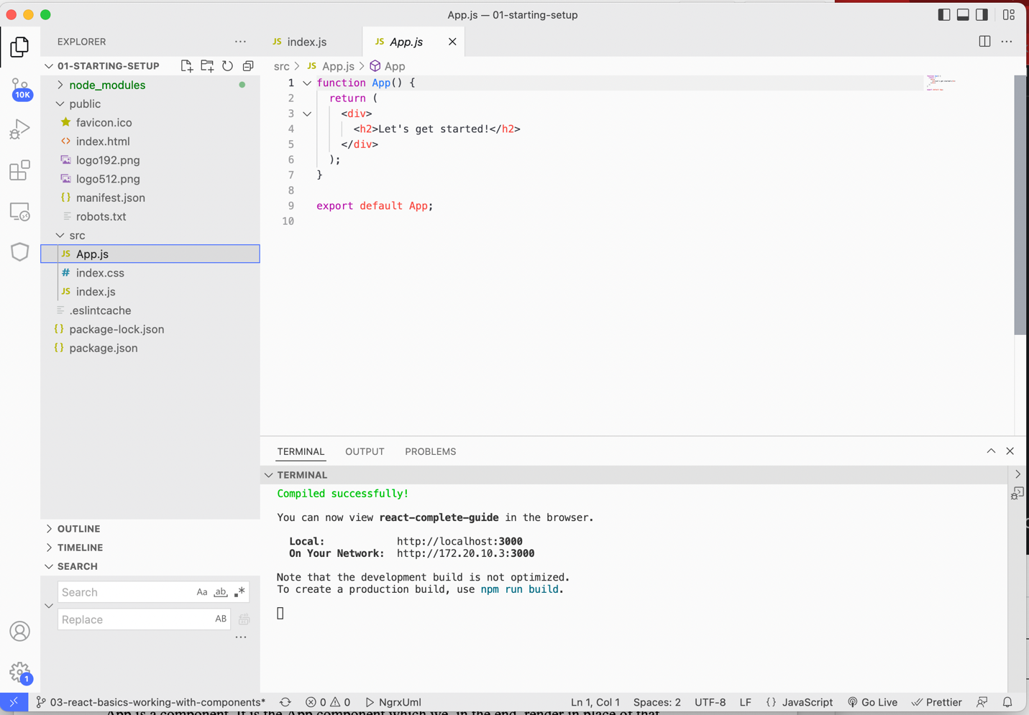

In modern JavaScript, if you have something like a function or a class or an object defined in one file and you want to use it in another file, you have to export and import it. So in App.js, where the function is defined, we export it, and then we import it in index.js, and that is how App.js and index.js are connected and how we can use a feature, in this case, a function defined in App.js inside of Index.js.

What is this function called App() doing after all? It is a function named App(). In the App() function we return HTML code, which may seem strange inside of a JavaScript file, but it works because it is a feature called JSX. JSX is a special syntax invented and introduced by the React team and it works in these JavaScript files because of our overall project setup, and again, because of these transformation steps, which are running behind the scenes.



### 31. Introducing JSX

So we have HTML code in JavaScript code, which only works because there are transformation steps running behind the scenes because of this npm start process which we started which transformed as JavaScript code to more browser friendly code before everything is being served here. We can see the transformed code by opening up the developer tools in Chrome and in the developer tools, go to the Sources tab, which shows all the sources, all the script files for example, that were downloaded as part of this page. If you see static.js folder, it should hold JS files, and if you click through the JS files you may see cryptic looking code, which is the transformed code and the whole react library and react library source code. You should find your function in these files, but the function will look different, as it is in the transformed code. It is the code that runs in the browser. We have the transformation steps because we can use this special JSX syntax which is not normally supported in the browser whilst we're writing our code and still it'll automatically be transformed to code which does run in the browser so that we have the best of both worlds, code which works in the browser and code that's easy to write as a developer.

### 32. How React Works



React is all about Components, and a component is basically just a custom HTML element.

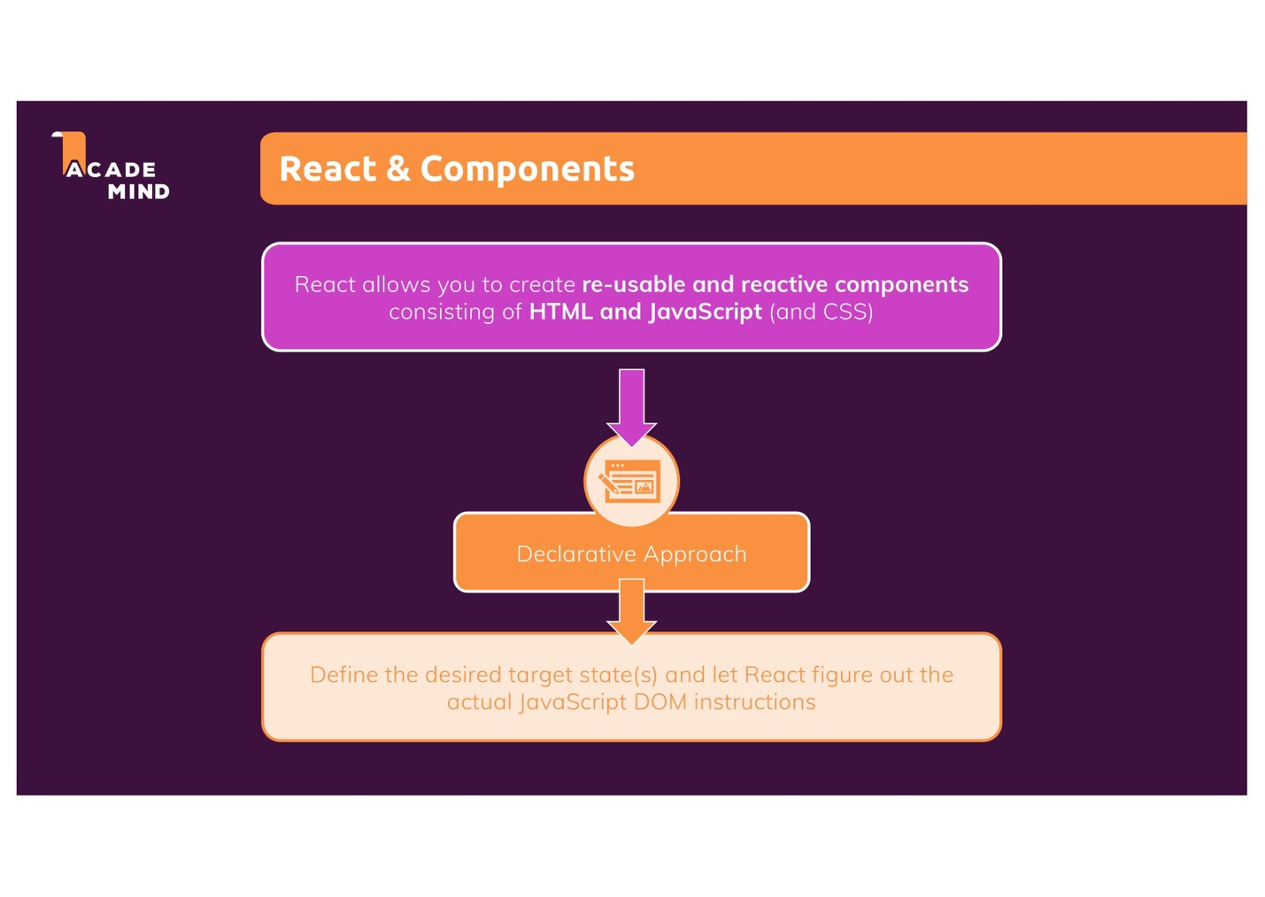

React uses a declarative approach, which means with React we define the desired target state, and React is then responsible for generating and running the actual DOM instructions, which update what's visible on the screen.

The code highlighted below is our desired target state. We want to render a div with an h2 tag with this text inside of it on our screen.

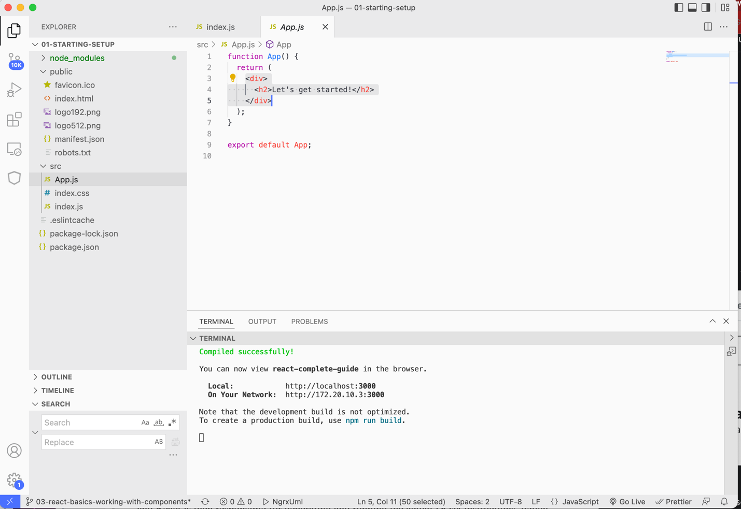

Because in index.js, we rendered this App component, this custom App HTML element, you could say

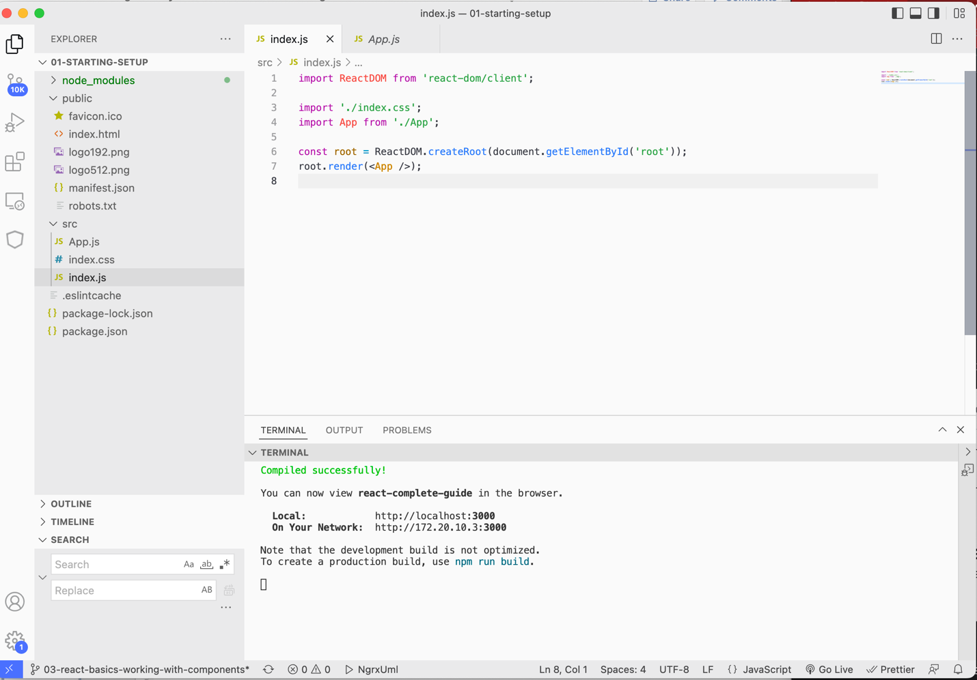

And inside of this custom element, which turns out just to be a function, we just return this HTML code. So ultimately, it is this HTML code, which is rendered on the screen.



If we were going to use vanilla JavaScript to produce the above output we would have to type the following as shown in the lines highlighted in the below screenshot:

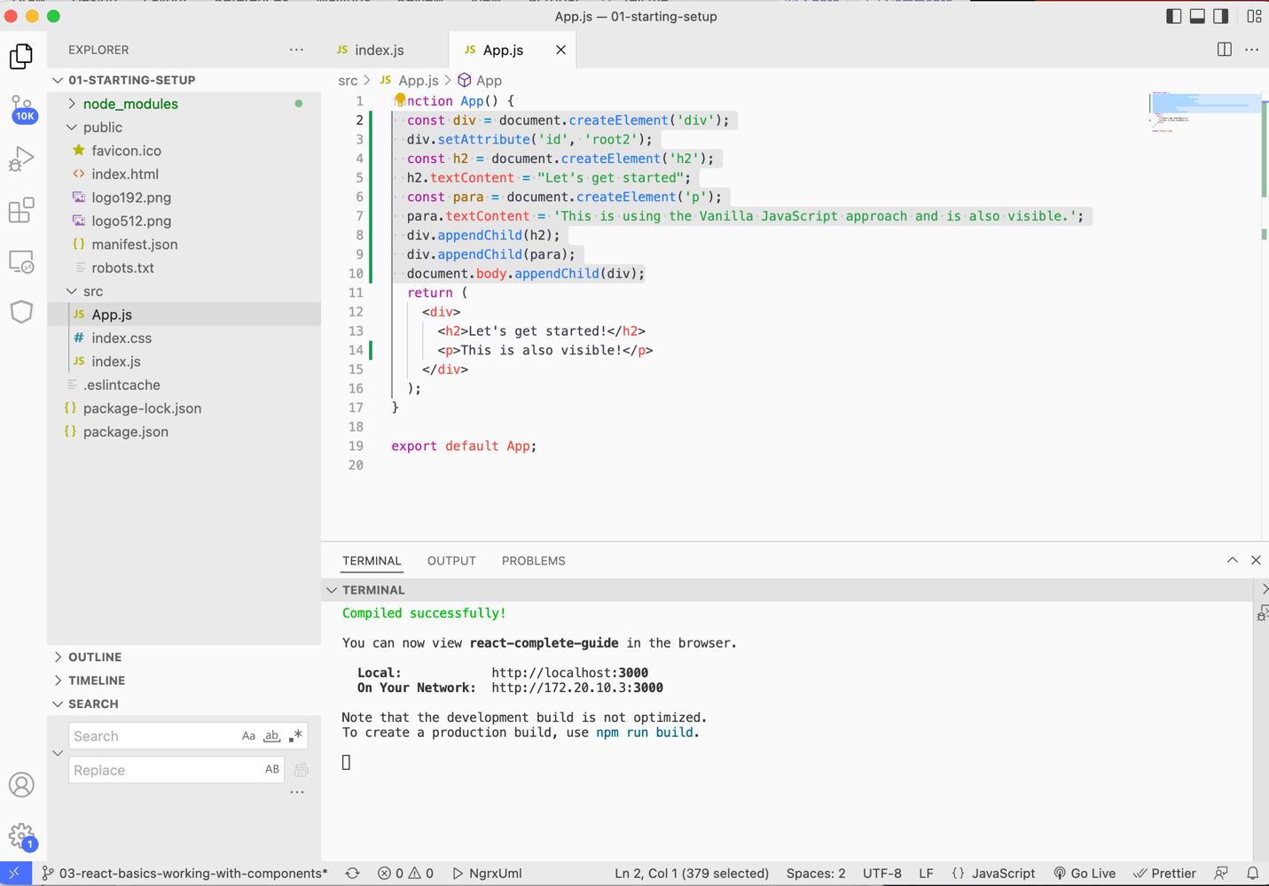

Lines 2-10 highlighted in the above screenshot are written in vanilla JavaScript and follow what is known as an imperative approach because you are giving clear step-by-step what JavaScript and the browser should be doing. This works, but it can get cumbersome or complex user interfaces with dozens or hundreds of elements which also may be changing and appearing and disappearing all the time. Having to write all these instructions is very cumbersome.

With React, we use a declarative approach, and just define the desired end state – that we want a div, an h2 tag, and a paragraph and React will then generate these instructions behind the scenes to bring that onto the screen.

React embraces the concept of components. We have our first component the function called App() in App.js which is used like a custom HTML element in index.js.

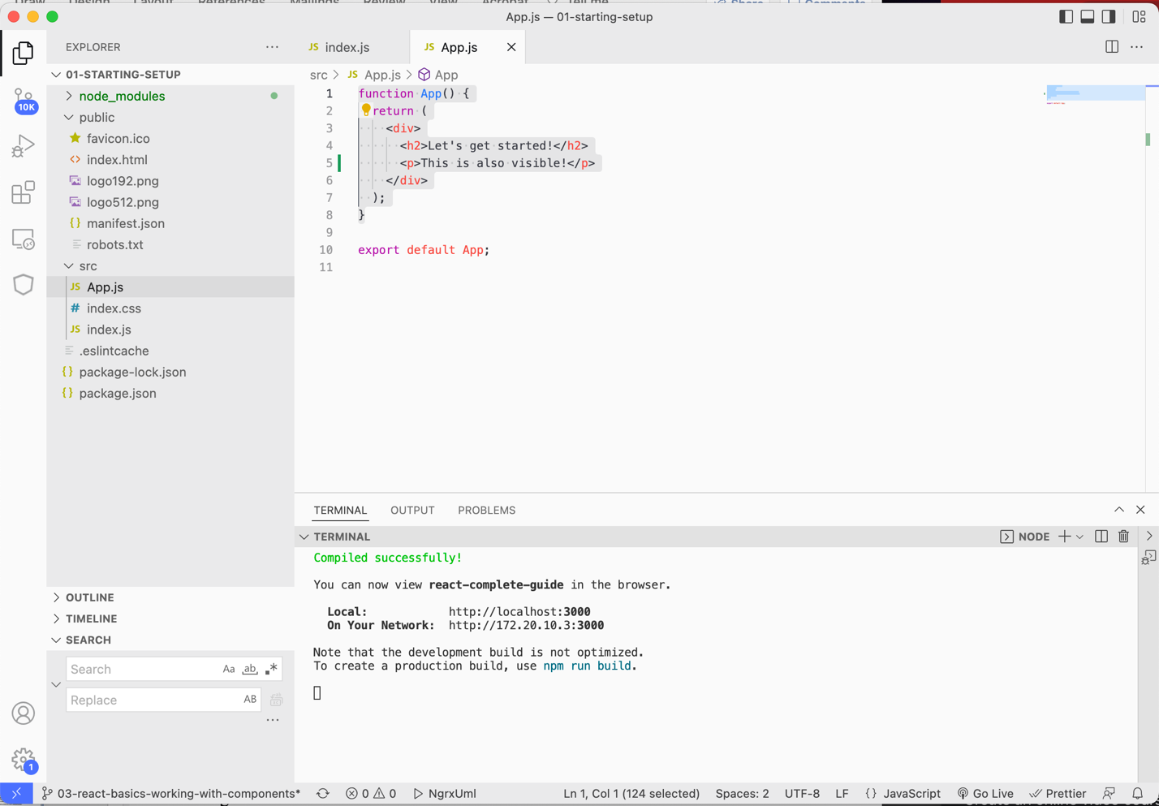

### 33. Building a First Custom Component

It is a best practice to put new components into new files, so that you have one file per Component. We will add a components folder inside of the src folder, which will hold all these components source files.

The function called App / the App component will not go inside of the Components directory because this app Component is a special kind of component because of its role in the application. App will be our so called root-component, which means it's the main Component being rendered in index.js. All other components will either be nested inside of App.js or will be nested inside of other components, which then in turn are nested somewhere else.

In React we build a Component Tree. You have the main App at the top and then below that you could have any other kinds of custom HTML elements, so other kinds of components, which in the end hold other pieces of the user interface. Big applications can result in quite big Component Trees where only the topmost component is rendered into the HTML page with help of that React dom render instruction. All the other components will not be rendered with this instruction but instead will be used as regular HTML elements inside of our HTML code, inside of our components. 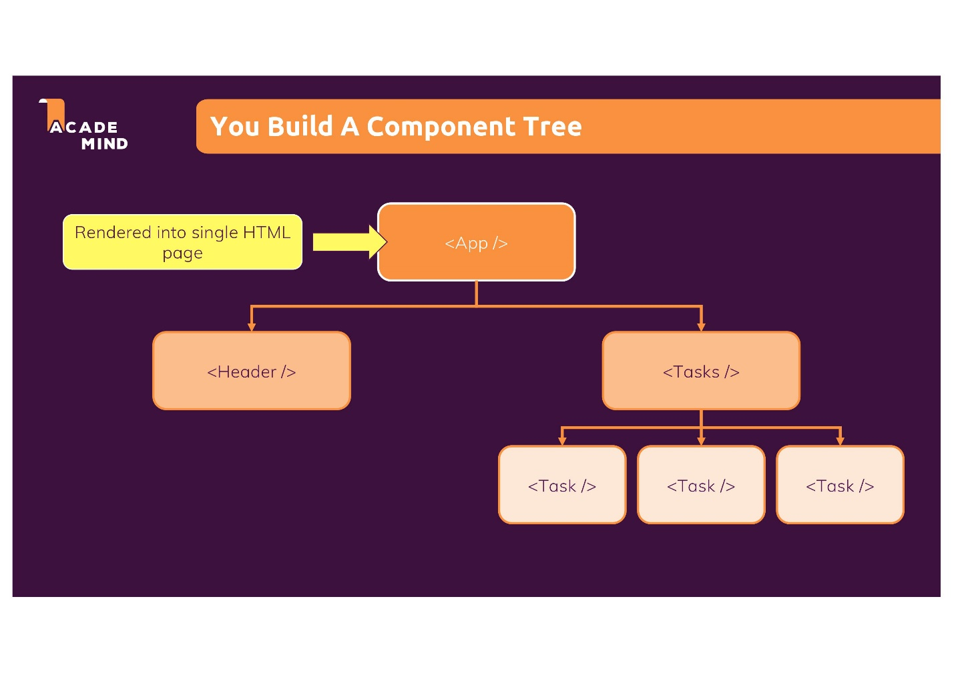

We create a file to hold our component inside of the src/components folder called ExpenseItem.js. You can name a file whatever you want, but it is a common convention in React applications to name the file where each word of the file name starts with a capital letter. What you name the file should relate to the component that you are creating inside the file. For example, ExpenseItem.js should have a component dealing with rendering expense item data.

A component in React is just a JavaScript function. A component in React is a special kind of JavaScript function in the regard that it returns JSX code, but other than that, its just a JavaScript function. When naming a component, it is the convention to name it the same as the filename (without the extension).

|  |
| --- |
| src/components/ExpenseItem.js |
| function ExpenseItem() {  return <h2>Expense item!</h2> // return JSX code  } |

To use this Component, we need to export it. We do this by adding an export statement. We export the function ExpenseItem as the default for this file.

|  |
| --- |
| src/components/ExpenseItem.js |
| function ExpenseItem() {  return <h2>Expense item!</h2> // return JSX code  }  export default ExpenseItem; |

Now that we have the export statement in ExpenseItem, we can import it in another file. We want to use this custom Component like a regular HTML element, so like an h2 element inside of the HTML code written in the App component. At the top of the App.js file we import our custom component—ExpenseItem.

|  |
| --- |
| src/components/App.js |
| import ExpenseItem from './components/ExpenseItem'  function App() {  return (  <div>  <h2>Let's get started!</h2>  <p>This is also visible!</p>  </div>  );  }  export default App; |

The path tells JavaScript that we are looking for the ExpenseItem file in a components folder, which sits next to the App.js file where we have this import statement.

Now that ExpenseItem is imported, we can use it like an HTML element. We can replace the paragraph with ExpenseItem as shown below:

|  |
| --- |
| src/components/App.js |
| import ExpenseItem from './components/ExpenseItem'  function App() {  return (  <div>  <h2>Let's get started!</h2>  <ExpenseItem></ExpenseItem>  </div>  );  }  export default App; |

The key difference between custom components and the built-in HTML elements just is that it doesn't start with a lowercase character but starts with an uppercase character. Custom React components must start with an uppercase character whenever you're using them in JSX as shown in the example above, so that React can detect that it is a custom component. This is because the simple rule which React applies is that lowercase elements are built-in HTML elements, so it will look for them as built in elements; whereas, elements starting with an uppercase character, are custom components defined by you or some other developer. We have to use the name that we use in the import in the JSX code because that's how this connection is established.

This line <ExpenseItem></ExpenseItem> tells React that we want to use this component which React knows about because of this line: import ExpenseItem from './components/ExpenseItem' where the custom component ExpenseItem is imported using the name ExpenseItem from the ExpenseItem file.

We now save our code and see the ExpenseItem component.

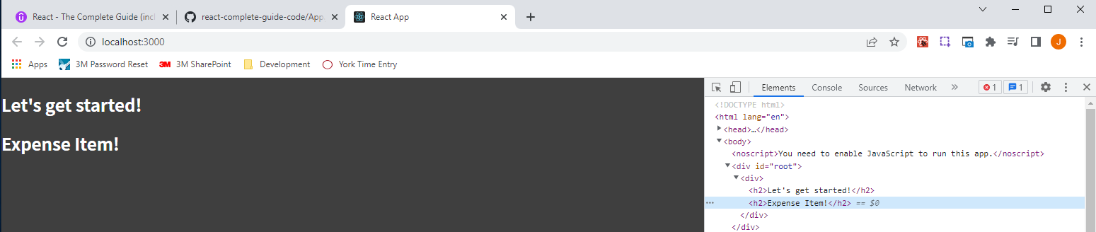

### 34. Writing More Complex JSX Code

Besides displaying the title, we also want ExpenseItem.js to display the amount of the expense, and also the date. We want to write HTML code that nicely displays and structures these three pieces of information.

In the below code snipped, the line that is striked through is not valid.

function ExpenseItem() {

return ~~<div>Date</div><div><h2>Title</h2><div>Amount</div></div>~~

}

export default ExpenseItem;

In React components, there is one important rule regarding the JSX code that you return inside of a component. You must only have one root element per return statement or per JSX code snippet you could say. In this line ~~<div>Date</div><div><h2>Title</h2><div>Amount</div></div>~~

we have this div: <div>Date</div> side-by-side with this div: <div><h2>Title</h2><div>Amount</div></div>, which means that we have two root elements here in this statement, which is not allowed.

How do we work around the rule that you can only have one root element per return statement or per JSX code snippet? One of the easiest workarounds would be to wrap the whole code snippet ~~<div>Date</div><div><h2>Title</h2><div>Amount</div></div>~~ inside of another div, which would make it valid: <div><div>Date</div><div><h2>Title</h2><div>Amount</div></div></div>

|  |
| --- |
| src/components/ExpenseItem.js |
| function ExpenseItem() {  return <div><div>Date</div><div><h2>Title</h2><div>Amount</div></div></div>  }  export default ExpenseItem; |

Regarding the readability, we can improve that by wrapping the code snippet in parenthesis, which signals to JavaScript that this is one and the same statement even if it spans multiple lines. We can then make the snippet span multiple lines as shown below. The quickest way of restructuring is use the format document shortcut.

|  |
| --- |
| src/components/ExpenseItem.js |
| function ExpenseItem() {  return (  <div>  <div>Date</div>  <div>  <h2>Title</h2>  <div>Amount</div>  </div>  </div>  );  }  export default ExpenseItem; |

It is very important that there is only one root element per return statement or JSX code snippet. Inside of the root element, you can then have multiple elements, and these elements may be side-by-side.

### 35. Adding Basic CSS Styling

We use CSS in React but there is nothing too React specific when it comes to CSS code. There is nothing too React specific when it comes to that CSS code. In the end, we can just add a new CSS file. And typically, for the CSS code of a given component you add that file next to the component JavaScript file. The CSS file will be called ExpenseItem.css.

We need to make the overall build process aware of that CSS file and tell it that the CSS code in there should be considered and should be injected in the finished application. It's not by default browsing all your files and automatically including everything. You have to explicitly tell React, you could say, or that build process that a certain file should be considered. We tell React that ExpesneItem.css should be considered by adding the following line in ExpenseItem.js: import './ExpenseItem.css';

|  |
| --- |
| src/components/ExpenseItem.js |
| import './ExpenseItem.css';  function ExpenseItem() {  return (  <div>  <div>Date</div>  <div>  <h2>Title</h2>  <div>Amount</div>  </div>  </div>  );  }  export default ExpenseItem; |

Inside of ExpenseItem.css, there are several classes which can be added to the HTML elements within ExpenseItem.js to apply a certain look.

In the file ExpenseItem.js inside of our component we need to add the classes from ExpenseItem.css. We don't type class as we would with regular HTML but instead className. It's important to keep in mind that the following bolded code is not really HTML; it is JSX.

|  |
| --- |
| src/components/ExpenseItem.js |
| import './ExpenseItem.css';  function ExpenseItem() {  return (  <div>  <div>Date</div>  <div>  <h2>Title</h2>  <div>Amount</div>  </div>  </div>  );  }  export default ExpenseItem; |

JSX is very similar to HTML, and that is why most attributes are the same but not all, like the class attribute in HTML being renamed to className in JSX. The class attribute in HTML was renamed to className in JSX because class is a reserved worked in JavaScript.

|  |
| --- |
| src/components/ExpenseItem.js |
| import './ExpenseItem.css';  function ExpenseItem() {  return (  <div className="expense-item">  <div>March 28th 2021</div>  <div className="expense-item__description">  <h2>Car Insurance</h2>  <div className="expense-item__price">$294.67</div>  </div>  </div>  );  }  export default ExpenseItem; |

### 36. Outputting Dynamic Data & Working with Expressions in JSX

In our application, we will not just have one expense and for sure not an expense where the data is just hard coded into the component as it is in ExpenseItem.js. The date, title, and amount are hard-coded, and it's the only expense we have. In our final tracker we want to be able to have more than one expense. We want to have multiple expense item components in action. And after all that is one of the core ideas behind components.

Components are not just about the separation of concerns, it's also the reusability. We want to define a component and its HTML code once, and then we want to be able to reuse it.

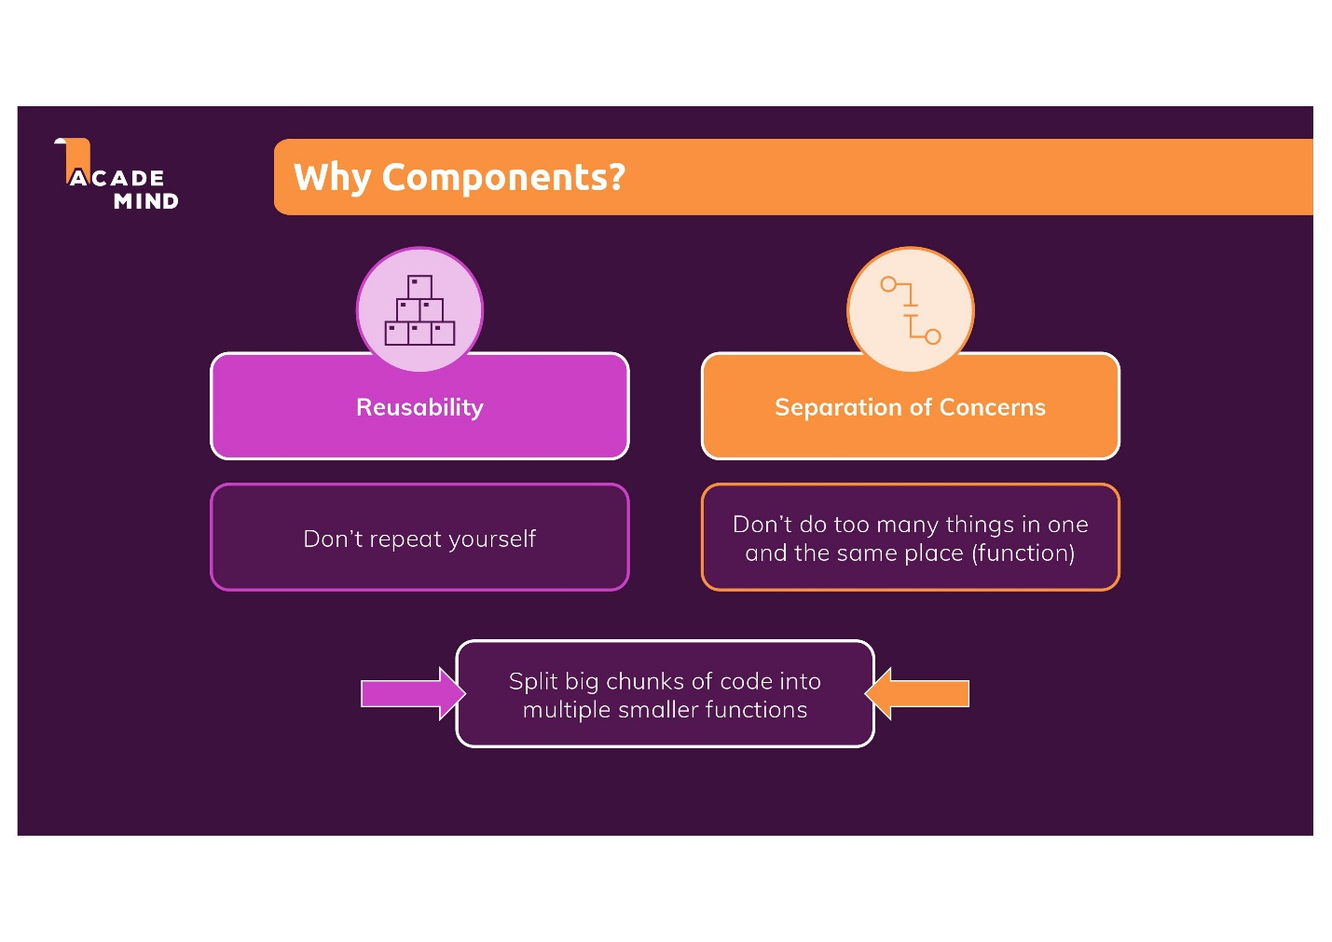

Currently, we are not able to reuse our React components, but before we take care of that issue, we need to deal with the issue of the data being hard coded in the JSX code. Sometimes data will be hard coded, but typically something like the date, title, and amount would typically be dynamic, which means it's not hard coded in the HTML code, and we would instead receive that data from somewhere, for example from the user who entered it into a form and then we output it dynamically. We don't have the capability yet to receive dynamic data from the user, but we can fake dynamic data by at least adding more than just HTML code to this component. A component in React is just a function. As mentioned earlier, components are a combination of HTML, CSS, and JavaScript.

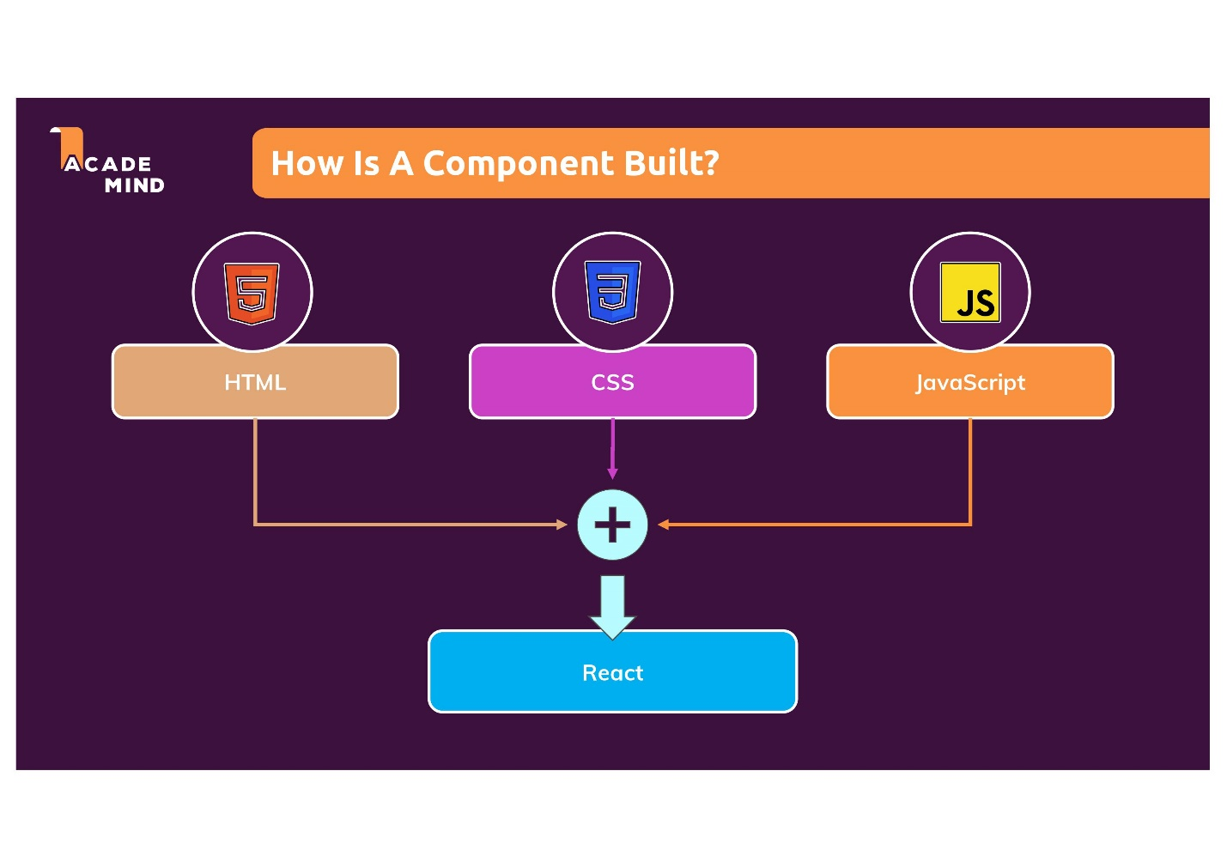

We see HTML in action, have seen some CSS, but where is the JavaScript other than ExpenseItem being a function? We can add some JavaScript code in that function before we return. We can add const expenseDate = new Date(2021, 2, 28); This is just regular JavaScript code and has nothing to do with React. We can also have const expenseTitle = 'Car Insurance'; and then we can have const expenseAmount = 294.67;

|  |
| --- |
| src/components/ExpenseItem.js |
| import './ExpenseItem.css';  **const expenseDate = new Date(2021, 2, 28);**  **const expenseTitle = 'Car Insurance';**  **const expenseAmount = 294.67;**  function ExpenseItem() {  return (  <div className="expense-item">  <div>March 28th 2021</div>  <div className="expense-item__description">  <h2>Car Insurance</h2>  <div className="expense-item__price">$294.67</div>  </div>  </div>  );  }  export default ExpenseItem; |

We have three constants as bolded in the code snippet above, which is just regular JavaScript code, and we want to output these values in the HTML code. Typically, you don't have data hard coded in HTML. To output dynamic data, you use a special syntax React gives you inside of these JSX code snippets. You can replace hard-coded data with single opening and closing curly braces where between them you can run basic JavaScript expressions such as {1+1}, where the result of the expression would then be output to the screen.

|  |
| --- |
| src/components/ExpenseItem.js |
| import './ExpenseItem.css';  const expenseDate = new Date(2021, 2, 28);  const expenseTitle = 'Car Insurance';  const expenseAmount = 294.67;  function ExpenseItem() {  return (  <div className="expense-item">  <div>March 28th 2021</div>  <div className="expense-item__description">  <h2>{1+1}</h2>  <div className="expense-item__price">$294.67</div>  </div>  </div>  );  }  export default ExpenseItem; |

We see that the result "2" is output to the screen.

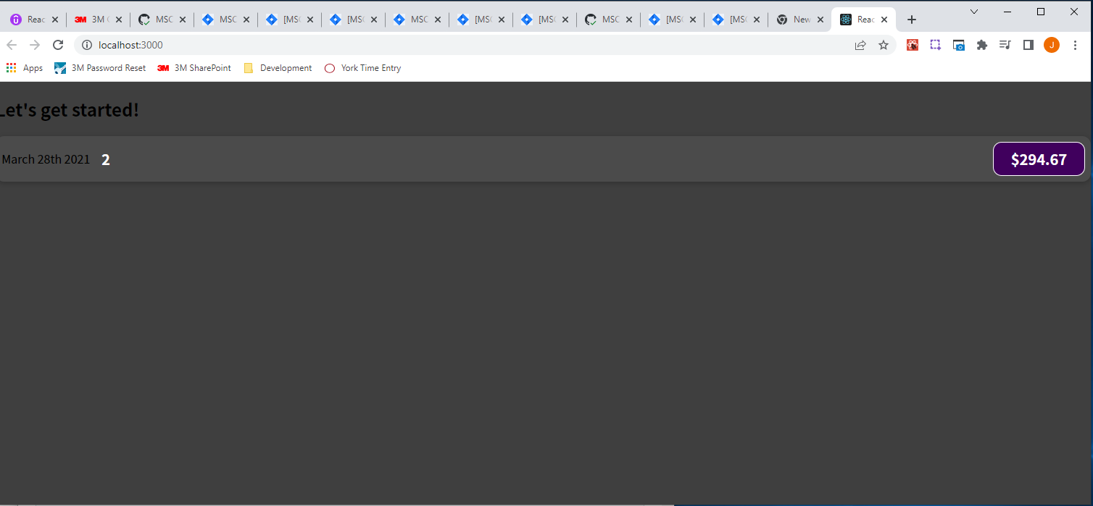

We could also do something like {Math.random()} to generate a random number with the Math object.

|  |
| --- |
| src/components/ExpenseItem.js |
| import './ExpenseItem.css';  const expenseDate = new Date(2021, 2, 28);  const expenseTitle = 'Car Insurance';  const expenseAmount = 294.67;  function ExpenseItem() {  return (  <div className="expense-item">  <div>March 28th 2021</div>  <div className="expense-item__description">  <h2>{Math.random()}</h2>  <div className="expense-item__price">$294.67</div>  </div>  </div>  );  }  export default ExpenseItem; |

The result of {Math.random()}, "0.725136286171973" was output onto the screen.

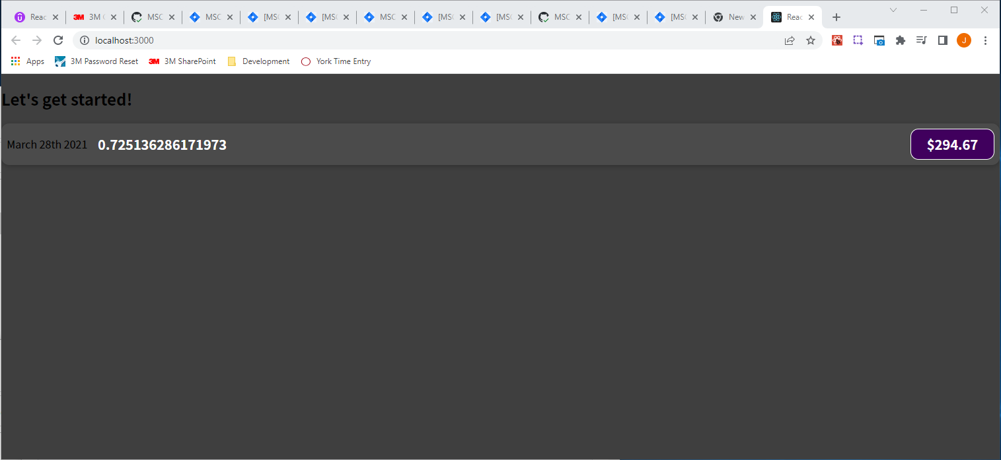

In the h2 tag, we want to refer to the value stored in the constant expenseTitle. We can just repeat the constant name {expenseTitle} within the h2 tags, which is also a valid JavaScript expression, just pointing at a variable or a constant, in this case a constant. And now JavaScript will extract the value stored in the constant and inject it into the HTML code.

|  |
| --- |
| src/components/ExpenseItem.js |
| import './ExpenseItem.css';  const expenseDate = new Date(2021, 2, 28);  const expenseTitle = 'Car Insurance';  const expenseAmount = 294.67;  function ExpenseItem() {  return (  <div className="expense-item">  <div>March 28th 2021</div>  <div className="expense-item__description">  <h2>{expenseTitle}</h2>  <div className="expense-item__price">$294.67</div>  </div>  </div>  );  }  export default ExpenseItem; |

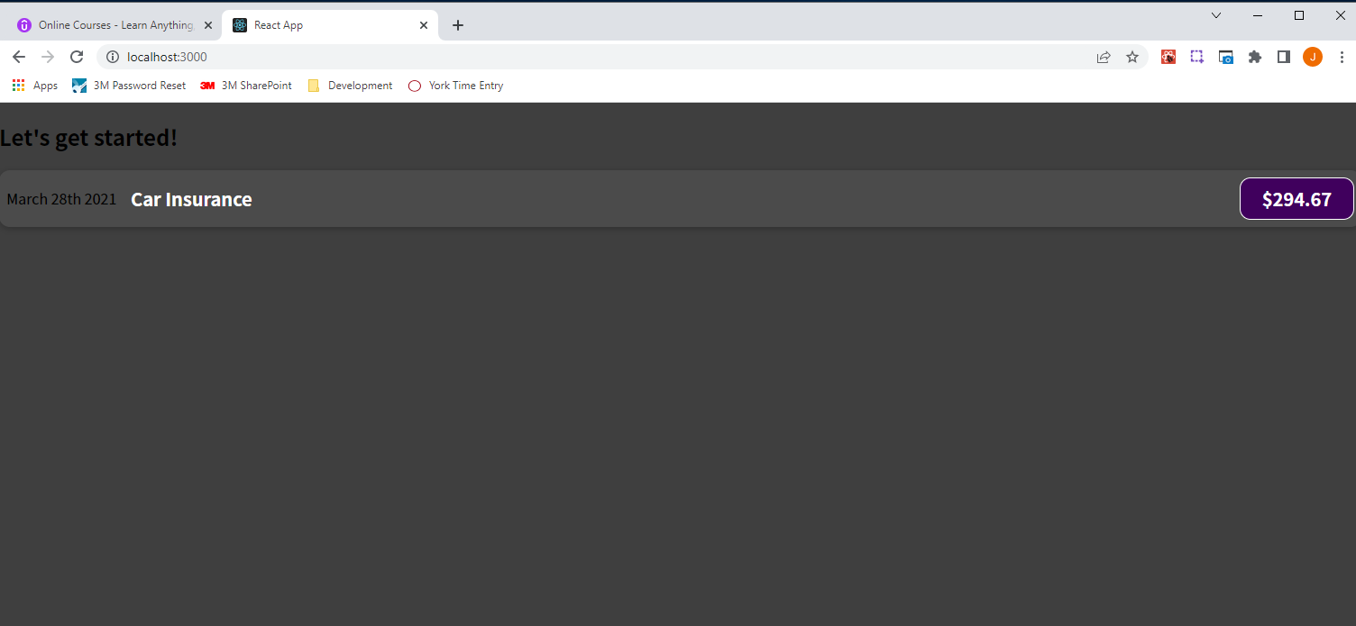

We can do the same thing for the expenseAmount variable, but we will leave the "$" hard coded for now.

|  |
| --- |
| src/components/ExpenseItem.js |
| import './ExpenseItem.css';  const expenseDate = new Date(2021, 2, 28);  const expenseTitle = 'Car Insurance';  const expenseAmount = 294.67;  function ExpenseItem() {  return (  <div className="expense-item">  <div>March 28th 2021</div>  <div className="expense-item__description">  <h2>{expenseTitle}</h2>  <div className="expense-item__price">$**{expenseAmount}**</div>  </div>  </div>  );  }  export default ExpenseItem; |

The output does not change after replacing the hard-coded expense amount with the expenseAmount constant in curly braces.

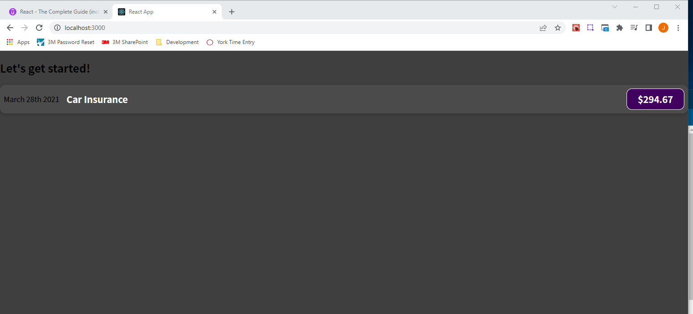

We can do something similar with the date where we put the expenseDate inside of curly braces, but we have to keep in mind that it is a date object, and therefore, if we try to save it like this…

|  |
| --- |
| src/components/ExpenseItem.js |
| import './ExpenseItem.css';  const expenseDate = new Date(2021, 2, 28);  const expenseTitle = 'Car Insurance';  const expenseAmount = 294.67;  function ExpenseItem() {  return (  <div className="expense-item">  <div>**{expenseDate}**</div>  <div className="expense-item__description">  <h2>{expenseTitle}</h2>  <div className="expense-item__price">${expenseAmount}</div>  </div>  </div>  );  }  export default ExpenseItem; |

The code will break if we do {expenseDate}

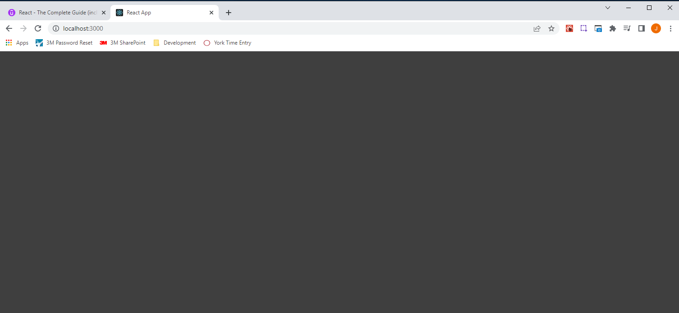

Since expenseDate holds a date object, it can't be output as text like this {expenseDate}, instead we need to find a way to convert it into text such as by calling toISOString(), for example:

|  |
| --- |
| src/components/ExpenseItem.js |
| import './ExpenseItem.css';  const expenseDate = new Date(2021, 2, 28);  const expenseTitle = 'Car Insurance';  const expenseAmount = 294.67;  function ExpenseItem() {  return (  <div className="expense-item">  <div>{expenseDate.toISOString()}</div>  <div className="expense-item__description">  <h2>{expenseTitle}</h2>  <div className="expense-item__price">${expenseAmount}</div>  </div>  </div>  );  }  export default ExpenseItem; |

Calling toISOString()on the expenseDate object, results in the expense date being converted to text.

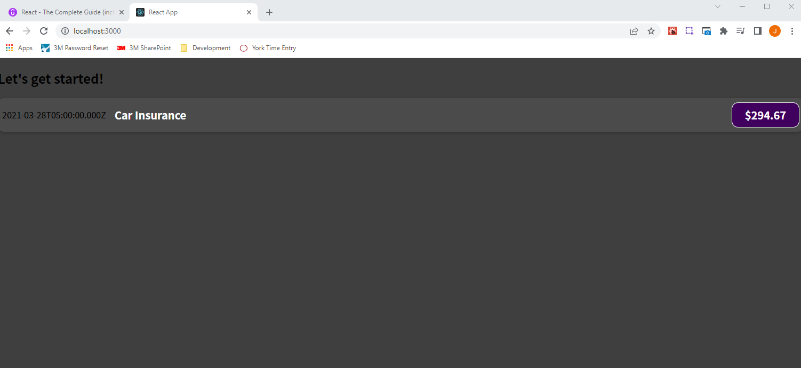

We now no longer work with hard coded text in our HTML code, but we have instead these dynamic placeholders where the concrete value can be the result of a calculation, of HTTP requests, or as it is here at the moment with the value stored in a constant or variable.

### 37. Passing Data via "Props"

How can we make the component "ExpenseItem" reusable? Well, the good news is that we can already reuse it. In App.js where I am using it,

|  |
| --- |
| src/App.js |
| import ExpenseItem from './components/ExpenseItem';  function App() {  return (  <div>  <h2>Let's get started!</h2>  <ExpenseItem></ExpenseItem>  </div>  );  }  export default App; |

we can simply copy that line and paste it in:

|  |
| --- |
| src/App.js |
| import ExpenseItem from './components/ExpenseItem';  function App() {  return (  <div>  <h2>Let's get started!</h2>  <ExpenseItem></ExpenseItem>  <ExpenseItem></ExpenseItem>  </div>  );  }  export default App; |

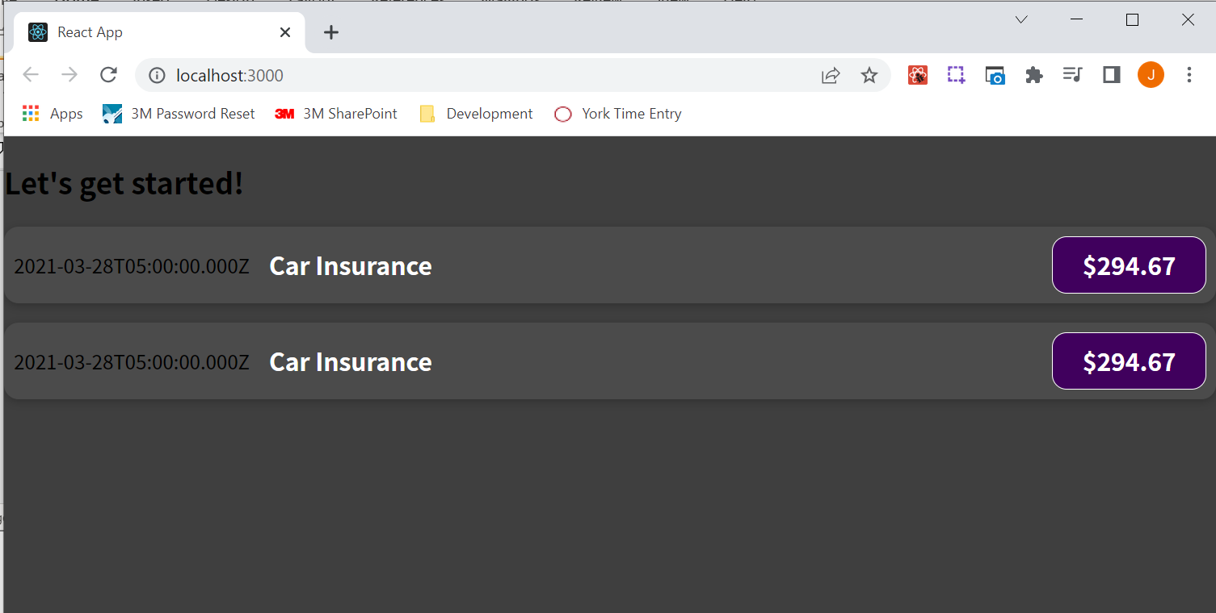

You can reuse this component as often as you want. Now, the component is not really reusable because it is always reusing the same data, and the reason is that the data is baked into the ExpenseItem component.

|  |
| --- |
| src/components/ExpenseItem.js |
| import './ExpenseItem.css';  const expenseDate = new Date(2021, 2, 28);  const expenseTitle = 'Car Insurance';  const expenseAmount = 294.67;  function ExpenseItem() {  return (  <div className="expense-item">  <div>{expenseDate.toISOString()}</div>  <div className="expense-item__description">  <h2>{expenseTitle}</h2>  <div className="expense-item__price">${expenseAmount}</div>  </div>  </div>  );  }  export default ExpenseItem; |

When we write functions in JavaScript, we make these functions reusable by accepting parameters, and that allows us to call the same function with different parameter values. And therefore, the function may and typically will produce different results for different input values, but it is still always the same function being called.

React basically has the same concept built in. We can make our components reusable by using parameters and a concept called props in React.

Let's say in your App component you have a goalItem variable or constant defined, which holds a string of 'Finish!' Then, lets say you have a custom component, the CourseGoalItem component, which has a list item inside of it where this goalItem should be output. That's just another example, not the exact code we've been working on. We can have a custom component, which should have a list item where the goalItem should be output dynamically. The problem is that the goalItem variable lives in the App component, not in the CourseGoalItem component. And to a certain extent that is good because it makes the CourseGoalItem independent if it doesn't store the concrete value internally. But, of course, we want to define what is being output by CourseGoalItem with help of the variable managed in App. And we don't have direct access to the HTML code output by some component in other components. We can't just send our stored data there, but, instead, we can utilize a concept called props. We can pass data to the custom component by adding an attribute, and inside of that component, we can then get access to all these attributes which might have been set on our custom component. Again, we're basically building our own custom HTML elements, and just as HTML elements can have attributes, it turns out that with React, our own custom components can also have attributes. In React, this concept is just called props instead of attributes. Props stands for properties. We can set properties of our own custom components.

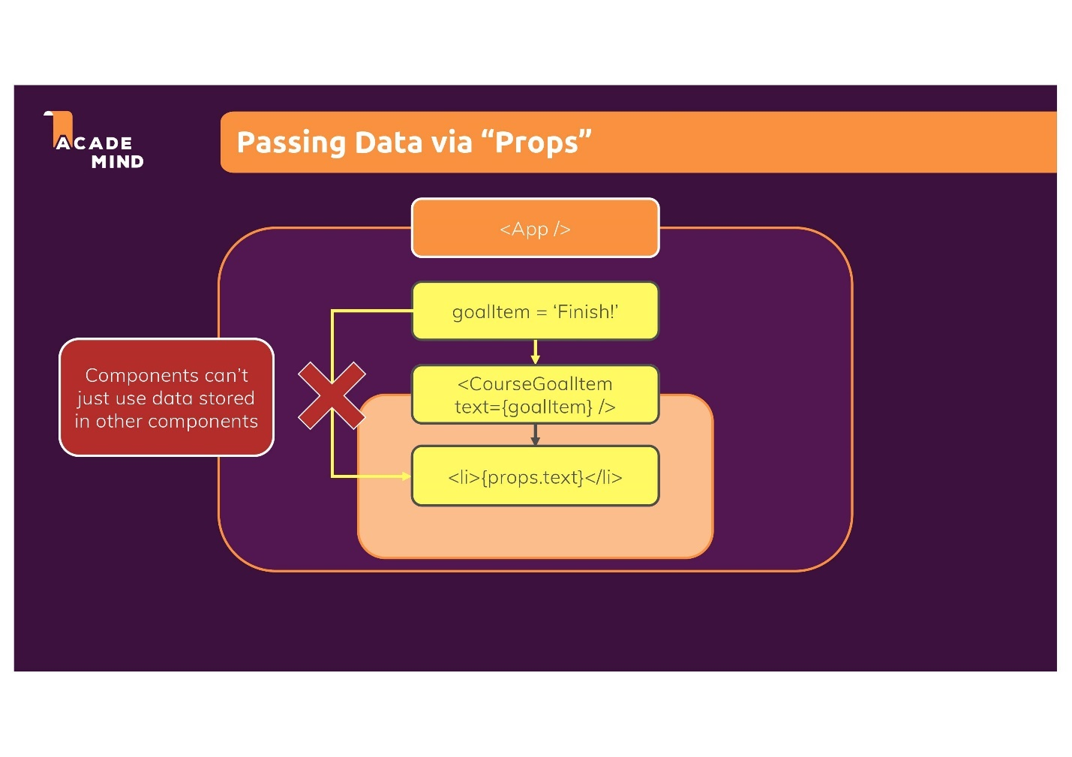

#### How does this props concept work, though?

In the ExpenseItem component, we have the date, the title, and the amount, but

|  |
| --- |
| src/components/ExpenseItem.js |
| import './ExpenseItem.css';  const expenseDate = new Date(2021, 2, 28);  const expenseTitle = 'Car Insurance';  const expenseAmount = 294.67;  function ExpenseItem() {  return (  <div className="expense-item">  <div>{**expenseDate**.toISOString()}</div>  <div className="expense-item__description">  <h2>{**expenseTitle**}</h2>  <div className="expense-item__price">${**expenseAmount**}</div>  </div>  </div>  );  }  export default ExpenseItem; |

the output should not be stored in "ExpenseItem.js"

|  |
| --- |
| src/components/ExpenseItem.js |
| import './ExpenseItem.css';  **const expenseDate = new Date(2021, 2, 28);**  **const expenseTitle = 'Car Insurance';**  **const expenseAmount = 294.67;**  function ExpenseItem() {  return (  <div className="expense-item">  <div>{expenseDate.toISOString()}</div>  <div className="expense-item__description">  <h2>{expenseTitle}</h2>  <div className="expense-item__price">${expenseAmount}</div>  </div>  </div>  );  }  export default ExpenseItem; |

But instead should be stored in App.js. In App.js we could have another constant or variable, such as expenses, which is an array, so multiple expense items.

|  |
| --- |
| src/App.js |
| import ExpenseItem from './components/ExpenseItem';  function App() {  **const expenses = [**  **];**  return (  <div>  <h2>Let's get started!</h2>  <ExpenseItem></ExpenseItem>  <ExpenseItem></ExpenseItem>  </div>  );  }  export default App; |

And let's say every expense in the array is a simple JavaScript object, which now has a title, price, and date. Let's say we have four expense items. We don't need to worry about the "id" field at the moment. We now have four objects inside of the expenses array.

|  |
| --- |
| src/App.js |
| import ExpenseItem from './components/ExpenseItem';  function App() {  const expenses = [  **{**  **id: 'e1',**  **title: 'Toilet Paper',**  **amount: 94.12,**  **date: new Date(2020, 7, 14),**  **},**  **{ id: 'e2', title: 'New TV', amount: 799.49, date: new Date(2021, 2, 12) },**  **{**  **id: 'e3',**  **title: 'Car Insurance',**  **amount: 294.67,**  **date: new Date(2021, 2, 28),**  **},**  **{**  **id: 'e4',**  **title: 'New Desk (Wooden)',**  **amount: 450,**  **date: new Date(2021, 5, 12),**  **},**  ];    return (  <div>  <h2>Let's get started!</h2>  <ExpenseItem></ExpenseItem>  <ExpenseItem></ExpenseItem>  <ExpenseItem></ExpenseItem>  <ExpenseItem></ExpenseItem>  </div>  );  }  export default App; |

Now we want to pass the data of these different objects to these different ExpenseItems. That means that we want to make these ExpenseItems configurable from outside, you could say. The data should not be stored inside of them but instead received from outside. And that works with this props concept.

|  |
| --- |
| src/App.js |
| import ExpenseItem from './components/ExpenseItem';  function App() {  const expenses = [  {  id: 'e1',  title: 'Toilet Paper',  amount: 94.12,  date: new Date(2020, 7, 14),  },  { id: 'e2', title: 'New TV', amount: 799.49, date: new Date(2021, 2, 12) },  {  id: 'e3',  title: 'Car Insurance',  amount: 294.67,  date: new Date(2021, 2, 28),  },  {  id: 'e4',  title: 'New Desk (Wooden)',  amount: 450,  date: new Date(2021, 5, 12),  },  ];    return (  <div>  <h2>Let's get started!</h2>  <ExpenseItem></ExpenseItem>  <ExpenseItem></ExpenseItem>  <ExpenseItem></ExpenseItem>  <ExpenseItem></ExpenseItem>  </div>  );  }  export default App; |

In App.js we can simply add attributes to these custom HTML elements, so to these components. *The terms custom HTML elements and components are being used interchangeably.

|  |
| --- |
| src/App.js |
| import ExpenseItem from './components/ExpenseItem';  function App() {  const expenses = [  {  id: 'e1',  title: 'Toilet Paper',  amount: 94.12,  date: new Date(2020, 7, 14),  },  { id: 'e2', title: 'New TV', amount: 799.49, date: new Date(2021, 2, 12) },  {  id: 'e3',  title: 'Car Insurance',  amount: 294.67,  date: new Date(2021, 2, 28),  },  {  id: 'e4',  title: 'New Desk (Wooden)',  amount: 450,  date: new Date(2021, 5, 12),  },  ];    return (  <div>  <h2>Let's get started!</h2>  <ExpenseItem></ExpenseItem>  <ExpenseItem></ExpenseItem>  <ExpenseItem></ExpenseItem>  <ExpenseItem></ExpenseItem>  </div>  );  }  export default App; |

For example, we could add a title attribute to ExpenseItem

|  |
| --- |
| src/App.js |
| import ExpenseItem from './components/ExpenseItem';  function App() {  const expenses = [  {  id: 'e1',  title: 'Toilet Paper',  amount: 94.12,  date: new Date(2020, 7, 14),  },  { id: 'e2', title: 'New TV', amount: 799.49, date: new Date(2021, 2, 12) },  {  id: 'e3',  title: 'Car Insurance',  amount: 294.67,  date: new Date(2021, 2, 28),  },  {  id: 'e4',  title: 'New Desk (Wooden)',  amount: 450,  date: new Date(2021, 5, 12),  },  ];    return (  <div>  <h2>Let's get started!</h2>  <ExpenseItem **title=""**></ExpenseItem>  <ExpenseItem></ExpenseItem>  <ExpenseItem></ExpenseItem>  <ExpenseItem></ExpenseItem>  </div>  );  }  export default App; |

And set this to a value of 'Toilet Paper'. So we can just type 'Toilet Paper' here, but this again would be hard-coding data in this JSX code:

|  |
| --- |
| src/App.js |
| import ExpenseItem from './components/ExpenseItem';  function App() {  const expenses = [  {  id: 'e1',  title: 'Toilet Paper',  amount: 94.12,  date: new Date(2020, 7, 14),  },  { id: 'e2', title: 'New TV', amount: 799.49, date: new Date(2021, 2, 12) },  {  id: 'e3',  title: 'Car Insurance',  amount: 294.67,  date: new Date(2021, 2, 28),  },  {  id: 'e4',  title: 'New Desk (Wooden)',  amount: 450,  date: new Date(2021, 5, 12),  },  ];    return (  <div>  <h2>Let's get started!</h2>  <ExpenseItem title="**Toilet Paper**"></ExpenseItem>  <ExpenseItem></ExpenseItem>  <ExpenseItem></ExpenseItem>  <ExpenseItem></ExpenseItem>  </div>  );  }  export default App; |

Since we already have the expenses array,

|  |
| --- |
| src/App.js |
| import ExpenseItem from './components/ExpenseItem';  function App() {  const expenses = [  {  id: 'e1',  title: 'Toilet Paper',  amount: 94.12,  date: new Date(2020, 7, 14),  },  { id: 'e2', title: 'New TV', amount: 799.49, date: new Date(2021, 2, 12) },  {  id: 'e3',  title: 'Car Insurance',  amount: 294.67,  date: new Date(2021, 2, 28),  },  {  id: 'e4',  title: 'New Desk (Wooden)',  amount: 450,  date: new Date(2021, 5, 12),  },  ];    return (  <div>  <h2>Let's get started!</h2>  <ExpenseItem title="Toilet Paper"></ExpenseItem>  <ExpenseItem></ExpenseItem>  <ExpenseItem></ExpenseItem>  <ExpenseItem></ExpenseItem>  </div>  );  }  export default App; |

we can dynamically retrieve the title stored in this first ExpenseItem

|  |
| --- |
| src/App.js |
| import ExpenseItem from './components/ExpenseItem';  function App() {  const expenses = [  **{**  id: 'e1',  **title: 'Toilet Paper',**  amount: 94.12,  date: new Date(2020, 7, 14),  },  { id: 'e2', title: 'New TV', amount: 799.49, date: new Date(2021, 2, 12) },  {  id: 'e3',  title: 'Car Insurance',  amount: 294.67,  date: new Date(2021, 2, 28),  },  {  id: 'e4',  title: 'New Desk (Wooden)',  amount: 450,  date: new Date(2021, 5, 12),  },  ];    return (  <div>  <h2>Let's get started!</h2>  <ExpenseItem title="Toilet Paper"></ExpenseItem>  <ExpenseItem></ExpenseItem>  <ExpenseItem></ExpenseItem>  <ExpenseItem></ExpenseItem>  </div>  );  }  export default App; |

for this first ExpenseItem here.

|  |
| --- |
| src/App.js |
| import ExpenseItem from './components/ExpenseItem';  function App() {  const expenses = [  {  id: 'e1',  title: 'Toilet Paper',  amount: 94.12,  date: new Date(2020, 7, 14),  },  { id: 'e2', title: 'New TV', amount: 799.49, date: new Date(2021, 2, 12) },  {  id: 'e3',  title: 'Car Insurance',  amount: 294.67,  date: new Date(2021, 2, 28),  },  {  id: 'e4',  title: 'New Desk (Wooden)',  amount: 450,  date: new Date(2021, 5, 12),  },  ];    return (  <div>  <h2>Let's get started!</h2>  **<ExpenseItem title="Toilet Paper"></ExpenseItem>**  <ExpenseItem></ExpenseItem>  <ExpenseItem></ExpenseItem>  <ExpenseItem></ExpenseItem>  </div>  );  }  export default App; |

We can assign values to attributes by using single curly brace syntax as shown below.

|  |
| --- |
| src/App.js |
| import ExpenseItem from './components/ExpenseItem';  function App() {  const expenses = [  {  id: 'e1',  title: 'Toilet Paper',  amount: 94.12,  date: new Date(2020, 7, 14),  },  { id: 'e2', title: 'New TV', amount: 799.49, date: new Date(2021, 2, 12) },  {  id: 'e3',  title: 'Car Insurance',  amount: 294.67,  date: new Date(2021, 2, 28),  },  {  id: 'e4',  title: 'New Desk (Wooden)',  amount: 450,  date: new Date(2021, 5, 12),  },  ];    return (  <div>  <h2>Let's get started!</h2>  <ExpenseItem title=**{expenses[0].title}**></ExpenseItem>  <ExpenseItem></ExpenseItem>  <ExpenseItem></ExpenseItem>  <ExpenseItem></ExpenseItem>  </div>  );  }  export default App; |

We can also do this for the amount. You can choose the attribute names. They don't need to be "title" and "amount".

|  |
| --- |
| src/App.js |
| import ExpenseItem from './components/ExpenseItem';  function App() {  const expenses = [  {  id: 'e1',  title: 'Toilet Paper',  amount: 94.12,  date: new Date(2020, 7, 14),  },  { id: 'e2', title: 'New TV', amount: 799.49, date: new Date(2021, 2, 12) },  {  id: 'e3',  title: 'Car Insurance',  amount: 294.67,  date: new Date(2021, 2, 28),  },  {  id: 'e4',  title: 'New Desk (Wooden)',  amount: 450,  date: new Date(2021, 5, 12),  },  ];    return (  <div>  <h2>Let's get started!</h2>  <ExpenseItem title={expenses[0].title **amount={expenses[0].amount**}></ExpenseItem>  <ExpenseItem></ExpenseItem>  <ExpenseItem></ExpenseItem>  <ExpenseItem></ExpenseItem>  </div>  );  }  export default App; |

We can also add a date attribute.

|  |
| --- |
| src/App.js |
| import ExpenseItem from './components/ExpenseItem';  function App() {  const expenses = [  {  id: 'e1',  title: 'Toilet Paper',  amount: 94.12,  date: new Date(2020, 7, 14),  },  { id: 'e2', title: 'New TV', amount: 799.49, date: new Date(2021, 2, 12) },  {  id: 'e3',  title: 'Car Insurance',  amount: 294.67,  date: new Date(2021, 2, 28),  },  {  id: 'e4',  title: 'New Desk (Wooden)',  amount: 450,  date: new Date(2021, 5, 12),  },  ];    return (  <div>  <h2>Let's get started!</h2>  <ExpenseItem  title={expenses[0].title  amount={expenses[0].amount}  **date={expenses[0].date}**  ></ExpenseItem>  <ExpenseItem></ExpenseItem>  <ExpenseItem></ExpenseItem>  <ExpenseItem></ExpenseItem>  </div>  );  }  export default App; |

We can now do the same thing for other expense items. For example, in the below code snippet, we add the attributes for each of them but access the second expense.

|  |
| --- |
| src/App.js |
| import ExpenseItem from './components/ExpenseItem';  function App() {  const expenses = [  {  id: 'e1',  title: 'Toilet Paper',  amount: 94.12,  date: new Date(2020, 7, 14),  },  { id: 'e2', title: 'New TV', amount: 799.49, date: new Date(2021, 2, 12) },  {  id: 'e3',  title: 'Car Insurance',  amount: 294.67,  date: new Date(2021, 2, 28),  },  {  id: 'e4',  title: 'New Desk (Wooden)',  amount: 450,  date: new Date(2021, 5, 12),  },  ];    return (  <div>  <h2>Let's get started!</h2>  <ExpenseItem  title={expenses[0].title  amount={expenses[0].amount}  date={expenses[0].date}  ></ExpenseItem>  <ExpenseItem  **title={expenses[1].title**  **amount={expenses[1].amount}**  **date={expenses[1].date}**  ><ExpenseItem></ExpenseItem>  <ExpenseItem></ExpenseItem>  </div>  );  }  export default App; |

If we change all of the ExpenseItems by adding in their attributes as shown below

|  |
| --- |
| src/App.js |
| import ExpenseItem from "./components/ExpenseItem";  function App() {  const expenses = [  {  id: "e1",  title: "Toilet Paper",  amount: 94.12,  date: new Date(2020, 7, 14),  },  { id: "e2", title: "New TV", amount: 799.49, date: new Date(2021, 2, 12) },  {  id: "e3",  title: "Car Insurance",  amount: 294.67,  date: new Date(2021, 2, 28),  },  {  id: "e4",  title: "New Desk (Wooden)",  amount: 450,  date: new Date(2021, 5, 12),  },  ];  return (  <div>  <h2>Let's get started!</h2>  <ExpenseItem  title={expenses[0].title}  amount={expenses[0].amount}  date={expenses[0].date}  ></ExpenseItem>  <ExpenseItem  title={expenses[1].title}  amount={expenses[1].amount}  date={expenses[1].date}  ></ExpenseItem>  <ExpenseItem  title={expenses[2].title}  amount={expenses[2].amount}  date={expenses[2].date}  ></ExpenseItem>  <ExpenseItem  title={expenses[3].title}  amount={expenses[3].amount}  date={expenses[3].date}  ></ExpenseItem>  </div>  );  }  export default App; |

We see no change when we reload the page in the browser:

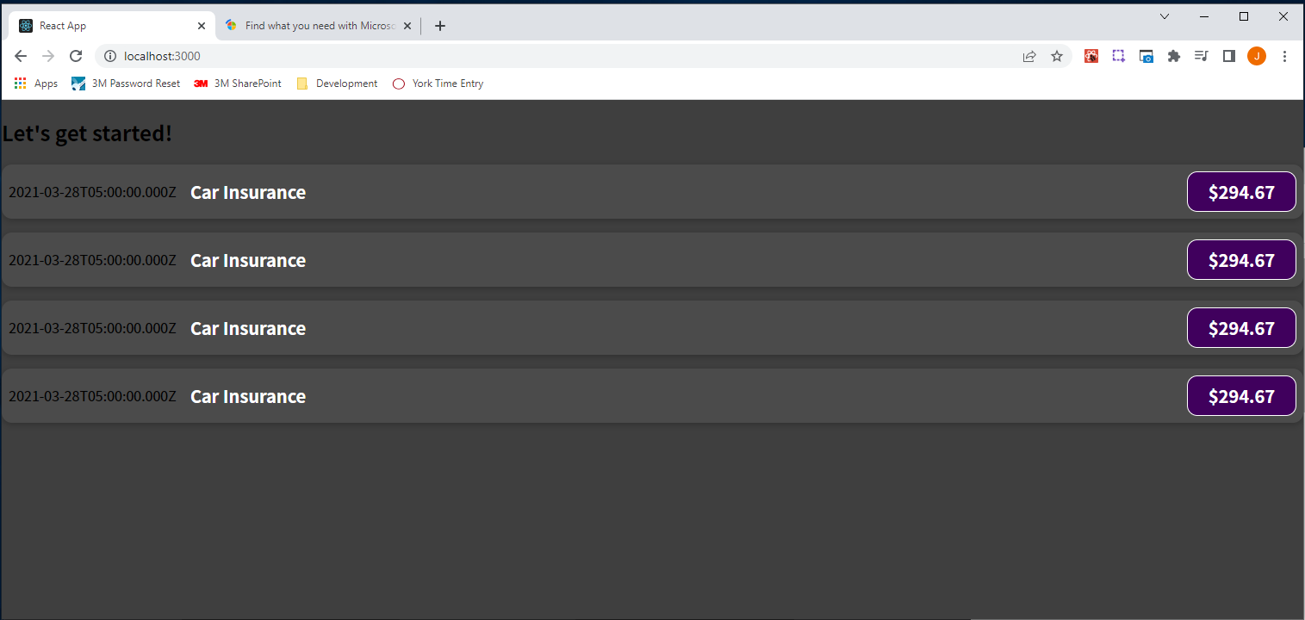

That is because we've only done half of the work we need to do.

Inside of ExpenseItem.js, we need to do something with the received attribute values, which is the half that it is missing. Inside of ExpesneItem.js, how do we get access to the values defined in the place where we use our custom components? The answer to that is parameters.

In regular JavaScript we use parameters for passing data into functions, and it's kind of similar for React. However, we're now not getting a title, amount, and date parameter as you might think:

|  |
| --- |
| src/components/ExpenseItem.js |
| import './ExpenseItem.css';  const expenseDate = new Date(2021, 2, 28);  const expenseTitle = 'Car Insurance';  const expenseAmount = 294.67;  function ExpenseItem(**~~title, amount, date~~**) {  return (  <div className="expense-item">  <div>{expenseDate.toISOString()}</div>  <div className="expense-item__description">  <h2>{expenseTitle}</h2>  <div className="expense-item__price">${expenseAmount}</div>  </div>  </div>  );  }  export default ExpenseItem; |

#### Props Overview

But instead, we get one parameter. React will ensure that we get one parameter in every component. That one parameter will be an object which holds all the received attributes as properties, hence the name props for the overall concept. Therefore, we get one parameter, and you can name this parameter whatever you want. You could name it "data", but typically it's named "props" to make it clear that this is the object which holds all the values we get for the attributes on our custom element.

|  |
| --- |
| src/components/ExpenseItem.js |
| import './ExpenseItem.css';  const expenseDate = new Date(2021, 2, 28);  const expenseTitle = 'Car Insurance';  const expenseAmount = 294.67;  function ExpenseItem(**props**) {  return (  <div className="expense-item">  <div>{expenseDate.toISOString()}</div>  <div className="expense-item__description">  <h2>{expenseTitle}</h2>  <div className="expense-item__price">${expenseAmount}</div>  </div>  </div>  );  }  export default ExpenseItem; |

We get key-value pairs in this props object shown in the code snippet above, which are passed in by React automatically. The keys will be the attribute names defined in App.js as shown in the code snippet below:

|  |
| --- |
| src/App.js |
| import ExpenseItem from "./components/ExpenseItem";  function App() {  const expenses = [  {  id: "e1",  title: "Toilet Paper",  amount: 94.12,  date: new Date(2020, 7, 14),  },  { id: "e2", title: "New TV", amount: 799.49, date: new Date(2021, 2, 12) },  {  id: "e3",  title: "Car Insurance",  amount: 294.67,  date: new Date(2021, 2, 28),  },  {  id: "e4",  title: "New Desk (Wooden)",  amount: 450,  date: new Date(2021, 5, 12),  },  ];  return (  <div>  <h2>Let's get started!</h2>  <ExpenseItem  **title**={expenses[0].title}  **amount**={expenses[0].amount}  **date**={expenses[0].date}  ></ExpenseItem>  <ExpenseItem  **title**={expenses[1].title}  **amount**={expenses[1].amount}  **date**={expenses[1].date}  ></ExpenseItem>  <ExpenseItem  **title**={expenses[2].title}  **amount**={expenses[2].amount}  **date**={expenses[2].date}  ></ExpenseItem>  <ExpenseItem  **title**={expenses[3].title}  **amount**={expenses[3].amount}  **date**={expenses[3].date}  ></ExpenseItem>  </div>  );  }  export default App; |

The values will be the attribute values that are set as shown in the below code snippet.

|  |
| --- |
| src/App.js |
| import ExpenseItem from "./components/ExpenseItem";  function App() {  const expenses = [  {  id: "e1",  title: "Toilet Paper",  amount: 94.12,  date: new Date(2020, 7, 14),  },  { id: "e2", title: "New TV", amount: 799.49, date: new Date(2021, 2, 12) },  {  id: "e3",  title: "Car Insurance",  amount: 294.67,  date: new Date(2021, 2, 28),  },  {  id: "e4",  title: "New Desk (Wooden)",  amount: 450,  date: new Date(2021, 5, 12),  },  ];  return (  <div>  <h2>Let's get started!</h2>  <ExpenseItem  title=**{expenses[0].title}**  amount=**{expenses[0].amount}**  date=**{expenses[0].date}**  ></ExpenseItem>  <ExpenseItem  title=**{expenses[1].title}**  amount=**{expenses[1].amount}**  date=**{expenses[1].date}**  ></ExpenseItem>  <ExpenseItem  title=**{expenses[2].title}**  amount=**{expenses[2].amount}**  date=**{expenses[2].date}**  ></ExpenseItem>  <ExpenseItem  title=**{expenses[3].title}**  amount=**{expenses[3].amount}**  date=**{expenses[3].date}**  ></ExpenseItem>  </div>  );  }  export default App; |

So if I now want to output the title received, in the h2 tag, I can now access props.title as shown in the below code snippet.

|  |
| --- |
| src/components/ExpenseItem.js |
| import './ExpenseItem.css';  const expenseDate = new Date(2021, 2, 28);  const expenseTitle = 'Car Insurance';  const expenseAmount = 294.67;  function ExpenseItem(props) {  return (  <div className="expense-item">  <div>{expenseDate.toISOString()}</div>  <div className="expense-item__description">  <h2>{**props.title**}</h2>  <div className="expense-item__price">${expenseAmount}</div>  </div>  </div>  );  }  export default ExpenseItem; |

The title property exists because we set a title attribute in App.js

|  |
| --- |
| src/App.js |
| import ExpenseItem from "./components/ExpenseItem";  function App() {  const expenses = [  {  id: "e1",  title: "Toilet Paper",  amount: 94.12,  date: new Date(2020, 7, 14),  },  { id: "e2", title: "New TV", amount: 799.49, date: new Date(2021, 2, 12) },  {  id: "e3",  title: "Car Insurance",  amount: 294.67,  date: new Date(2021, 2, 28),  },  {  id: "e4",  title: "New Desk (Wooden)",  amount: 450,  date: new Date(2021, 5, 12),  },  ];  return (  <div>  <h2>Let's get started!</h2>  <ExpenseItem  **title**={expenses[0].title}  amount={expenses[0].amount}  date={expenses[0].date}  ></ExpenseItem>  <ExpenseItem  **title**={expenses[1].title}  amount={expenses[1].amount}  date={expenses[1].date}  ></ExpenseItem>  <ExpenseItem  **title**={expenses[2].title}  amount={expenses[2].amount}  date={expenses[2].date}  ></ExpenseItem>  <ExpenseItem  **title**={expenses[3].title}  amount={expenses[3].amount}  date={expenses[3].date}  ></ExpenseItem>  </div>  );  }  export default App; |

If you named the attribute something different instead of title such as name

|  |
| --- |
| src/App.js |
| import ExpenseItem from "./components/ExpenseItem";  function App() {  const expenses = [  {  id: "e1",  title: "Toilet Paper",  amount: 94.12,  date: new Date(2020, 7, 14),  },  { id: "e2", title: "New TV", amount: 799.49, date: new Date(2021, 2, 12) },  {  id: "e3",  title: "Car Insurance",  amount: 294.67,  date: new Date(2021, 2, 28),  },  {  id: "e4",  title: "New Desk (Wooden)",  amount: 450,  date: new Date(2021, 5, 12),  },  ];  return (  <div>  <h2>Let's get started!</h2>  <ExpenseItem  **name**={expenses[0].title}  amount={expenses[0].amount}  date={expenses[0].date}  ></ExpenseItem>  <ExpenseItem  **name**={expenses[1].title}  amount={expenses[1].amount}  date={expenses[1].date}  ></ExpenseItem>  <ExpenseItem  **name**={expenses[2].title}  amount={expenses[2].amount}  date={expenses[2].date}  ></ExpenseItem>  <ExpenseItem  **name**={expenses[3].title}  amount={expenses[3].amount}  date={expenses[3].date}  ></ExpenseItem>  </div>  );  }  export default App; |

then you would have to access props.name in ExpenseItem.js

|  |
| --- |
| src/components/ExpenseItem.js |
| import './ExpenseItem.css';  const expenseDate = new Date(2021, 2, 28);  const expenseTitle = 'Car Insurance';  const expenseAmount = 294.67;  function ExpenseItem(props) {  return (  <div className="expense-item">  <div>{expenseDate.toISOString()}</div>  <div className="expense-item__description">  <h2>{**props.name**}</h2>  <div className="expense-item__price">${expenseAmount}</div>  </div>  </div>  );  }  export default ExpenseItem; |

So the key which you access on your props object, has to be the name you picked for your attribute. Otherwise, it will not work. You want to choose prop/attribute names that are self-explanatory and make sense.

In ExpenseItem, we can also output props.amount and props.date.toISOString()

|  |
| --- |
| src/components/ExpenseItem.js |
| import './ExpenseItem.css';  const expenseDate = new Date(2021, 2, 28);  const expenseTitle = 'Car Insurance';  const expenseAmount = 294.67;  function ExpenseItem(props) {  return (  <div className="expense-item">  <div>{props.date.toISOString()}</div>  <div className="expense-item__description">  <h2>{props.title}</h2>  <div className="expense-item__price">${**props.amount**}</div>  </div>  </div>  );  }  export default ExpenseItem; |

And then we can now get rid of the constants in ExpenseItem.js since we now get all of the data we need from outside the ExpenseItem component. We're not defining the data inside of the ExpenseItem component

|  |
| --- |
| src/components/ExpenseItem.js |
| import './ExpenseItem.css';  function ExpenseItem(props) {  return (  <div className="expense-item">  <div>{props.date.toISOString()}</div>  <div className="expense-item__description">  <h2>{props.title}</h2>  <div className="expense-item__price">${props.amount}</div>  </div>  </div>  );  }  export default ExpenseItem; |

Instead, the data is defined in App.js and passed into ExpenseItem

|  |
| --- |
| src/App.js |
| import ExpenseItem from "./components/ExpenseItem";  function App() {  const expenses = [  {  id: "e1",  title: "Toilet Paper",  amount: 94.12,  date: new Date(2020, 7, 14),  },  { id: "e2", title: "New TV", amount: 799.49, date: new Date(2021, 2, 12) },  {  id: "e3",  title: "Car Insurance",  amount: 294.67,  date: new Date(2021, 2, 28),  },  {  id: "e4",  title: "New Desk (Wooden)",  amount: 450,  date: new Date(2021, 5, 12),  },  ];  return (  <div>  <h2>Let's get started!</h2>  <ExpenseItem  title={expenses[0].title}  amount={expenses[0].amount}  date={expenses[0].date}  ></ExpenseItem>  <ExpenseItem  title={expenses[1].title}  amount={expenses[1].amount}  date={expenses[1].date}  ></ExpenseItem>  <ExpenseItem  title={expenses[2].title}  amount={expenses[2].amount}  date={expenses[2].date}  ></ExpenseItem>  <ExpenseItem  title={expenses[3].title}  amount={expenses[3].amount}  date={expenses[3].date}  ></ExpenseItem>  </div>  );  }  export default App; |

For the different usages of ExpenseItem through attributes:

|  |
| --- |
| src/App.js |
| import ExpenseItem from "./components/ExpenseItem";  function App() {  const expenses = [  {  id: "e1",  title: "Toilet Paper",  amount: 94.12,  date: new Date(2020, 7, 14),  },  { id: "e2", title: "New TV", amount: 799.49, date: new Date(2021, 2, 12) },  {  id: "e3",  title: "Car Insurance",  amount: 294.67,  date: new Date(2021, 2, 28),  },  {  id: "e4",  title: "New Desk (Wooden)",  amount: 450,  date: new Date(2021, 5, 12),  },  ];  return (  <div>  <h2>Let's get started!</h2>  <ExpenseItem  **title**={expenses[0].title}  **amount**={expenses[0].amount}  **date**={expenses[0].date}  ></ExpenseItem>  <ExpenseItem  **title**={expenses[1].title}  **amount**={expenses[1].amount}  **date**={expenses[1].date}  ></ExpenseItem>  <ExpenseItem  **title**={expenses[2].title}  **amount**={expenses[2].amount}  **date**={expenses[2].date}  ></ExpenseItem>  <ExpenseItem  **title**={expenses[3].title}  **amount**={expenses[3].amount}  **date**={expenses[3].date}  ></ExpenseItem>  </div>  );  }  export default App; |

### 38. Adding "normal" JavaScript Logic to Components

We're basically done with our first custom component. The ExpenseItem component is now reusable, and we can use this props concept to configure it differently every time that we're using it so that the four times we're using ExpenseItem, we're also getting a different output four times. Props are not limited to dynamically set values, though. We can do that, but we don't have to.

Let's continue working on that ExpenseItem component because at the moment date is not output very clearly. We want to give the date a calendar like look. And therefore, of course we need to change the HTML code, that JSX code, which is responsible for outputting that date. Inside of that main div, which would hold the overall date element, we want to have three inner divs, where the top most div is responsible for outputting the month, the middle is responsible for outputting the year, and the bottom div then shows the date.

|  |
| --- |
| src/components/ExpenseItem.js |
| import './ExpenseItem.css';  function ExpenseItem(props) {  return (  <div className="expense-item">  <div>  <div>Month</div>  <div>Year</div>  <div>Day</div>  </div>  <div className="expense-item__description">  <h2>{props.title}</h2>  <div className="expense-item__price">${props.amount}</div>  </div>  </div>  );  }  export default ExpenseItem; |

We want to extract month, year, and day from the incoming date. So from that date prop which we're setting in App.js:

|  |
| --- |
| src/App.js |
| import ExpenseItem from "./components/ExpenseItem";  function App() {  const expenses = [  {  id: "e1",  title: "Toilet Paper",  amount: 94.12,  date: new Date(2020, 7, 14),  },  { id: "e2", title: "New TV", amount: 799.49, date: new Date(2021, 2, 12) },  {  id: "e3",  title: "Car Insurance",  amount: 294.67,  date: new Date(2021, 2, 28),  },  {  id: "e4",  title: "New Desk (Wooden)",  amount: 450,  date: new Date(2021, 5, 12),  },  ];  return (  <div>  <h2>Let's get started!</h2>  <ExpenseItem  title={expenses[0].title}  amount={expenses[0].amount}  date={expenses[0].date}  ></ExpenseItem>  <ExpenseItem  title={expenses[1].title}  amount={expenses[1].amount}  date={expenses[1].date}  ></ExpenseItem>  <ExpenseItem  title={expenses[2].title}  amount={expenses[2].amount}  date={expenses[2].date}  ></ExpenseItem>  <ExpenseItem  title={expenses[3].title}  amount={expenses[3].amount}  date={expenses[3].date}  ></ExpenseItem>  </div>  );  }  export default App; |

For the month, we can output a value dynamically and access props.date. But how do we access the month? Well, we can use a JavaScript built-in method accessible on all date objects in JavaScript. We can call the toLocaleString() method on props.date. This method simply helps you with outputting dates in human readable format. You could simply call toLocaleString() and pass in two arguments—language and object where you configure how specifically that date should be formatted—as shown below.

|  |
| --- |
| src/components/ExpenseItem.js |
| import './ExpenseItem.css';  function ExpenseItem(props) {  return (  <div className="expense-item">  <div>  <div>{props.date.toLocaleString('en-US', {month: 'long'})</div>  <div>Year</div>  <div>Day</div>  </div>  <div className="expense-item__description">  <h2>{props.title}</h2>  <div className="expense-item__price">${props.amount}</div>  </div>  </div>  );  }  export default ExpenseItem; |

Now we get each of the months output:

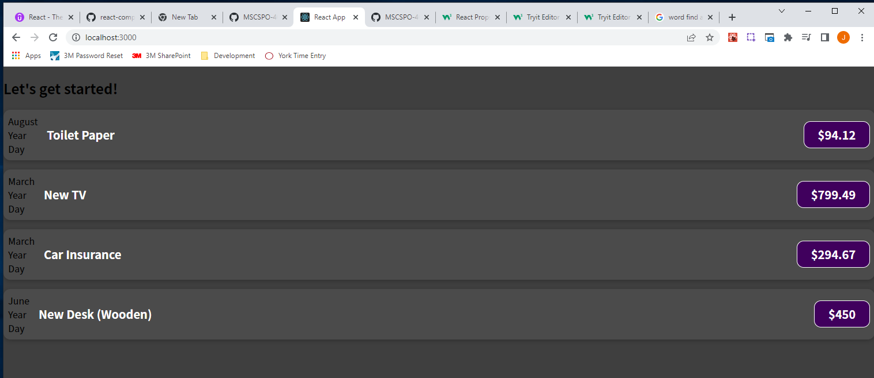

We can do something similar for year and day.

|  |
| --- |
| src/components/ExpenseItem.js |
| import './ExpenseItem.css';  function ExpenseItem(props) {  const month = props.date.toLocaleString('en-US', {month: 'long'});  const day = props.date.toLocaleString('en-US', {day: '2-digit'});  const year = props.date.getFullYear();  return (  <div className="expense-item">  <div>  <div>{month}</div>  <div>{year}</div>  <div>{day}</div>  </div>  <div className="expense-item__description">  <h2>{props.title}</h2>  <div className="expense-item__price">${props.amount}</div>  </div>  </div>  );  }  export default ExpenseItem; |

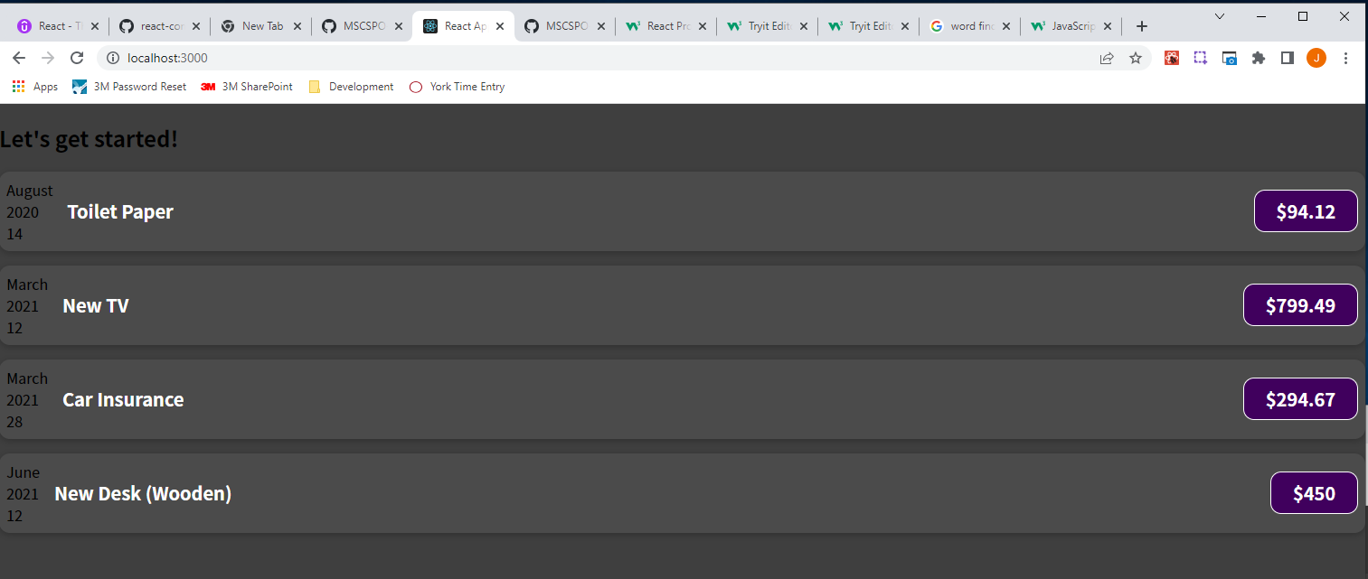

### 39. Splitting Components Into Multiple Components

It is a good idea to split your application into smaller building blocks where every building block/every component, is focused on one core task. You then build your overall user interface by combining these building blocks. By doing that, you keep every component, on its own, relatively small and manageable while still being able to build a complex user interface.

We could already argue that our ExpenseItem component is becoming too big. Based on this, we could argue that the calendar item that we want to show in the user interface could be treated as a separate component. The same case could be made for the title, for the amount, or for title and amount combined. There is no hard rule. Since, for this calendar, we'll have a couple of helper constants and have extra styles, we will split the ExpenseItem component into two components—the ExpenseItem component which we already have and a new component for rendering the date.

We now create a second custom component by creating a new file in the components folder and name it "ExpenseDate.js". In this file we create a new component which is still a function. We call the function ExpenseDate following the convention that we repeat the file name. We then export default ExpenseDate to make the component reusable.

|  |
| --- |
| src/components/ExpenseDate.js |
| function ExpenseDate() {}  export default ExpenseDate; |

In the ExpenseDate function we want to calculate month, day, and year, so we cut the three constants month, day, and year from the ExpenseItem component and put them in the ExpenseDate component, and therefore, of course, we also need to accept props as a parameter in the ExpenseDate function.

|  |
| --- |
| src/components/ExpenseDate.js |
| function ExpenseDate(**props**) {  const month = props.date.toLocaleString('en-US', {month: 'long'});  const day = props.date.toLocaleString('en-US', {day: '2-digit'});  const year = props.date.getFullYear();  }  export default ExpenseDate; |

And I do now expect this component will be used such that a date prop is set. We also need to cut the div from the ExpenseItem component and move it to the ExpenseDate component, returning it as JSX code as shown in the code snippet below:

|  |
| --- |
| src/components/ExpenseDate.js |
| function ExpenseDate(props) {  const month = props.date.toLocaleString("en-US", { month: "long" });  const day = props.date.toLocaleString("en-US", { day: "2-digit" });  const year = props.date.getFullYear();  return (  **<div>**  **<div>{month}</div>**  **<div>{year}</div>**  **<div>{day}</div>**  **</div>**  );  }  export default ExpenseDate; |

Now at the top of ExpenseItem.js, we can add import ExpenseDate from './ExpenseDate';

|  |
| --- |
| src/components/ExpenseItem.js |
| **import ExpenseDate from './ExpenseDate';**  import './ExpenseItem.css';  function ExpenseItem(props) {  return (  <div className="expense-item">  <div className="expense-item__description">  <h2>{props.title}</h2>  <div className="expense-item__price">${props.amount}</div>  </div>  </div>  );  }  export default ExpenseItem; |

Now, where we previously had our JSX code for the date, we instead output this ExpenseDate component.

|  |
| --- |
| src/components/ExpenseItem.js |
| import ExpenseDate from './ExpenseDate';  import './ExpenseItem.css';  function ExpenseItem(props) {  return (  <div className="expense-item">  **<ExpenseDate></ExpenseDate>**  <div className="expense-item__description">  <h2>{props.title}</h2>  <div className="expense-item__price">${props.amount}</div>  </div>  </div>  );  }  export default ExpenseItem; |

As a side note, if you have a component that has no content between the opening and closing tags, you can also write it a little differently by writing it as a self-closing element like this <ExpenseDate />

|  |
| --- |
| src/components/ExpenseItem.js |
| import ExpenseDate from './ExpenseDate';  import './ExpenseItem.css';  function ExpenseItem(props) {  return (  <div className="expense-item">  **<ExpenseDate />**  <div className="expense-item__description">  <h2>{props.title}</h2>  <div className="expense-item__price">${props.amount}</div>  </div>  </div>  );  }  export default ExpenseItem; |

In App.js we can make the ExpenseItem tags be self-closing as well:

|  |
| --- |
| src/App.js |
| import ExpenseItem from "./components/ExpenseItem";  function App() {  const expenses = [  {  id: "e1",  title: "Toilet Paper",  amount: 94.12,  date: new Date(2020, 7, 14),  },  { id: "e2", title: "New TV", amount: 799.49, date: new Date(2021, 2, 12) },  {  id: "e3",  title: "Car Insurance",  amount: 294.67,  date: new Date(2021, 2, 28),  },  {  id: "e4",  title: "New Desk (Wooden)",  amount: 450,  date: new Date(2021, 5, 12),  },  ];  return (  <div>  <h2>Let's get started!</h2>  <ExpenseItem  title={expenses[0].title}  amount={expenses[0].amount}  date={expenses[0].date}  **/>**  title={expenses[1].title}  amount={expenses[1].amount}  date={expenses[1].date}  **/>**  <ExpenseItem  title={expenses[2].title}  amount={expenses[2].amount}  date={expenses[2].date}  **/>**  <ExpenseItem  title={expenses[3].title}  amount={expenses[3].amount}  date={expenses[3].date}  **/>**  </div>  );  }  export default App; |

Now we're using ExpenseDate in the ExpenseItem component, and we're doing this to move some of the JSX code and JavaScript logic out of the ExpenseItem and into a separate component. The ExpenseDate component is also reusable and can be used anywhere in the React application. And it now helps us with keeping ExpenseItem lean. The bigger your application gets and your components become, the more you should look into splitting them up. There is no hard rule on when to split into components; this is something that will come with experience.

Our ExpenseDate component needs a prop. It needs the date prop, at least that's the name that we use to refer to it as, to well, extract that date and format it, extracting the month, day, and year.

|  |
| --- |
| src/components/ExpenseDate.js |
| function ExpenseDate(props) {  const month = props.**date**.toLocaleString("en-US", { month: "long" });  const day = props.**date**.toLocaleString("en-US", { day: "2-digit" });  const year = props.**date**.getFullYear();  return (  <div>  <div>{month}</div>  <div>{year}</div>  <div>{day}</div>  </div>  );  }  export default ExpenseDate; |

Hence, on ExpenseItem or in ExpenseItem, when we use ExpenseDate, we should set the date prop.

|  |
| --- |
| src/components/ExpenseItem.js |
| import ExpenseDate from './ExpenseDate';  import './ExpenseItem.css';  function ExpenseItem(props) {  return (  <div className="expense-item">  <ExpenseDate **date=""**/>  <div className="expense-item__description">  <h2>{props.title}</h2>  <div className="expense-item__price">${props.amount}</div>  </div>  </div>  );  }  export default ExpenseItem; |

If you used a name for the date prop other than date in ExpenseDate, you'll want to use that name when referring to that prop/attribute in ExpenseItem.

The value that will be passed to the date attribute in the ExpenseDate tag in the ExpenseItem component will be props.date as shown in the code snippet below:

|  |
| --- |
| src/components/ExpenseItem.js |
| import ExpenseDate from './ExpenseDate';  import './ExpenseItem.css';  function ExpenseItem(props) {  return (  <div className="expense-item">  <ExpenseDate **date={props.date}**/>  <div className="expense-item__description">  <h2>{props.title}</h2>  <div className="expense-item__price">${props.amount}</div>  </div>  </div>  );  }  export default ExpenseItem; |

In the end, we can see this component tree come to life now because now we don't just have the App component, and then one other custom component, but we have multiple custom components and they are nested inside of each other.



In the App component, we're using the ExpenseItem component and inside of the ExpenseItem component, we're using the ExpenseDate component. And not just that, we're also forwarding our data with the help of props through multiple components. We're passing data from the App component into ExpenseItem and in ExpenseItem, we're outputting some of the data but other parts of the data, the date to be precise, which we also receive in ExpenseItem through props, is then forwarded even further into the ExpenseDate component, again, by using props because props are our way of passing data from component A to component B.

It's totally fine to have a component which just passes data on. In the end, you could say that we pass data from App to ExpenseDate, the date, to be precise, is passed on, and we passed it on through ExpenseItem because that is how props work. We pass data from a component to a direct child component, so to a component which is used in that other components JSX code, and we can't skip such a component.

We also want to have some styling for our component, and therefore, we'll add a new file in the components folder, the ExpenseDate.css file (Max gives the code for this file). In ExpenseDate.js we import './ExpenseDate.css'; to make the project aware of that CSS file. We then add the CSS classes in ExpenseDate.js:

|  |
| --- |
| src/components/ExpenseDate.js |
| import './ExpenseDate.css';  function ExpenseDate(props) {  const month = props.date.toLocaleString("en-US", { month: "long" });  const day = props.date.toLocaleString("en-US", { day: "2-digit" });  const year = props.date.getFullYear();  return (  <div className="expense-date">  <div className="expense-date__month">{month}</div>  <div className="expense-date__year">{year}</div>  <div className="expense-date__day">{day}</div>  </div>  );  }  export default ExpenseDate; |

### Assignment 1: Time to Practice: React & Component Basics

* Keep the expenses array in App.js. Create a new component that is responsible for rendering these four ExpenseItems, so that these ExpenseItems are no longer rendered in the App component.

|  |
| --- |
| src/App.js |
| import ExpenseItem from "./components/ExpenseItem";  function App() {  const expenses = [  {  id: "e1",  title: "Toilet Paper",  amount: 94.12,  date: new Date(2020, 7, 14),  },  { id: "e2", title: "New TV", amount: 799.49, date: new Date(2021, 2, 12) },  {  id: "e3",  title: "Car Insurance",  amount: 294.67,  date: new Date(2021, 2, 28),  },  {  id: "e4",  title: "New Desk (Wooden)",  amount: 450,  date: new Date(2021, 5, 12),  },  ];  return (  <div>  <h2>Let's get started!</h2>  <ExpenseItem  title={expenses[0].title}  amount={expenses[0].amount}  date={expenses[0].date}  />  title={expenses[1].title}  amount={expenses[1].amount}  date={expenses[1].date}  />  <ExpenseItem  title={expenses[2].title}  amount={expenses[2].amount}  date={expenses[2].date}  />  <ExpenseItem  title={expenses[3].title}  amount={expenses[3].amount}  date={expenses[3].date}  />  </div>  );  }  export default App; |

* Create a new component that displays ExpenseItems instead, and it is that new component, which should then instead be rendered in App.js, making the App component leaner by extracting some JSX code into a new component.
* You will also need to use props to still get your expenses into this new to be created component.
* You could name this new component Expenses since it will be responsible for rendering a couple of expenses.
* This new expenses component should wrap all of the ExpenseItems with a div on which you should add a className = 'expenses' because attached to this lecture, you will find an expenses.css file, which you also should incorporate into the new component so that this list of expenses is nice and styled.

* Reference code with Assignment 1 that I completed.

### 40. The Concept of "Composition" ("children props")

Throughout this course we're going to learn about more features, which we can add to components to make them more interactive, to improve their performance, to send HTTP requests, and much more.

Props are used to pass data into components. Components really are just custom HTML elements where you combine HTML code, JSX code, to be precise, and styling, and if you want to, also extra JavaScript logic, like we're doing in ExpenseDate.js:

|  |
| --- |
| src/components/ExpenseDate.js |
| import './ExpenseDate.css';  function ExpenseDate(props) {  const month = props.date.toLocaleString("en-US", { month: "long" });  const day = props.date.toLocaleString("en-US", { day: "2-digit" });  const year = props.date.getFullYear();  return (  <div className="expense-date">  <div className="expense-date__month">{month}</div>  <div className="expense-date__year">{year}</div>  <div className="expense-date__day">{day}</div>  </div>  );  }  export default ExpenseDate; |

We build all of these components to then build a user interface, and we are already doing that. In App.js, we're using Expenses:

|  |
| --- |
| src/App.js |
| import Expenses from './components/Expenses';  function App() {  const expenses = [  {  id: "e1",  title: "Toilet Paper",  amount: 94.12,  date: new Date(2020, 7, 14),  },  { id: "e2", title: "New TV", amount: 799.49, date: new Date(2021, 2, 12) },  {  id: "e3",  title: "Car Insurance",  amount: 294.67,  date: new Date(2021, 2, 28),  },  {  id: "e4",  title: "New Desk (Wooden)",  amount: 450,  date: new Date(2021, 5, 12),  },  ];  return (  <div>  <h2>Let's get started!</h2>  **<Expenses expenses={expenses} />**  </div>  );  }  export default App; |

In the Expenses.js file within the Expenses component, we are using ExpenseItem:

|  |
| --- |
| src/components/Expenses.js |
| import './Expenses.css';  import ExpenseItem from './ExpenseItem';  function Expenses(props) {  return (  <div className='expenses'>  **<ExpenseItem**  **title={props.expenses[0].title}**  **amount={props.expenses[0].amount}**  **date={props.expenses[0].date}**  **/>**  **<ExpenseItem**  **title={props.expenses[1].title}**  **amount={props.expenses[1].amount}**  **date={props.expenses[1].date}**  **/>**  **<ExpenseItem**  **title={props.expenses[2].title}**  **amount={props.expenses[2].amount}**  **date={props.expenses[2].date}**  **/>**  **<ExpenseItem**  **title={props.expenses[3].title}**  **amount={props.expenses[3].amount}**  **date={props.e**xpenses[3].date}  />  </div>  );  }  export default Expenses; |

In the ExpenseItem.js file within the ExpenseItem component, we are using ExpenseDate:

|  |
| --- |
| src/components/ExpenseItem.js |
| import ExpenseDate from './ExpenseDate';  import './ExpenseItem.css';  function ExpenseItem(props) {  return (  <div className="expense-item">  **<ExpenseDate date={props.date}/>**  <div className="expense-item__description">  <h2>{props.title}</h2>  <div className="expense-item__price">${props.amount}</div>  </div>  </div>  );  }  export default ExpenseItem; |

Generally this concept of building a user interface from smaller building blocks is called composition.

Now, there's one interesting aspect of composition that we haven't seen this far. What if we wanted to create a component that serves as a shell around any kind of other content? At the moment we have highly specific components—the ExpenseDate component outputs a date. The ExpenseItem component is just outputting an expense item. In your React application, you will have a lot of very specific components. All of these components are just configured through props: the date prop, the title prop, and amount prop:

|  |
| --- |
| src/components/ExpenseItem.js |
| import ExpenseDate from './ExpenseDate';  import './ExpenseItem.css';  function ExpenseItem(props) {  return (  <div className="expense-item">  <ExpenseDate date={**props.date**}/>  <div className="expense-item__description">  <h2>{**props.title**}</h2>  <div className="expense-item__price">${**props.amount**}</div>  </div>  </div>  );  }  export default ExpenseItem; |

Sometimes, you want to have a component where you don't configure everything through props but where instead you're able to pass content between the opening and closing tags of that component.

If we have a look at our current output, we see two types of boxes or containers. We have a container around all the expense items. It has a light gray background, rounded corners, and a slight drop shadow. And we have a container around the overall expenses list, with a darker gray background but also rounded corners and a slight drop shadow. Now the idea behind all of these components is to have reusable building blocks also to avoid code duplication.

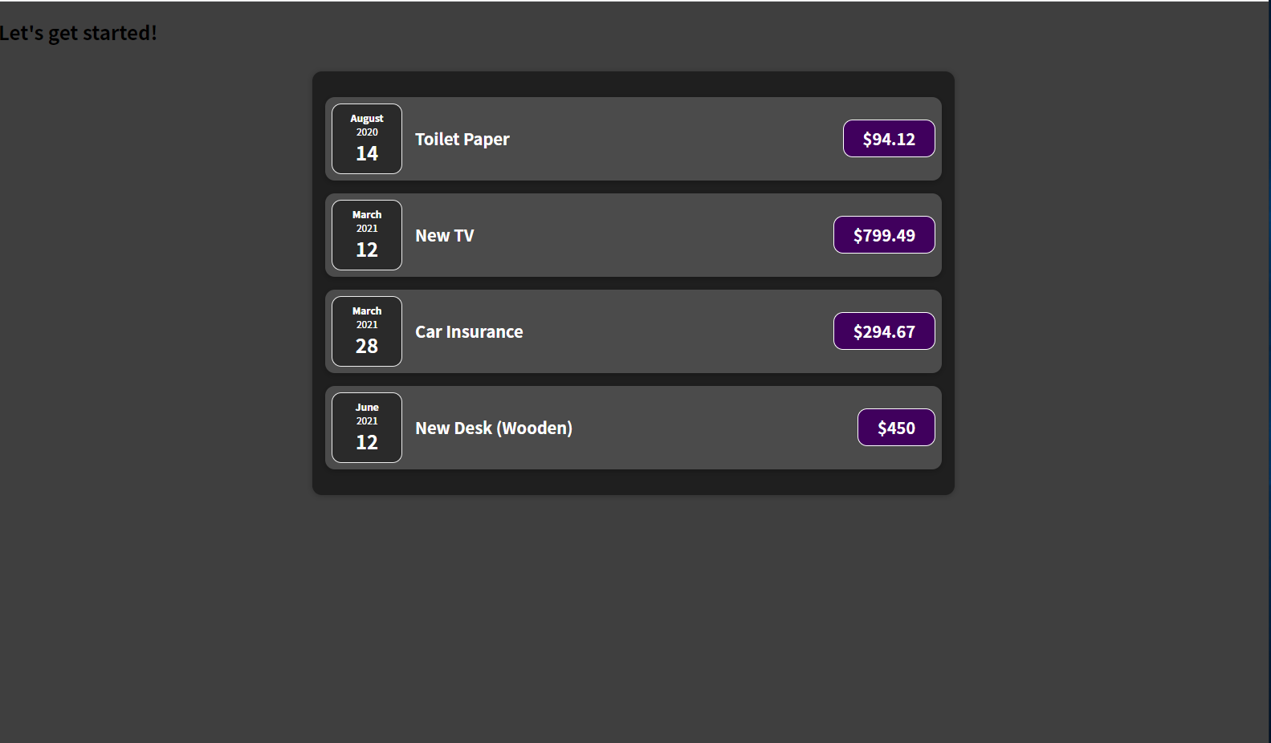

At the moment we have some style duplication also maybe some HTML structure duplication. Expenses has a div which surrounds our ExpenseItems, which has a certain style thanks to the expenses class. The ExpenseItem component in ExpenseItem.js also has a div that surrounds its inner elements. Now, of course not all divs have the same look. While the two surrounding containers may not be the same, we could extract the surrounding container divs in both components and extract the styles they have in common, like rounded corners and a drop shadow, into a separate component.

|  |
| --- |
| src/components/Expenses.js |
| import './Expenses.css';  import ExpenseItem from './ExpenseItem';  function Expenses(props) {  return (  <div className='expenses'> // This div will be extracted.  <ExpenseItem  title={props.expenses[0].title}  amount={props.expenses[0].amount}  date={props.expenses[0].date}  />  <ExpenseItem  title={props.expenses[1].title}  amount={props.expenses[1].amount}  date={props.expenses[1].date}  />  <ExpenseItem  title={props.expenses[2].title}  amount={props.expenses[2].amount}  date={props.expenses[2].date}  />  <ExpenseItem  title={props.expenses[3].title}  amount={props.expenses[3].amount}  date={props.expenses[3].date}  />  </div>  );  }  export default Expenses; |

|  |
| --- |
| src/components/ExpenseItem.js |
| import ExpenseDate from './ExpenseDate';  import './ExpenseItem.css';  function ExpenseItem(props) {  return (  **<div className="expense-item"> // This div will be extracted.**  <ExpenseDate date={props.date}/>  <div className="expense-item__description">  <h2>{props.title}</h2>  <div className="expense-item__price">${props.amount}</div>  </div>  </div>  );  }  export default ExpenseItem; |

The new component file we will call "Card.js" and name the component Card because this is a specific card look. In general, in web development, when you hear the term card, it typically means some kind of container look such as in this example with rounded corners, drop shadows, and elements like these. A card component could now do one main thing—it could return a div or any other kind of container HTML element with a className of "card".

|  |
| --- |
| src/components/Card.js |
| function Card(){  return <div **className="card"**></div>;  }  export default Card; |

We also add a "Card.css" file and import it into the Card component.

|  |
| --- |
| src/components/Card.js |
| import './Card.css';  function Card(){  return <div className="card"></div>;  }  export default Card; |

In the "Card.css" file, we can have the box-shadow and border-radius from "Expenses.css". We will cut them from "Expenses.css" and from "ExpenseItem.css" and add them to "Card.css".

|  |
| --- |
| src/components/Expenses.css |
| .expenses {  padding: 1rem;  background-color: rgb(31, 31, 31);  margin: 2rem auto;  width: 50rem;  max-width: 95%;  ~~border-radius: 12px;~~ // This line is extracted from this file.  ~~box-shadow: 0 1px 8px rgba(0, 0, 0, 0.25);~~ // This line is extracted from this file.  } |

|  |
| --- |
| src/components/ExpenseItem.css |
| .expense-item {  display: flex;  justify-content: space-between;  align-items: center;  ~~box-shadow: 0 2px 8px rgba(0, 0, 0, 0.25);~~ // This line is extracted from this file.  padding: 0.5rem;  margin: 1rem 0;  ~~border-radius: 12px;~~ // This line is extracted this file.  background-color: #4b4b4b;  }    .expense-item__description {  display: flex;  flex-direction: column;  gap: 1rem;  align-items: flex-end;  flex-flow: column-reverse;  justify-content: flex-start;  flex: 1;  }    … |

We get rid of code duplication in "Expenses.css" and "ExpenseItem.css" and move into "Card.css," which we import into the separate wrapper component – "Card.js."

|  |
| --- |
| src/components/Card.css |
| .card {  border-radius: 12px;  box-shadow: 0 1px 8px rgba(0, 0, 0, 0.25);  } |

We now have this Card container component you could say, which should act as a shell around either our ExpenseItem content or our Expenses content.

The Card component will not be configured through some attributes, but instead, in ExpenseItem, we can simply replace this built-in div.

Before replacing built-in div:

|  |
| --- |
| src/components/ExpenseItem.js |
| import ExpenseDate from './ExpenseDate';  import './ExpenseItem.css';  function ExpenseItem(props) {  return (  <div className="expense-item"> // This div will be extracted.  <ExpenseDate date={props.date}/>  <div className="expense-item__description">  <h2>{props.title}</h2>  <div className="expense-item__price">${props.amount}</div>  </div>  </div>  );  }  export default ExpenseItem; |

After replacing built-in div with our custom Card component, and then we get the predefined styles in "Card.css" automatically.

|  |
| --- |
| src/components/ExpenseItem.js |
| import ExpenseDate from './ExpenseDate';  import Card from './Card';  import './ExpenseItem.css';  function ExpenseItem(props) {  return (  <Card className='expense-item'>  <ExpenseDate date={props.date}/>  <div className="expense-item__description">  <h2>{props.title}</h2>  <div className="expense-item__price">${props.amount}</div>  </div>  </Card>  );  }  export default ExpenseItem; |

The issue is that if I save this, I get the following output, which is not what I am expecting, as all of the ExpenseItems are lost.

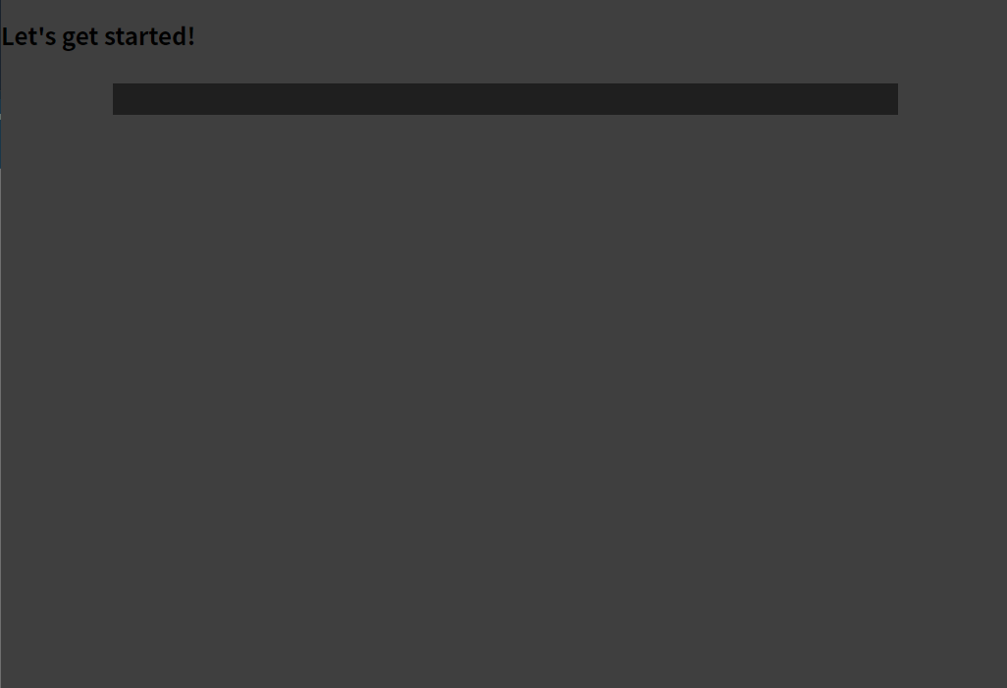

The reason that all of the ExpenseItems are lost is that out of the box, as shown in the below code snippet, you cannot use your custom components as wrappers around other kind of content.

|  |
| --- |
| src/components/ExpenseItem.js |
| import ExpenseDate from './ExpenseDate';  import Card from './Card';  import './ExpenseItem.css';  function ExpenseItem(props) {  return (  ~~<Card className='expense-item'>~~ // Cannot use custom component as a wrapper around this kind of content.  <ExpenseDate date={props.date}/>  <div className="expense-item__description">  <h2>{props.title}</h2>  <div className="expense-item__price">${props.amount}</div>  </div>  ~~</Card>~~ // Cannot use custom component as a wrapper around this kind of content.  );  }  export default ExpenseItem; |

Having content between opening and closing tags of custom components does not work the way it is shown in the code snippet immediately above this one. Having content between opening and closing tags of built-in HTML elements, such as the div or h2 tag, works just fine; however, having content between opening closing tags of custom components does not. It would be nice if there was a way to make this work for our custom components, to build such reusable wrapper components, such as this one, for example:

|  |
| --- |
| src/components/ExpenseItem.js |
| import ExpenseDate from './ExpenseDate';  import Card from './Card';  import './ExpenseItem.css';  function ExpenseItem(props) {  return (  <Card className='expense-item'>  <ExpenseDate date={props.date}/>  <div className="expense-item__description">  <h2>{props.title}</h2>  <div className="expense-item__price">${props.amount}</div>  </div>  </Card>  );  }  export default ExpenseItem; |

React has a solution, allowing us to build such wrapper components. In "Card.js", we can use one special prop, which is built into React, which every component receives, even if you're never setting it explicitly. And that's a prop whose value I want to output between the opening and closing tags of the div in the Card component function as bolded in the below code snippet:

|  |
| --- |
| src/components/Card.js |
| function Card(){  return <div className="card">{}</div>;  }  export default Card; |

It is the props' children prop as shown in the below code snippet:

|  |
| --- |
| src/components/Card.js |
| function Card(props){  return <div className="card">{**props.children**}</div>;  }  export default Card; |

"children" is a reserved name. We don't set a children prop on this Card. We're setting a className prop on this Card.

|  |
| --- |
| src/components/ExpenseItem.js |
| import ExpenseDate from './ExpenseDate';  import Card from './Card';  import './ExpenseItem.css';  function ExpenseItem(props) {  return (  <Card className='expense-item'>  <ExpenseDate date={props.date}/>  <div className="expense-item__description">  <h2>{props.title}</h2>  <div className="expense-item__price">${props.amount}</div>  </div>  </Card>  );  }  export default ExpenseItem; |

"children" is a reserved name and the value of this special children prop will always be the content between the opening and closing tags of your custom component. So, in this case, the value of the children prop is the following lines that are bolded between the opening and closing tags of the Card

|  |
| --- |
| src/components/ExpenseItem.js |
| import ExpenseDate from './ExpenseDate';  import Card from './Card';  import './ExpenseItem.css';  function ExpenseItem(props) {  return (  <Card className='expense-item'>  <ExpenseDate date={props.date}/>  <div className="expense-item__description">  <h2>{props.title}</h2>  <div className="expense-item__price">${props.amount}</div>  </div>  </Card>  );  }  export default ExpenseItem; |

component is the content that will be available on props.children inside of that card.

|  |
| --- |
| src/components/Card.js |
| function Card(props){  return <div className="card">{**props.children**}</div>;  }  export default Card; |

When we save this, we get some content back; however, it's also a bit broken.

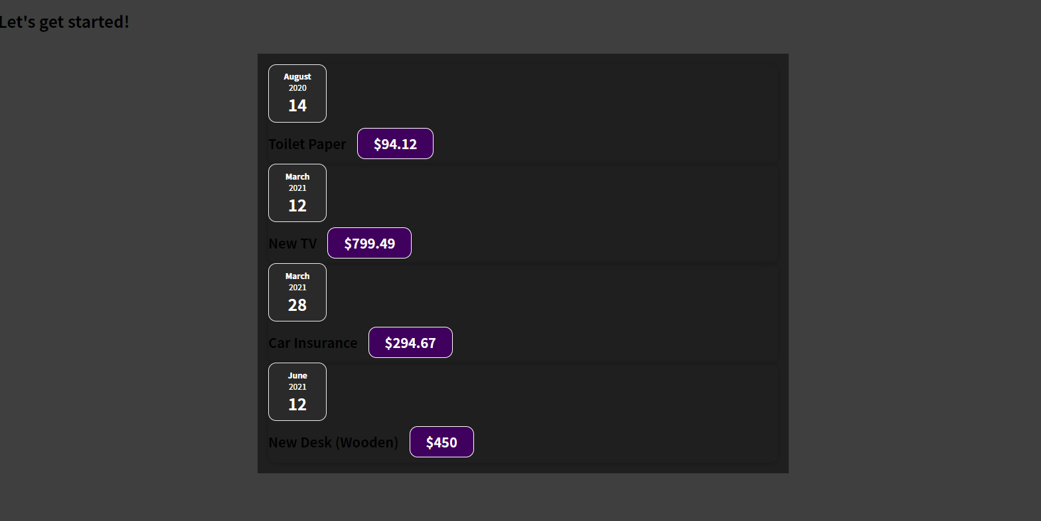

The reason for that is I extracted some styles that ExpenseItem and Expenses had in common, but I had more styles defined for ExpenseItems and these styles are important, but they are missing now.

|  |
| --- |
| src/components/ExpenseItem.css |
| .expense-item {  display: flex;  justify-content: space-between;  align-items: center;  padding: 0.5rem;  margin: 1rem 0;  background-color: #4b4b4b;  }  … |

If you want to make sure that a className can be set on your Card component and then has an effect, you have to tweak the code of the Card component. And we probably want to tweak it such that we add whatever is set as a className on Card

|  |
| --- |
| src/components/ExpenseItem.js |
| import ExpenseDate from './ExpenseDate';  import Card from './Card';  import './ExpenseItem.css';  function ExpenseItem(props) {  return (  <Card className='expense-item'>  <ExpenseDate date={props.date}/>  <div className="expense-item__description">  <h2>{props.title}</h2>  <div className="expense-item__price">${props.amount}</div>  </div>  </Card>  );  }  export default ExpenseItem; |

to this className string called "card"

|  |
| --- |
| src/components/Card.js |
| function Card(props){  return <div className=**"card"**>{props.children}</div>;  }  export default Card; |

that we're setting as a className

|  |
| --- |
| src/components/Card.js |
| function Card(props){  return <div **className**="card">{props.children}</div>;  }  export default Card; |

on this div.

|  |
| --- |
| src/components/Card.js |
| function Card(props){  return <**div** className="card">{props.children}<**/div**>;  }  export default Card; |

So in the Card component before the return statement we can add a constant called classes, which is 'card ' as a default class, which is always applied and white space, plus props.className. So now anything that we receive as a class name from outside is added to that string.

|  |
| --- |
| src/components/Card.js |
| import './Card.css';  function Card(props){  const classes = 'card ' + props.className;  return <div className="card">{props.children}</div>;  }  export default Card; |

We can then dynamically point at the classes constant as shown below:

|  |
| --- |
| src/components/Card.js |
| import './Card.css';  function Card(props){  const classes = 'card ' + props.className;  return <div className=**{classes}**>{props.children}</div>;  }  export default Card; |

So with that, we're now making sure that any value set on the className prop:

|  |
| --- |
| src/components/Card.js |
| import './Card.css';  function Card(props){  const classes = 'card ' + props.**className**;  return <div className={classes}>{props.children}</div>;  }  export default Card; |

is added to this long string of class names,

|  |
| --- |
| src/components/Card.js |
| import './Card.css';  function Card(props){  const classes = 'card ' + props.className;  return <div className={classes}>{props.children}</div>;  }  export default Card; |

which is then finally set on the div inside of the card as shown in the below code snippet.

|  |
| --- |
| src/components/Card.js |
| import './Card.css';  function Card(props){  const classes = 'card ' + props.className;  return <div className={classes}>{props.children}</div>;  }  export default Card; |

When we reload the browser, we have the box-shadow and border-radius styles for expense items but not yet for expenses.

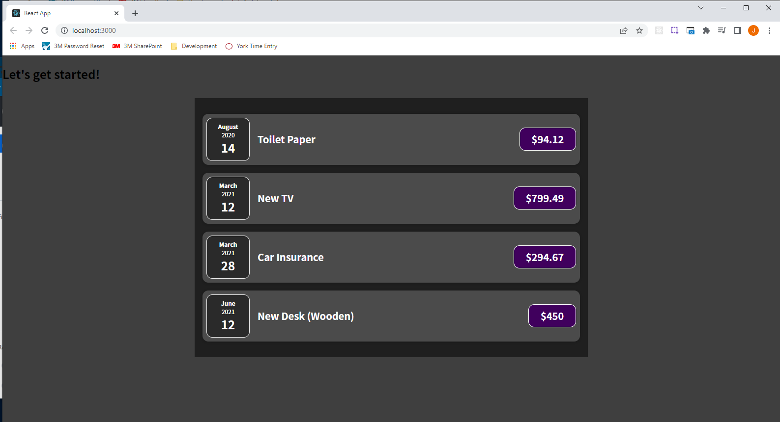

But now we have this reusable wrapper component:

|  |
| --- |
| src/components/Card.js |
| import './Card.css';  function Card(props){  const classes = 'card ' + props.className;  return <div className={classes}>{props.children}</div>;  }  export default Card; |

We can now use the reusable wrapper component, the Card component, in the Expenses component, which will replace the root div.

|  |
| --- |
| src/components/Expenses.js |
| import './Expenses.css';  import ExpenseItem from './ExpenseItem';  function Expenses(props) {  return (  ~~<div className='expenses'>~~ // This div will be removed.  <ExpenseItem  title={props.expenses[0].title}  amount={props.expenses[0].amount}  date={props.expenses[0].date}  />  <ExpenseItem  title={props.expenses[1].title}  amount={props.expenses[1].amount}  date={props.expenses[1].date}  />  <ExpenseItem  title={props.expenses[2].title}  amount={props.expenses[2].amount}  date={props.expenses[2].date}  />  <ExpenseItem  title={props.expenses[3].title}  amount={props.expenses[3].amount}  date={props.expenses[3].date}  />  ~~</div>~~ // This div will be removed.  );  }  export default Expenses; |

Now we import the Card component and replace the div with the Card component while keeping the className expenses.

|  |
| --- |
| src/components/Expenses.js |
| import ExpenseItem from './ExpenseItem';  import Card from './Card';  import './Expenses.css';  function Expenses(props) {  return (  <Card className="expenses">  <ExpenseItem  title={props.expenses[0].title}  amount={props.expenses[0].amount}  date={props.expenses[0].date}  />  <ExpenseItem  title={props.expenses[1].title}  amount={props.expenses[1].amount}  date={props.expenses[1].date}  />  <ExpenseItem  title={props.expenses[2].title}  amount={props.expenses[2].amount}  date={props.expenses[2].date}  />  <ExpenseItem  title={props.expenses[3].title}  amount={props.expenses[3].amount}  date={props.expenses[3].date}  />  </Card>  );  }  export default Expenses; |

Now when we save the file and reload the web browser, we have the box-shadow and border-radius styles applied to the expenses container as well.

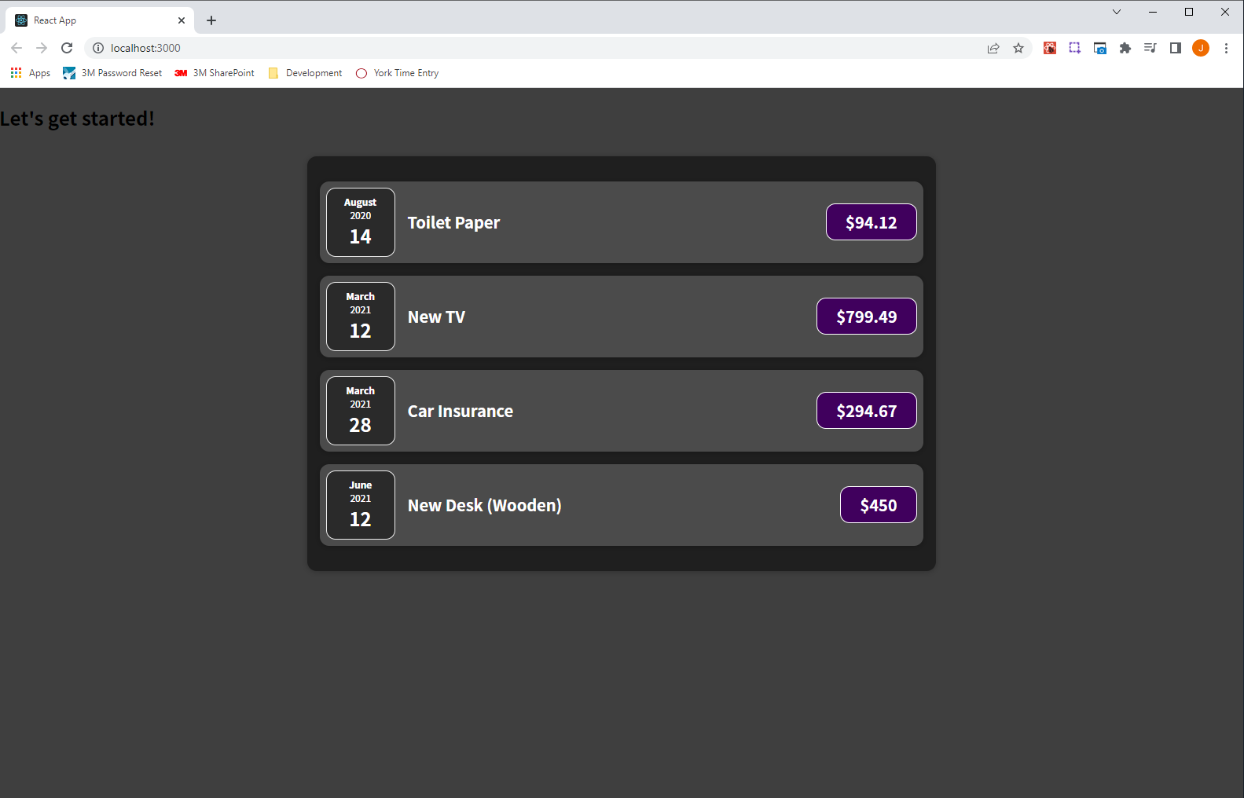

By adding this Card component, we were able to get rid of some code duplication from our CSS files--"Expenses.css" and "ExpenseItem.css"—moving the border-radius and box-shadow styles into "Card.css" and importing "Card.css" into "Card.js," a separate wrapper component. It's not just duplicate CSS code, we were also able to extract the duplicate root divs. While it is just one div in this case, you can build components in React which have a more complex JSX structure including for things like modals and alerts. And in such cases, being able to extract that often saves you a lot of code duplication and it often allows you to keep your other components clean.

There is also another aspect of composition we are using here. We compose our ExpenseItem component by using Card as a wrapper, by using built-in HTML elements, and then by putting in the ExpenseDate. And all these components and elements are composed together to form the overall ExpenseItem component, which then is used by other components to build the overall user interface. So composition is important. You use it all the time when working with React. Whenever you combine components, you are using composition. And an especially important part of composition is this props.children feature, which allows you to also create wrapper components, which you could consider as a special type of component.

|  |
| --- |
| src/components/Card.js |
| import './Card.css';  function Card(props){  const classes = 'card ' + props.className;  return <div className={classes}>{**props.children**}</div>;  }  export default Card; |

### 41. A First Summary

We create user interfaces by building and combining components. In the end, what ends up on the screen are just default HTML elements. If you inspect your page in the Chrome developer tools, and view the Elements tab, you will not see your custom components there, so you don't see the Card or ExpenseItem components, you just see divs, h2 elements, and so on. What ends up on the screen is just HTML elements because, ulitimately, every custom component you build either uses these built-in HTML elements or it uses another component which, at some point, if you drill into your components deeply enough, will end up using these built-in elements. This application as we built it also has a downside in that it is still static. Yes we have components that can be configured with props but, ultimately, we have the expenses array in the "App.js" file, and the expenses array never changes.

The data that comes from the expenses array that is rendered to the UI, as shown in the below screenshot, is set in stone; it does not change. It is still a static application in the end. Nothing is changing here. As a user, we have no chance of interacting with this application. And that's therefore what we're going change in the next section of the course where we're going to bring this to life and learn about another concept called "state."



### 42. A Closer Look At JSX

You can open the developer tools in Chrome, click on Sources, expand the folder called "top" under the "Page" tab, expand "localhost:3000", expand "static/js", and click on "main.chunk.js". There you can view the JavaScript code responsible for what you're seeing on the page. There you will find the component functions that we wrote. It will look different in the end, because there you have no JSX code because JSX code is not supported in the browser. The JSX code we write is syntactic sugar, which works here thanks to the behind-the-scenes transformations.

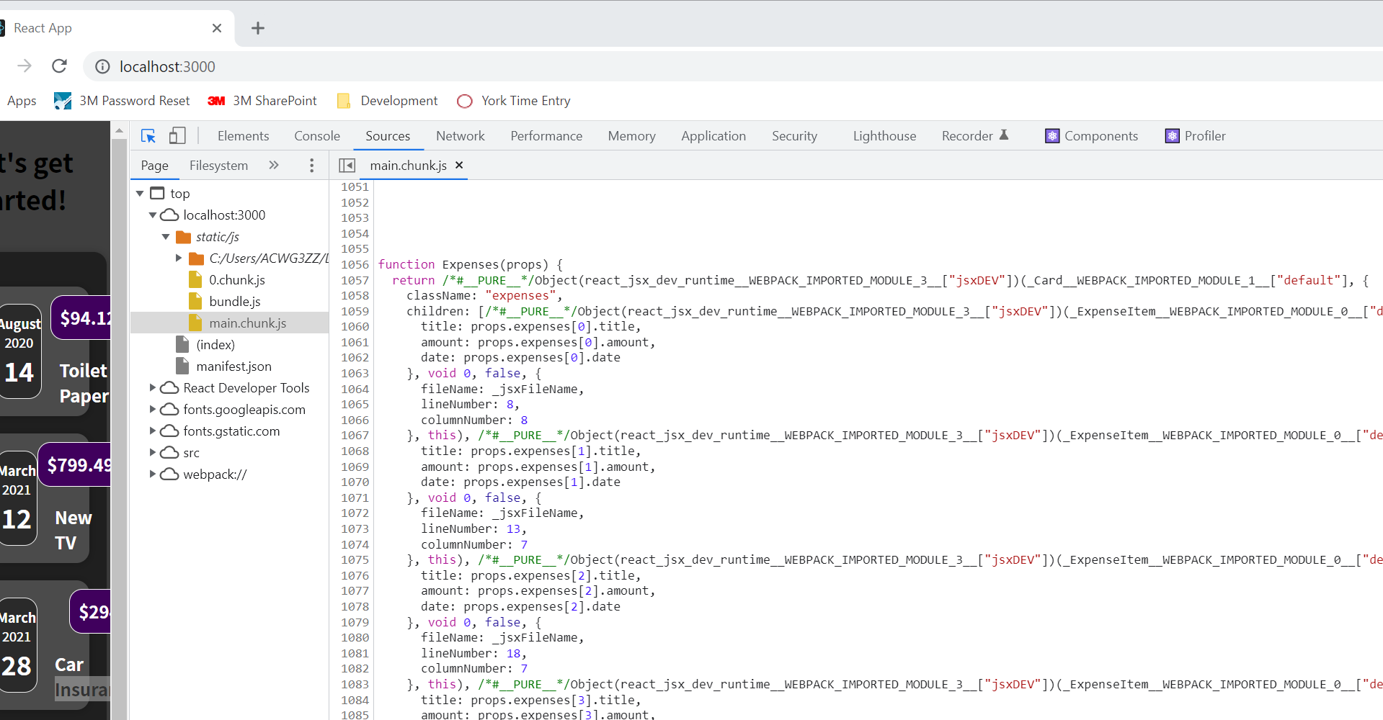

The dependencies in package.js "react" and "react-dom" We are importing "react-dom" in our index.js file; however, we are never using React anywhere nor importing React anywhere. This actually just works in this kind of project setup and all modern project setups which are created by create-react-app. In older React projects you had to import React in all files where you used JSX.

When you use JSX, under the hood the method React.createElement() is called. The method createElement() takes three arguments. The first argument is the element which should be created, for example a div, if it's a built in HTML element you just pass in a string with the name of that element like React.createElement('div'); The second argument is an object that configures this element. Specifically, an object which sets all the attributes of this element. This div has no attributes so we can pass in an empty object like this: React.createElement('div', {}); The third argument is the content between the opening and closing div tags, and actually it's not just a third argument. You can now have an infinitely long list of arguments, which are the different content pieces between the opening and closing tags. In the past you had to import React in all of your files because this was the under-the-hood code which kind of gets created automatically when you use JSX.

|  |
| --- |
| src/App.js |
| import React from "react";  import Expenses from "./components/Expenses";  function App() {  const expenses = [  {  id: "e1",  title: "Toilet Paper",  amount: 94.12,  date: new Date(2020, 7, 14),  },  { id: "e2", title: "New TV", amount: 799.49, date: new Date(2021, 2, 12) },  {  id: "e3",  title: "Car Insurance",  amount: 294.67,  date: new Date(2021, 2, 28),  },  {  id: "e4",  title: "New Desk (Wooden)",  amount: 450,  date: new Date(2021, 5, 12),  },  ];  return React.createElement(  "div",  {},  React.createElement("h2", {}, "Let's get started!"),  React.createElement(Expenses, {expenses: expenses})  );  // return (  // <div>  // <h2>Let's get started!</h2>  // <Expenses expenses={expenses} />  // </div>  // );  }  export default App; |

React is being used under the hood when you use JSX code because that code under the hood is transformed into something like this

return React.createElement(

"div",

{},

React.createElement("h2", {}, "Let's get started!"),

React.createElement(Expenses, {expenses: expenses})

**);**

before it's transformed even more to what is shown in "main.chunk.js". You need some wrapping element as a root JSX element because under the hood you can only have one React.createElement method since you cannot return more than one thing. You cannot return this

React.createElement("h2", {}, "Let's get started!"),

React.createElement(Expenses, {expenses: expenses})

as this is two separate elements side by side. That's why you always need such a wrapper because in the createElement world, you always create one element that may have more child elements. That is why we have this one wrapper root JSX element. That's why we have this under-the-hood, behind-the-scenes stuff that is going on.

### 43. Organizing Component Files

As you add more components, you may want to add your components to sub-folders and not just have them all in one components folder. We have feature specific components and non-feature specific components that are generally more UI components. Some general UI elements that are not tied to a specific feature of the app. And then we have some feature-specific components that are concerned with rendering expenses and expense data. In the components folder we could create two sub-folders—UI and Expenses. We can move the ExpenseDate files, ExpenseItem files, and Expenses files into the Expenses sub-folder and move the Card files into the UI folder.

We need to remember to update our import statements after moving the components into subfolders.

### 44. An Alternative Function Syntax

There is an alternative syntax for writing functions for components and really for any kind of functions in JavaScript. The syntax is not exclusive to React and can be used in any JavaScript application. Instead of writing a function with the function keyword, you can also write an arrow function. To use the arrow function syntax you replace the function keyword with const to create a new constant with a given name, App in this case.

|  |
| --- |
| src/App.js |
| import React from "react"; // Technically we don't need this import but this is how it was done in the past.  import Expenses from "./components/Expenses/Expenses";  const App = () => {  const expenses = [  {  id: "e1",  title: "Toilet Paper",  amount: 94.12,  date: new Date(2020, 7, 14),  },  { id: "e2", title: "New TV", amount: 799.49, date: new Date(2021, 2, 12) },  {  id: "e3",  title: "Car Insurance",  amount: 294.67,  date: new Date(2021, 2, 28),  },  {  id: "e4",  title: "New Desk (Wooden)",  amount: 450,  date: new Date(2021, 5, 12),  },  ];  return React.createElement(  "div",  {},  React.createElement("h2", {}, "Let's get started!"),  React.createElement(Expenses, { expenses: expenses })  );  // return (  // <div>  // <h2>Let's get started!</h2>  // <Expenses expenses={expenses} />  // </div>  // );  }  export default App; |

## Section 4: React State & Working with Events

### 46. Module Introduction

We will be taking a closer look at user interaction and handling user events like clicks or input into text fields, and so on. We're going to look at the very important concept called state in React apps because, as you might remember, that with React we follow a declarative approach.

You define the desired target state(s) and let React figure out the actual JavaScript DOM instructions. 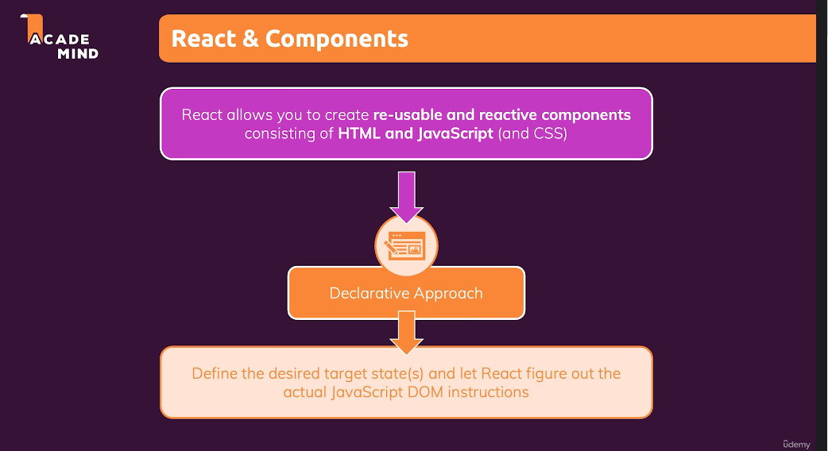

You want to have applications that are interactive, so that you can react to clicks by the user and which are reactive so that the application also changes when certain things happen. And, therefore, in this module we are going to look at handling events, handling user events, like clicks and so on, how we can add such event handlers and more. And then, we're going to take a look at how we can ensure that what's visible on the screen changes, that we reach a different target state. For that, we're going to take a look at this state concept in React, and we'll learn how we can manipulate the state and transition from state A to state B, if we want to. We're also going to take a look at components and state again. 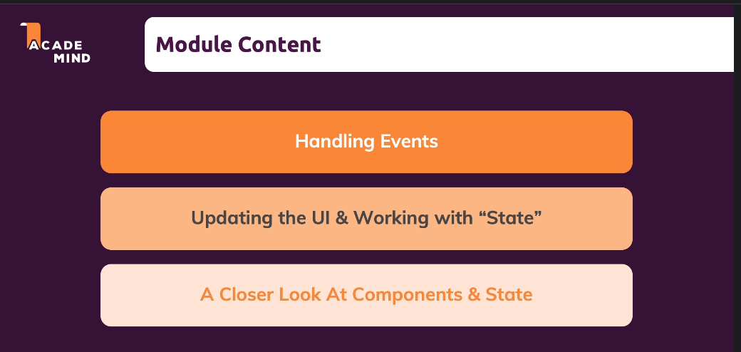

### 47. Listening to Events & Working with Event Handlers

Let's dive into how we can react to user events before we have a look how such events could trigger a state change.

We will start with clicks on a button to which we want to react. To get started, we go to "src/components/Expenses/ExpenseItem.js" where we output the title, amount, and so on.

|  |
| --- |
| src/components/Expenses/ExpenseItem.js |
| import React from 'react'; // Technically we don't need this import but this is how it was done in the past.  import ExpenseDate from './ExpenseDate';  import Card from '../UI/Card';  import './ExpenseItem.css';  const ExpenseItem = props => {  return (  <Card className='expense-item'>  <ExpenseDate date={props.date}/>  <div className="expense-item__description">  <h2>{**props.title**}</h2>  <div className="expense-item__price">${**props.amount**}</div>  </div>  </Card>  );  }  export default ExpenseItem; |

In the ExpenseItem component, I will add a button element below the div right before we close the Card. In the button element we will say "Change Title."

|  |
| --- |
| src/components/Expenses/ExpenseItem.js |
| import React from 'react'; // Technically we don't need this import but this is how it was done in the past.  import ExpenseDate from './ExpenseDate';  import Card from '../UI/Card';  import './ExpenseItem.css';  const ExpenseItem = props => {  return (  <Card className='expense-item'>  <ExpenseDate date={props.date}/>  <div className="expense-item__description">  <h2>{props.title}</h2>  <div className="expense-item__price">${props.amount}</div>  </div>  <button>Change Title</button>  </Card>  );  }  export default ExpenseItem; |

If we save the above code snippet, we will see the following output:

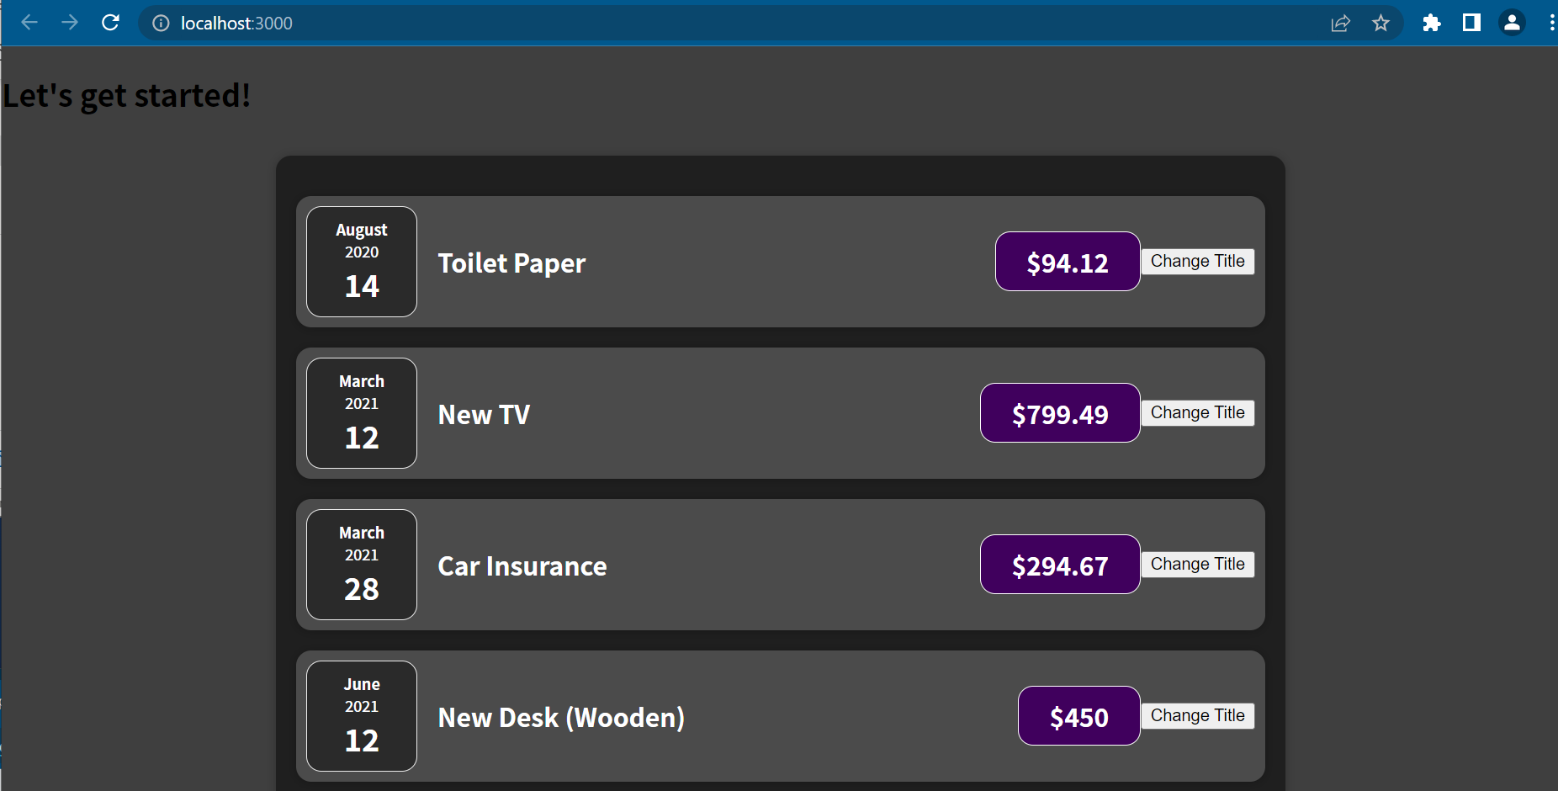

We now have one button per ExpenseItem component, and our goal now is we want to change the output of the title when button is clicked.

|  |
| --- |
| src/components/Expenses/ExpenseItem.js |
| import React from 'react'; // Technically we don't need this import but this is how it was done in the past.  import ExpenseDate from './ExpenseDate';  import Card from '../UI/Card';  import './ExpenseItem.css';  const ExpenseItem = props => {  return (  <Card className='expense-item'>  <ExpenseDate date={props.date}/>  <div className="expense-item__description">  <h2>{props.title}</h2> // trying to make output of props.title change when button is clicked  <div className="expense-item__price">${props.amount}</div>  </div>  <button>Change Title</button>  </Card>  );  }  export default ExpenseItem; |

We want to find out how we can react to button clicks in React.js. On all built-in HTML elements, like divs, h2 tags, buttons, and so on, we have full access to all these native DOM events, which we can listen to. Instead of adding a listener as we would normally do in JavaScript, which is an imperative way, for example, by selecting an element by ID and then adding an event listener like what is bolded below,

|  |
| --- |
| src/components/Expenses/ExpenseItem.js |
| import React from 'react'; // Technically we don't need this import but this is how it was done in the past.  import ExpenseDate from './ExpenseDate';  import Card from '../UI/Card';  import './ExpenseItem.css';  const ExpenseItem = props => {  **document.getElementById('root').addEventListener() // JS way of listening to an event**  return (  <Card className='expense-item'>  <ExpenseDate date={props.date}/>  <div className="expense-item__description">  <h2>{props.title}</h2> // trying to make output of props.title change when button is clicked  <div className="expense-item__price">${props.amount}</div>  </div>  <button>Change Title</button>  </Card>  );  }  export default ExpenseItem; |

In React, we add an event listener by going to the JSX element, like the button, and there we add a special prop. Now, it's not a prop which sets some value for this button, but instead it's a prop which starts with on because React exposes all these default events as props which start with on. For example, we can add onClick, which adds an event listener for click events to this button. We now need to define what will happen when such a click occurs, and we do this by assigning a value to the click event. The value of the click event of course needs to be code that should be executed when that click occurs. We define code that should eventually be executed in programming using a function. All of these on props, all these event handler props, want a function as a value, a function passed as a value for onClick and any other on props, which then is executed when that event occurs. We can either create a function on the fly such as in the below code snippet where we create an anonymous arrow function. We can then do console.log('clicked!')

|  |
| --- |
| src/components/Expenses/ExpenseItem.js |
| import React from 'react'; // Technically we don't need this import but this is how it was done in the past.  import ExpenseDate from './ExpenseDate';  import Card from '../UI/Card';  import './ExpenseItem.css';  const ExpenseItem = props => {    return (  <Card className='expense-item'>  <ExpenseDate date={props.date}/>  <div className="expense-item__description">  <h2>{props.title}</h2> {/* trying to make output of props.title change when button is clicked */}  <div className="expense-item__price">${props.amount}</div>  </div>  **<button onClick={() => {console.log('Clicked!')}}>Change Title</button>**  </Card>  );  }  export default ExpenseItem; |

If we save the above code snippet, we then go back to the browser, open the developer tools, and click on the Console tab. If we click the button "Change Title", we see "Clicked!" appear in the developer tools.

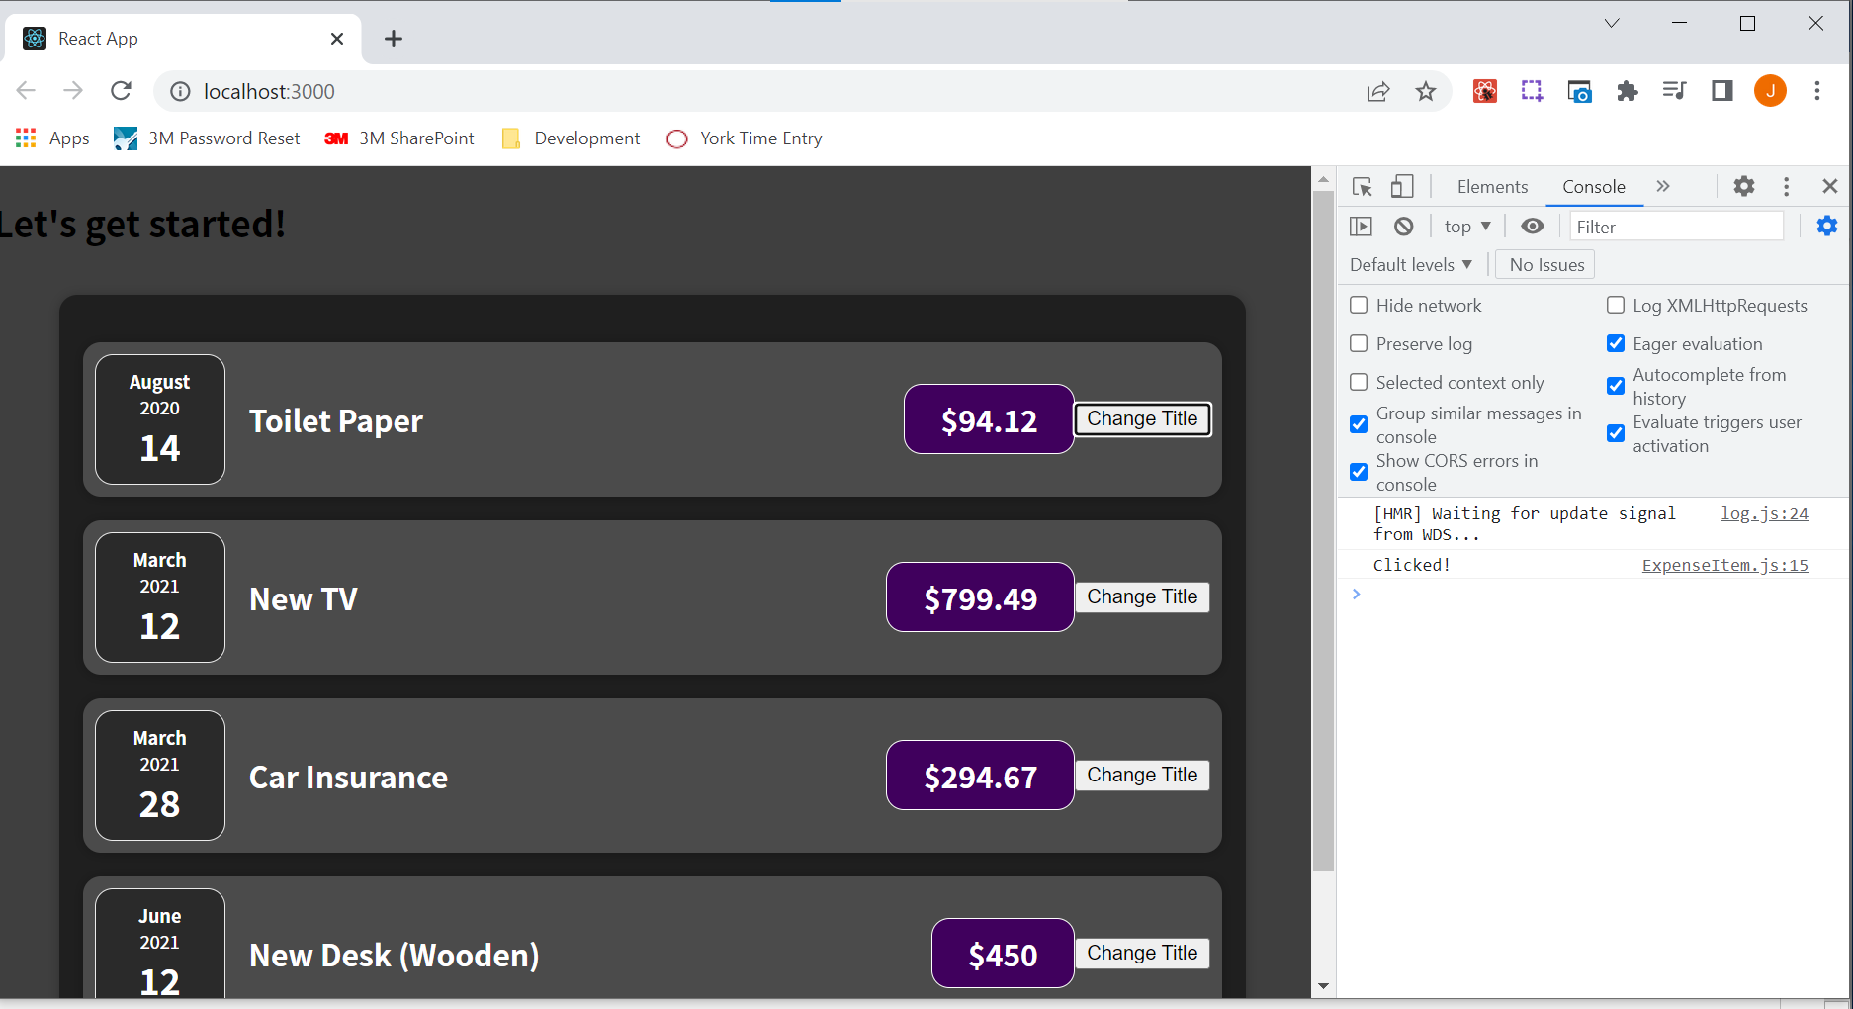

You typically don't want to work with anonymous inline arrow functions, though. By the way, it does not have to be an arrow function. You could also create a function with the function keyword. You don’t want to overdo it at least. Because it would mean that you put a lot of code into your JSX, and that's generally not a good idea. You want to keep it lean and not put too much logic into your JSSX code. You typically want to define a function before you return. You can do that either with the function keyword or by creating a const or variable which holds an arrow function. We could create a function called clickHandler, which holds an arrow function, and in the arrow function I can console.log('Clicked!') as shown in the code below:

|  |
| --- |
| src/components/Expenses/ExpenseItem.js |
| import React from 'react'; // Technically we don't need this import but this is how it was done in the past.  import ExpenseDate from './ExpenseDate';  import Card from '../UI/Card';  import './ExpenseItem.css';  const ExpenseItem = props => {  **const clickHandler = () => {**  **console.log('Clicked!');**  **};**    return (  <Card className='expense-item'>  <ExpenseDate date={props.date}/>  <div className="expense-item__description">  <h2>{props.title}</h2> {/* trying to make output of props.title change when button is clicked */}  <div className="expense-item__price">${props.amount}</div>  </div>  <button onClick={}>Change Title</button>  </Card>  );  }  export default ExpenseItem; |

In this button, I just point at clickHandler as shown in the below code snippet. We just point at the clickHandler function. We do not execute it, which is why it is onClick={clickHandler}(without parentheses) rather than onClick={clickHandler()}. Adding the parentheses would mean that JavaScript would execute the clickHandler() function when the entire line of code that it is in <button onClick={clickHandler()}>Change Title</button> is being parsed, and this line of code is being parsed when the JSX code is returned. It would then not be executing clickHandler when the click occurs but when this JSX code is evaluated, and that would be too early. That's why instead we just point at clickHandler. We pass a pointer at the function called clickHandler as a value to onClick and then React basically memorizes this and executes the clickHandler function for us whenever the click occurs, which is what we want.

|  |
| --- |
| src/components/Expenses/ExpenseItem.js |
| import React from 'react'; // Technically we don't need this import but this is how it was done in the past.  import ExpenseDate from './ExpenseDate';  import Card from '../UI/Card';  import './ExpenseItem.css';  const ExpenseItem = props => {  const clickHandler = () => {  console.log('Clicked!');  };    return (  <Card className='expense-item'>  <ExpenseDate date={props.date}/>  <div className="expense-item__description">  <h2>{props.title}</h2> {/* trying to make output of props.title change when button is clicked */}  <div className="expense-item__price">${props.amount}</div>  </div>  <button onClick={**clickHandler**}>Change Title</button>  </Card>  );  }  export default ExpenseItem; |

To all of the built-in HTML elements, we can add supported event listeners. Some events are only available on specific elements but that is all based on the default DOM behavior. If an element supports an event, then you can add a listener with React by adding on and then the event name prop. Just make sure that the event name starts with a capital character such as onClick, where "Click" is the name of the event. You then just point at a function either defined in-line or before the return statement. React will execute that function for you when that event occurs.

A convention that is good to follow is to name your functions if they are triggered based on an event so that they end with Handler such as clickHandler. It is good to do it this way so that it is clear that it is a function that is not called by us somewhere else in our code, but that it is a function that we attached to an event listener, so that it's eventually called by React when that event occurs.

### 48. How Component Functions Are Executed

Reacting to Events is an important first step. How can we now change what shows up on the screen? Well, we want to change the title when the button is clicked.

|  |
| --- |
| src/components/Expenses/ExpenseItem.js |
| import React from 'react'; // Technically we don't need this import but this is how it was done in the past.  import ExpenseDate from './ExpenseDate';  import Card from '../UI/Card';  import './ExpenseItem.css';  const ExpenseItem = props => {  const clickHandler = () => {  console.log('Clicked!');  };    return (  <Card className='expense-item'>  <ExpenseDate date={props.date}/>  <div className="expense-item__description">  <h2>{props.title}</h2> {/* trying to make output of props.title change when button is clicked */}  <div className="expense-item__price">${props.amount}</div>  </div>  <button onClick={clickHandler}>Change Title</button>  </Card>  );  }  export default ExpenseItem; |

One thing that we can do is create a variable with let that we maybe rename title, and initially, that holds the value we find in props title.

|  |
| --- |
| src/components/Expenses/ExpenseItem.js |
| import React from 'react'; // Technically we don't need this import but this is how it was done in the past.  import ExpenseDate from './ExpenseDate';  import Card from '../UI/Card';  import './ExpenseItem.css';  const ExpenseItem = props => {  **let title = props.title;**  const clickHandler = () => {  console.log('Clicked!');  };    return (  <Card className='expense-item'>  <ExpenseDate date={props.date}/>  <div className="expense-item__description">  <h2>{props.title}</h2> {/* trying to make output of props.title change when button is clicked */}  <div className="expense-item__price">${props.amount}</div>  </div>  <button onClick={clickHandler}>Change Title</button>  </Card>  );  }  export default ExpenseItem; |

We then use the title variable inside the h2 tag:

|  |
| --- |
| src/components/Expenses/ExpenseItem.js |
| import React from 'react'; // Technically we don't need this import but this is how it was done in the past.  import ExpenseDate from './ExpenseDate';  import Card from '../UI/Card';  import './ExpenseItem.css';  const ExpenseItem = props => {  let title = props.title;  const clickHandler = () => {  console.log('Clicked!');  };    return (  <Card className='expense-item'>  <ExpenseDate date={props.date}/>  <div className="expense-item__description">  <h2>**{title}**</h2>  <div className="expense-item__price">${props.amount}</div>  </div>  <button onClick={clickHandler}>Change Title</button>  </Card>  );  }  export default ExpenseItem; |

When we create and use the title variable, we get the same result in the browser as before:

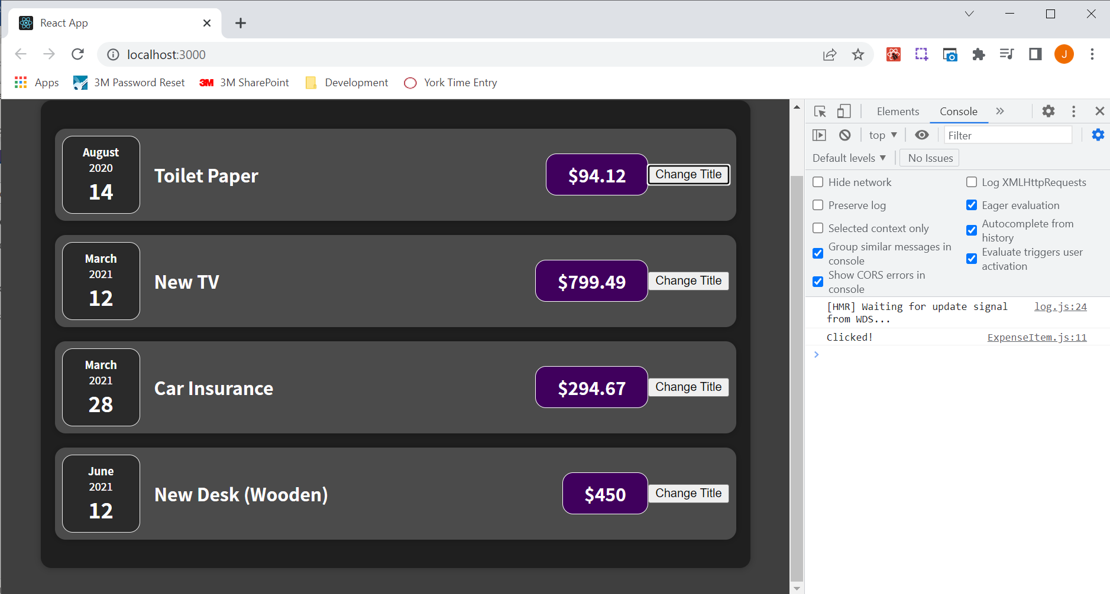

Why am I creating the title variable? We create the title variable, so we can change it whenever the clickHandler function executes (whenever the button that says "Change Title" is clicked, the clickHandler function is executed). In the clickHandler function, we can change title to 'Updated!'.

|  |
| --- |
| src/components/Expenses/ExpenseItem.js |
| import React from 'react'; // Technically we don't need this import but this is how it was done in the past.  import ExpenseDate from './ExpenseDate';  import Card from '../UI/Card';  import './ExpenseItem.css';  const ExpenseItem = props => {  let title = props.title;  const clickHandler = () => {  **title = 'Updated!';**  };    return (  <Card className='expense-item'>  <ExpenseDate date={props.date}/>  <div className="expense-item__description">  <h2>{title}</h2>  <div className="expense-item__price">${props.amount}</div>  </div>  <button onClick={clickHandler}>Change Title</button>  </Card>  );  }  export default ExpenseItem; |

We think that we would see the changed title on our screen after clicking the button that says "Change Title", but when we click "Change Title", nothing happens. The title does not change.

Is something wrong with our clickHandler function? Well, the function is getting triggered, and we can prove this by doing console.log(title); as shown in the below code snippet:

|  |
| --- |
| src/components/Expenses/ExpenseItem.js |
| import React from 'react'; // Technically we don't need this import but this is how it was done in the past.  import ExpenseDate from './ExpenseDate';  import Card from '../UI/Card';  import './ExpenseItem.css';  const ExpenseItem = props => {  let title = props.title;  const clickHandler = () => {  title = 'Updated!';  **console.log(title);**  };    return (  <Card className='expense-item'>  <ExpenseDate date={props.date}/>  <div className="expense-item__description">  <h2>{title}</h2>  <div className="expense-item__price">${props.amount}</div>  </div>  <button onClick={clickHandler}>Change Title</button>  </Card>  );  }  export default ExpenseItem; |

If we save and reload the browser, and click "Change Title", we see the "Updated!" title text appearing in the Console of the Dev Tools as shown in the below screenshot.

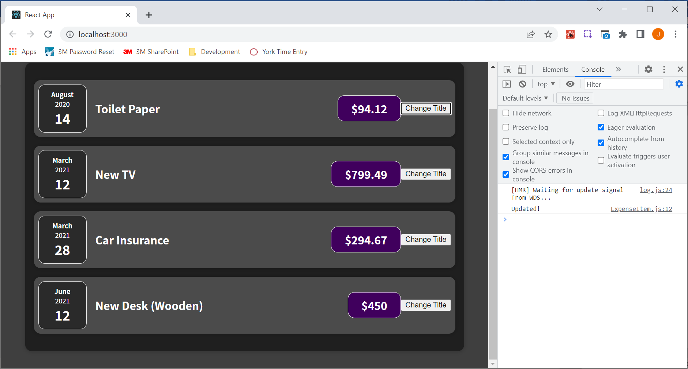

Because we are getting the "Updated!" title text in the browser, the title clearly was changed; otherwise, we wouldn't see that new value for title that we assign in this line title = 'Updated!'; and log using this line console.log(title);

So if the function executes and the title is changed, why don't we see that reflected in our DOM, after all we are outputting the title in the h2 tags?

|  |
| --- |
| src/components/Expenses/ExpenseItem.js |
| import React from 'react'; // Technically we don't need this import but this is how it was done in the past.  import ExpenseDate from './ExpenseDate';  import Card from '../UI/Card';  import './ExpenseItem.css';  const ExpenseItem = props => {  let title = props.title;  const clickHandler = () => {  title = 'Updated!';  console.log(title);  };    return (  <Card className='expense-item'>  <ExpenseDate date={props.date}/>  <div className="expense-item__description">  <h2>{title}</h2>  <div className="expense-item__price">${props.amount}</div>  </div>  <button onClick={clickHandler}>Change Title</button>  </Card>  );  }  export default ExpenseItem; |

The change is not reflected in the DOM because the title is not being updated in the DOM because React doesn't work like this. We need to dive into how react actually passes the JSX code and how it considers that and how it brings it onto the screen. Keep in mind that your component is a regular function, and the only special thing about that function is that it returns JSX.

Since a component is a function, someone has to call it, but we have never called our component functions.

|  |
| --- |
| src/components/Expenses/ExpenseItem.js |
| import React from 'react'; // Technically we don't need this import but this is how it was done in the past.  import ExpenseDate from './ExpenseDate';  import Card from '../UI/Card';  import './ExpenseItem.css';  const ExpenseItem = props => {  let title = props.title;  const clickHandler = () => {  title = 'Updated!';  **console.log(title);**  };    return (  <Card className='expense-item'>  <ExpenseDate date={props.date}/>  <div className="expense-item__description">  <h2>{title}</h2>  <div className="expense-item__price">${props.amount}</div>  </div>  <button onClick={clickHandler}>Change Title</button>  </Card>  );  }  export default ExpenseItem; |

Instead, we just use these functions like HTML elements inside of our JSX code.

Under the hood this

<ExpenseItem

title={props.expenses[0].title}

amount={props.expenses[0].amount}

date={props.expenses[0].date}

/>

is almost like a function call. By using our components in JSX code, we make React aware of our component functions.

For example, the code bolded below makes React aware of the ExpenseItem function.

|  |
| --- |
| src/components/Expenses/Expenses.js |
| import React from 'react'; // Technically we don't need this import but this is how it was done in the past.  import ExpenseItem from './ExpenseItem';  import Card from '../UI/Card';  import './Expenses.css';  const Expenses = props => {  return (  <Card className='expenses'>  **<ExpenseItem**  **title={props.expenses[0].title}**  **amount={props.expenses[0].amount}**  **date={props.expenses[0].date}**  **/>**  **<ExpenseItem**  **title={props.expenses[1].title}**  **amount={props.expenses[1].amount}**  **date={props.expenses[1].date}**  **/>**  **<ExpenseItem**  **title={props.expenses[2].title}**  **amount={props.expenses[2].amount}**  **date={props.expenses[2].date}**  **/>**  **<ExpenseItem**  **title={props.expenses[3].title}**  **amount={props.expenses[3].amount}**  **date={props.expenses[3].date}**  **/>**  </Card>  );  }  export default Expenses; |

Whenever React evaluates this JSX code (code bolded in snippet below),

|  |
| --- |
| src/components/Expenses/Expenses.js |
| import React from 'react'; // Technically we don't need this import but this is how it was done in the past.  import ExpenseItem from './ExpenseItem';  import Card from '../UI/Card';  import './Expenses.css';  const Expenses = props => {  return (  **<Card className='expenses'>**  **<ExpenseItem**  **title={props.expenses[0].title}**  **amount={props.expenses[0].amount}**  **date={props.expenses[0].date}**  **/>**  **<ExpenseItem**  **title={props.expenses[1].title}**  **amount={props.expenses[1].amount}**  **date={props.expenses[1].date}**  **/>**  **<ExpenseItem**  **title={props.expenses[2].title}**  **amount={props.expenses[2].amount}**  **date={props.expenses[2].date}**  **/>**  **<ExpenseItem**  **title={props.expenses[3].title}**  **amount={props.expenses[3].amount}**  **date={props.expenses[3].date}**  **/>**  **</Card>**  );  }  export default Expenses; |

it will call these component functions:

|  |
| --- |
| src/components/Expenses/ExpenseItem.js |
| import React from 'react'; // Technically we don't need this import but this is how it was done in the past.  import ExpenseDate from './ExpenseDate';  import Card from '../UI/Card';  import './ExpenseItem.css';  const **ExpenseItem** = props => {  let title = props.title;  const clickHandler = () => {  title = 'Updated!';  console.log(title);  };    return (  <Card className='expense-item'>  <ExpenseDate date={props.date}/>  <div className="expense-item__description">  <h2>{title}</h2>  <div className="expense-item__price">${props.amount}</div>  </div>  <button onClick={clickHandler}>Change Title</button>  </Card>  );  }  export default ExpenseItem; |

And these component functions then return JSX code, which is also evaluated

|  |
| --- |
| src/components/Expenses/ExpenseItem.js |
| import React from 'react'; // Technically we don't need this import but this is how it was done in the past.  import ExpenseDate from './ExpenseDate';  import Card from '../UI/Card';  import './ExpenseItem.css';  const ExpenseItem = props => {  let title = props.title;  const clickHandler = () => {  title = 'Updated!';  console.log(title);  };    return (  **<Card className='expense-item'>**  **<ExpenseDate date={props.date}/>**  **<div className="expense-item__description">**  **<h2>{title}</h2>**  **<div className="expense-item__price">${props.amount}</div>**  **</div>**  **<button onClick={clickHandler}>Change Title</button>**  **</Card>**  );  }  export default ExpenseItem; |

React keeps on calling any component functions it encounters in JSX, then calls any functions that those functions might have returned, so any elements those components might have used in their JSX code until there are no more functions left.

So in the case of "Expenses.js" if React encounters this ExpenseItem,

|  |
| --- |
| src/components/Expenses/Expenses.js |
| import React from 'react'; // Technically we don't need this import but this is how it was done in the past.  import ExpenseItem from './ExpenseItem';  import Card from '../UI/Card';  import './Expenses.css';  const Expenses = props => {  return (  <Card className='expenses'>  **<ExpenseItem**  **title={props.expenses[0].title}**  **amount={props.expenses[0].amount}**  **date={props.expenses[0].date}**  **/>**  <ExpenseItem  title={props.expenses[1].title}  amount={props.expenses[1].amount}  date={props.expenses[1].date}  />  <ExpenseItem  title={props.expenses[2].title}  amount={props.expenses[2].amount}  date={props.expenses[2].date}  />  <ExpenseItem  title={props.expenses[3].title}  amount={props.expenses[3].amount}  date={props.expenses[3].date}  />  </Card>  );  }  export default Expenses; |

it calls this ExpenseItem component function, executes all the code in the function

|  |
| --- |
| src/components/Expenses/ExpenseItem.js |
| import React from 'react'; // Technically we don't need this import but this is how it was done in the past.  import ExpenseDate from './ExpenseDate';  import Card from '../UI/Card';  import './ExpenseItem.css';  const ExpenseItem = props => {  let title = props.title;  const clickHandler = () => {  title = 'Updated!';  console.log(title);  };    return (  <Card className='expense-item'>  <ExpenseDate date={props.date}/>  <div className="expense-item__description">  <h2>{title}</h2>  <div className="expense-item__price">${props.amount}</div>  </div>  <button onClick={clickHandler}>Change Title</button>  </Card>  );  }  export default ExpenseItem; |

encounters the JSX code bolded below

|  |
| --- |
| src/components/Expenses/ExpenseItem.js |
| import React from 'react'; // Technically we don't need this import but this is how it was done in the past.  import ExpenseDate from './ExpenseDate';  import Card from '../UI/Card';  import './ExpenseItem.css';  const ExpenseItem = props => {  let title = props.title;  const clickHandler = () => {  title = 'Updated!';  console.log(title);  };    return (  **<Card className='expense-item'>**  **<ExpenseDate date={props.date}/>**  **<div className="expense-item__description">**  **<h2>{title}</h2>**  **<div className="expense-item__price">${props.amount}</div>**  **</div>**  **<button onClick={clickHandler}>Change Title</button>**  **</Card>**  );  }  export default ExpenseItem; |

and calls this Card function (bolded below)

|  |
| --- |
| src/components/Expenses/ExpenseItem.js |
| import React from 'react'; // Technically we don't need this import but this is how it was done in the past.  import ExpenseDate from './ExpenseDate';  import Card from '../UI/Card';  import './ExpenseItem.css';  const ExpenseItem = props => {  let title = props.title;  const clickHandler = () => {  title = 'Updated!';  console.log(title);  };    return (  **<Card** className='expense-item'>  <ExpenseDate date={props.date}/>  <div className="expense-item__description">  <h2>{title}</h2>  <div className="expense-item__price">${props.amount}</div>  </div>  <button onClick={clickHandler}>Change Title</button>  </Card>  );  }  export default ExpenseItem; |

and calls this ExpenseDate function (bolded below)

|  |
| --- |
| src/components/Expenses/ExpenseItem.js |
| import React from 'react'; // Technically we don't need this import but this is how it was done in the past.  import ExpenseDate from './ExpenseDate';  import Card from '../UI/Card';  import './ExpenseItem.css';  const ExpenseItem = props => {  let title = props.title;  const clickHandler = () => {  title = 'Updated!';  console.log(title);  };    return (  <Card className='expense-item'>  **<ExpenseDate** date={props.date}/>  <div className="expense-item__description">  <h2>{title}</h2>  <div className="expense-item__price">${props.amount}</div>  </div>  <button onClick={clickHandler}>Change Title</button>  </Card>  );  }  export default ExpenseItem; |

it then goes through the JSX code of these components until there is no more component code left to call.

|  |
| --- |
| src/components/Card.js |
| import './Card.css';  function Card(props){  const classes = 'card ' + props.className;  return <div className={classes}>{**props.children**}</div>;  }  export default Card; |

|  |
| --- |
| src/components/Expenses/ExpenseDate.js |
| import React from 'react'; // Technically we don't need this import but this is how it was done in the past.  import './ExpenseDate.css';  const ExpenseDate = props => {  const month = props.date.toLocaleString("en-US", { month: "long" });  const day = props.date.toLocaleString("en-US", { day: "2-digit" });  const year = props.date.getFullYear();  return (  <div className="expense-date">  <div className="expense-date__month">{month}</div>  <div className="expense-date__year">{year}</div>  <div className="expense-date__day">{day}</div>  </div>  );  }  export default ExpenseDate; |

And then it evaluates the overall result and translates that into DOM instructions, which renders something like this onto the screen:

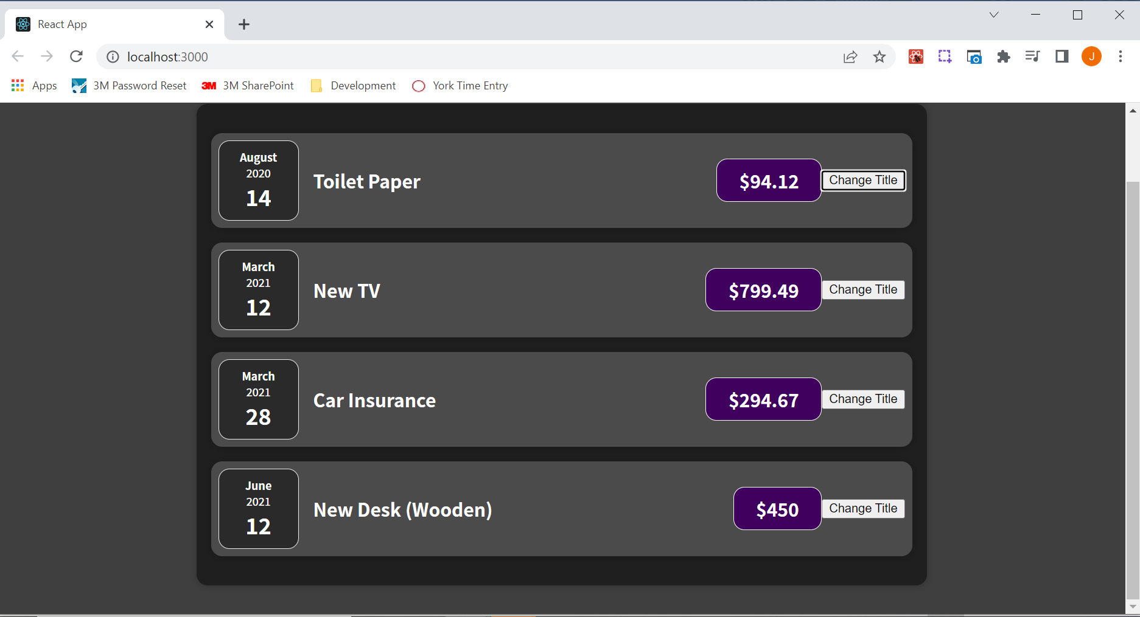

That's how react works. It's all started by the "index.js" file where we initially point at this App component (bolded below), which is the first component function being called, and that happens when the React app is being loaded on the screen, which happens when the page is being visited.

|  |
| --- |
| src/index.js |
| import React from 'react'; // Technically we don't need this import but this is how it was done in the past.  import ReactDOM from 'react-dom/client';  import './index.css';  import App from './App';  const root = ReactDOM.createRoot(document.getElementById('root'));  root.render(**<App />**); |

That's how React goes through all these components, executes all these component functions, and draws something onto the screen. The only problem with that is that react never repeats that. React goes through all of that when the application is initially rendered, and thereafter it's done. However, in Modern application, of course you sometimes want to update what's visible on the screen. For example, because a button was clicked, and that button should change some text which is being output. So we need a way of telling React that something changed and that a certain component should be re-evaluated and that's where React introduces a special concept called 'state'.

### 49. Working with "State"

State is actually not a React specific concept, but it is a key concept in React. In the ExpenseItem component, we have a scenario where we want to use that built-in state concept.

The title that changes when the clickHandler function executes

|  |
| --- |
| src/components/Expenses/ExpenseItem.js |
| import React from 'react'; // Technically we don't need this import but this is how it was done in the past.  import ExpenseDate from './ExpenseDate';  import Card from '../UI/Card';  import './ExpenseItem.css';  const ExpenseItem = props => {  let title = props.title;  const clickHandler = () => {  title = 'Updated!';  console.log(title);  };    return (  <Card className='expense-item'>  <ExpenseDate date={props.date}/>  <div className="expense-item__description">  <h2>{title}</h2>  <div className="expense-item__price">${props.amount}</div>  </div>  <button onClick={clickHandler}>Change Title</button>  </Card>  );  }  export default ExpenseItem; |

is actually data that should result in this component being re-evaluated and re-drawn on the screen when it changes, when that title data changes. And by default, regular variables like title

|  |
| --- |
| src/components/Expenses/ExpenseItem.js |
| import React from 'react'; // Technically we don't need this import but this is how it was done in the past.  import ExpenseDate from './ExpenseDate';  import Card from '../UI/Card';  import './ExpenseItem.css';  const ExpenseItem = props => {  let title = props.title;  const clickHandler = () => {  title = 'Updated!';  console.log(title);  };    return (  <Card className='expense-item'>  <ExpenseDate date={props.date}/>  <div className="expense-item__description">  <h2>{title}</h2>  <div className="expense-item__price">${props.amount}</div>  </div>  <button onClick={clickHandler}>Change Title</button>  </Card>  );  }  export default ExpenseItem; |

are not triggering such a re-evaluation. React does not care about that. If you have a variable in your component function, and that variable changes, React ignores it. It doesn't care about that, that code executes, sure, but the overall component function does not execute again just because some variable changed. As a side note, even if the component would execute again, then the title variable would also just be recreated and re initialized to the props value because as part of this component function, we are creating this title variable. So even if that component was re-created, we would not reach the desired result but we don't even need to think about that because the ExpenseItem component function is not called a second time after the initial rendering. The click of a button or a button change will not trigger the ExpenseItem component function to run again.

To tell React that the component function should run again, we need to import something from the React library. We do this by adding a so-called named import.

In the code snippet below, in the first line, an import, the bolded word is an example of a default import where we imported the overall React object.

|  |
| --- |
| src/components/Expenses/ExpenseItem.js |
| import **React** from 'react';  import ExpenseDate from './ExpenseDate';  import Card from '../UI/Card';  import './ExpenseItem.css';  const ExpenseItem = props => {  let title = props.title;  const clickHandler = () => {  title = 'Updated!';  console.log(title);  };    return (  <Card className='expense-item'>  <ExpenseDate date={props.date}/>  <div className="expense-item__description">  <h2>{title}</h2>  <div className="expense-item__price">${props.amount}</div>  </div>  <button onClick={clickHandler}>Change Title</button>  </Card>  );  }  export default ExpenseItem; |

We can now add a comma and curly braces, and between the curly braces, we can now extract specifically named things from the React library. We are importing single pieces from the React library, and we want to import a function here, a function which is called useState, which is a function provided by the React library. The function useState allows us to define values as state where changes to these values should reflect in the component function being called again.

|  |
| --- |
| src/components/Expenses/ExpenseItem.js |
| import React, **{ useState }** from 'react';  import ExpenseDate from './ExpenseDate';  import Card from '../UI/Card';  import './ExpenseItem.css';  const ExpenseItem = props => {  let title = props.title;  const clickHandler = () => {  title = 'Updated!';  console.log(title);  };    return (  <Card className='expense-item'>  <ExpenseDate date={props.date}/>  <div className="expense-item__description">  <h2>{title}</h2>  <div className="expense-item__price">${props.amount}</div>  </div>  <button onClick={clickHandler}>Change Title</button>  </Card>  );  }  export default ExpenseItem; |

To use this useState function, inside of our component function, we just call the function useState();

|  |
| --- |
| src/components/Expenses/ExpenseItem.js |
| import React, { useState } from 'react';  import ExpenseDate from './ExpenseDate';  import Card from '../UI/Card';  import './ExpenseItem.css';  const ExpenseItem = props => {  **useState();**  let title = props.title;  const clickHandler = () => {  title = 'Updated!';  console.log(title);  };    return (  <Card className='expense-item'>  <ExpenseDate date={props.date}/>  <div className="expense-item__description">  <h2>{title}</h2>  <div className="expense-item__price">${props.amount}</div>  </div>  <button onClick={clickHandler}>Change Title</button>  </Card>  );  }  export default ExpenseItem; |

#### React Hooks Intro

The function useState, is a so-called React hook. There are other hooks as well, and of course, we are going to learn about all important hooks throughout this course, but that is one of the most important ones. And all of these React hooks can be recognized by the fact that they have the word "use" in their name, and all of these hooks must only be called inside of React component functions like ExpenseItem. Hooks cannot be called outside of React component functions and should also not be called inside of any nested functions like clickHandler. They must be called directly inside of component functions. The useState function wants a default state value because with useState, we basically create a special kind of variable, you could say, a variable where changes will lead this component function to be called again. And of course, we can therefore, then assign an initial value for that special variable, just as we're assigning the value props.title to the regular variable called title. The initial value that we pass in as an argument to the useState function is props.title.

|  |
| --- |
| src/components/Expenses/ExpenseItem.js |
| import React, { useState } from 'react';  import ExpenseDate from './ExpenseDate';  import Card from '../UI/Card';  import './ExpenseItem.css';  const ExpenseItem = props => {  useState(**props.title**)**;**  let title = props.title;  const clickHandler = () => {  title = 'Updated!';  console.log(title);  };    return (  <Card className='expense-item'>  <ExpenseDate date={props.date}/>  <div className="expense-item__description">  <h2>{title}</h2>  <div className="expense-item__price">${props.amount}</div>  </div>  <button onClick={clickHandler}>Change Title</button>  </Card>  );  }  export default ExpenseItem; |

We also want to be able to use that special variable that we created above, in the h2 tags for example, and therefore, useState also returns something. It gives us access to this special variable. However, it does not just return that; it also returns a function which we can then call to assign a new value to that variable. We will not be assigning new values like this title = 'Updated!', with the equals sign. Instead, we will be assigning new values by calling a function. useState actually returns an array where the first value is the variable/value itself, and the second element in the array is that updating function. We can use a modern JavaScript feature called array destructuring, which you do using a pair of square brackets to store both elements in separate variables or constants, and here we'll use constants. You can choose any name of your choice because for array destructuring, it's just the order which matters. We'll name the variables title and setTitle.

|  |
| --- |
| src/components/Expenses/ExpenseItem.js |
| import React, { useState } from 'react';  import ExpenseDate from './ExpenseDate';  import Card from '../UI/Card';  import './ExpenseItem.css';  const ExpenseItem = props => {  **const [title, setTitle] =** useState(props.title)**;**  let title = props.title;  const clickHandler = () => {  title = 'Updated!';  console.log(title);  };    return (  <Card className='expense-item'>  <ExpenseDate date={props.date}/>  <div className="expense-item__description">  <h2>{title}</h2>  <div className="expense-item__price">${props.amount}</div>  </div>  <button onClick={clickHandler}>Change Title</button>  </Card>  );  }  export default ExpenseItem; |

The first element in the square brackets is a pointer at that managed value. So, initially we set the variable of title to the value stored in props.title.

|  |
| --- |
| src/components/Expenses/ExpenseItem.js |
| import React, { useState } from 'react';  import ExpenseDate from './ExpenseDate';  import Card from '../UI/Card';  import './ExpenseItem.css';  const ExpenseItem = props => {  const [**title**, setTitle] **= useState(props.title);**  let title = props.title;  const clickHandler = () => {  title = 'Updated!';  console.log(title);  };    return (  <Card className='expense-item'>  <ExpenseDate date={props.date}/>  <div className="expense-item__description">  <h2>{title}</h2>  <div className="expense-item__price">${props.amount}</div>  </div>  <button onClick={clickHandler}>Change Title</button>  </Card>  );  }  export default ExpenseItem; |

The second element in the square brackets is a function which we can later call to set a new title; hence, the reason why we chose the name setTitle.

|  |
| --- |
| src/components/Expenses/ExpenseItem.js |
| import React, { useState } from 'react';  import ExpenseDate from './ExpenseDate';  import Card from '../UI/Card';  import './ExpenseItem.css';  const ExpenseItem = props => {  const [title, **setTitle**] = useState(props.title);  let title = props.title;  const clickHandler = () => {  title = 'Updated!';  console.log(title);  };    return (  <Card className='expense-item'>  <ExpenseDate date={props.date}/>  <div className="expense-item__description">  <h2>{title}</h2>  <div className="expense-item__price">${props.amount}</div>  </div>  <button onClick={clickHandler}>Change Title</button>  </Card>  );  }  export default ExpenseItem; |

The variable names in the array destructuring, the square brackets, can be named anything you want. However, the convention is to use something which describes the value as the name for the first element, and then for the second element, the function that updates the value of the first element, use the word set and then the name of the variable that you used for the first element just with a capital starting character such as [title, setTitle]. That's the convention on how you name these two elements returned by useState. The function useState, this hook useState(props.title); always returns an array with exactly two elements. It's always the case that the first element is the current state value and the second element is a function for updating the current state value.

We can now remove the title variable, and we can remove that value assignment in the clickHandler function.

|  |
| --- |
| src/components/Expenses/ExpenseItem.js |
| import React, { useState } from 'react';  import ExpenseDate from './ExpenseDate';  import Card from '../UI/Card';  import './ExpenseItem.css';  const ExpenseItem = props => {  const [title, setTitle] = useState(props.title);  let title = props.title; // Remove title  const clickHandler = () => {  ~~title = 'Updated!';~~ // Remove title value assignment  console.log(title);  };    return (  <Card className='expense-item'>  <ExpenseDate date={props.date}/>  <div className="expense-item__description">  <h2>{title}</h2>  <div className="expense-item__price">${props.amount}</div>  </div>  <button onClick={clickHandler}>Change Title</button>  </Card>  );  }  export default ExpenseItem; |

We now get the following code snippet as shown below, and we can still use title in this way between the h2 tags because of the array destructuring.

|  |
| --- |
| src/components/Expenses/ExpenseItem.js |
| import React, { useState } from 'react';  import ExpenseDate from './ExpenseDate';  import Card from '../UI/Card';  import './ExpenseItem.css';  const ExpenseItem = props => {  const [title, setTitle] = useState(props.title);  const clickHandler = () => {  console.log(title);  };    return (  <Card className='expense-item'>  <ExpenseDate date={props.date}/>  <div className="expense-item__description">  <h2>**{title}**</h2>  <div className="expense-item__price">${props.amount}</div>  </div>  <button onClick={clickHandler}>Change Title</button>  </Card>  );  }  export default ExpenseItem; |

If we save it and reload, we still see the same titles in the DOM as before but of course the button still doesn't do anything because we're never updating the title. However, we do see the specific title being logged to the console when the button corresponding with that tile is clicked.

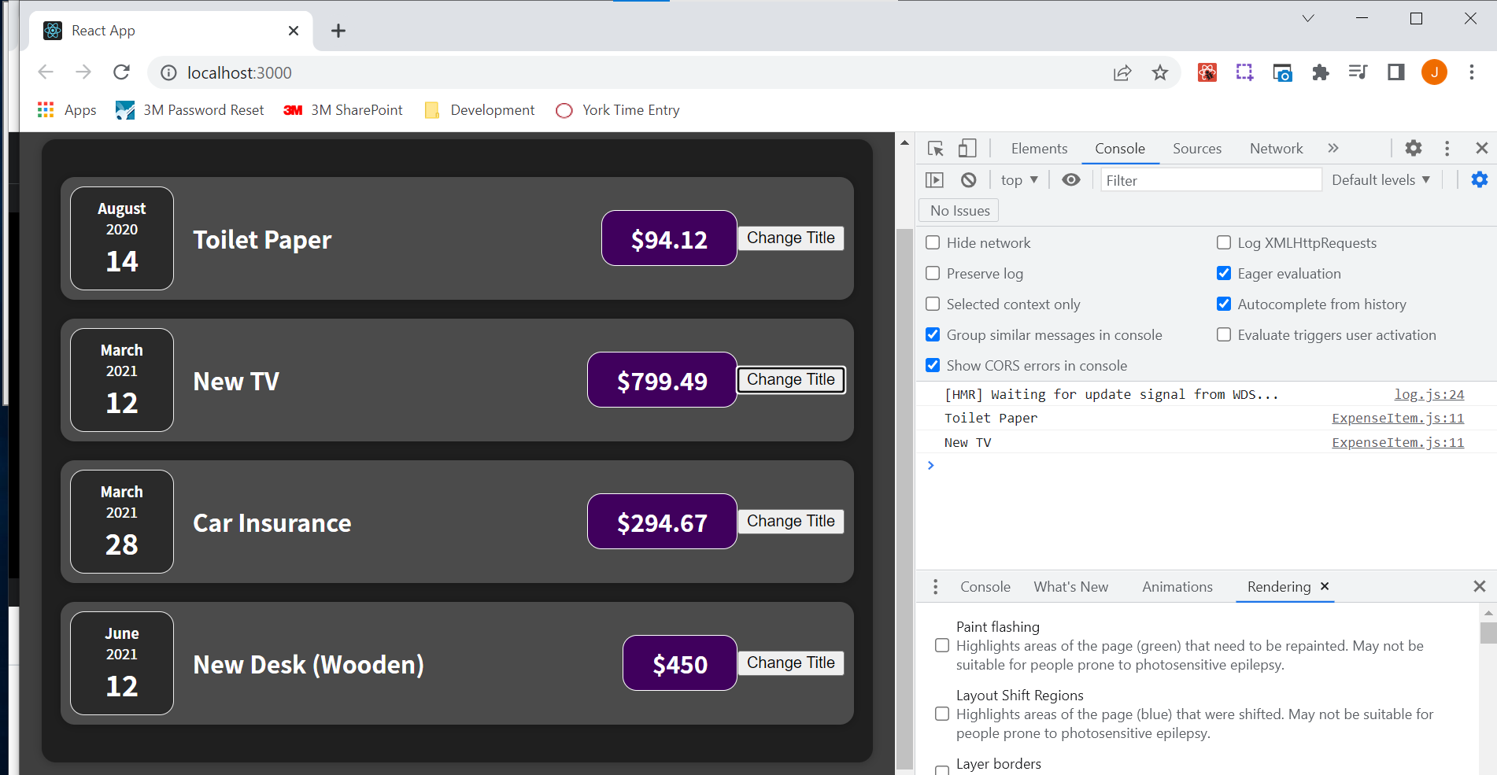

With the value returned by useState, we're not going to assign a new value with an equals sign. Instead, we assign a new value by calling the state updating function called setTitle() in the clickHandler() function. We can then just pass a new value as an argument. In this case, we will pass "Updated!".

|  |
| --- |
| src/components/Expenses/ExpenseItem.js |
| import React, { useState } from "react";  import ExpenseDate from "./ExpenseDate";  import Card from "../UI/Card";  import "./ExpenseItem.css";  const ExpenseItem = (props) => {  const [title, setTitle] = useState(props.title);  const clickHandler = () => {  **setTitle("Updated!");**  console.log(title);  };  return (  <Card className="expense-item">  <ExpenseDate date={props.date} />  <div className="expense-item__description">  <h2>{title}</h2>  <div className="expense-item__price">${props.amount}</div>  </div>  <button onClick={clickHandler}>Change Title</button>  </Card>  );  };  export default ExpenseItem; |

Why does it work like this? Why do we have this state updating function setTitle("Updated!"); instead of assigning a new value like this title = "Updated!";? The reason for that is calling this function setTitle("Updated!"); does not just assign a new value to some variable, but instead const [title,setTitle] = useState(props.title); it is a special variable to begin with. It's managed by React somewhere in memory, and when we call this state updating function setTitle('Updated!'); this special variable will not just receive a new value, but the component function, ExpenseItem.js, where you called this state updating function and in which you initialized your state with useState, will be executed again. That is exactly what we need. We want to call the component function ExpenseItem again when our state changes. And by calling the state-updating function setTitle, the component function ExpenseItem is being called again. By calling the function setTitle('Updated!'); you're telling React that you want to assign a new value to this state. And that then also tells React that the component in which you said this state useState(props.title) was registered with useState should be re-evaluated. And, therefore, React will go ahead and execute this component function again, and therefore, also evaluate the JSX code in ExpenseItem again and then it will draw any changes which it detects compared to the last time it evaluated this onto the screen. So if we now save everything and click "Change Title" we will see that the existing title in the top ExpenseItem that says "Toilet Paper" in this case, will be changed to "Updated!"

Before clicking "Change Title":

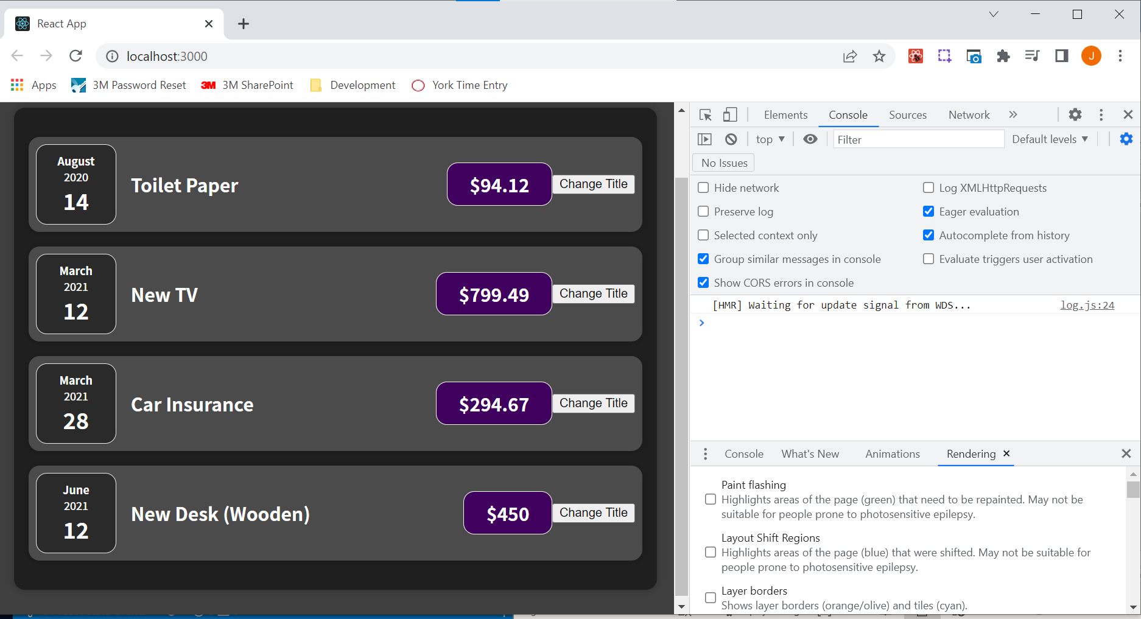

After clicking "Change Title":

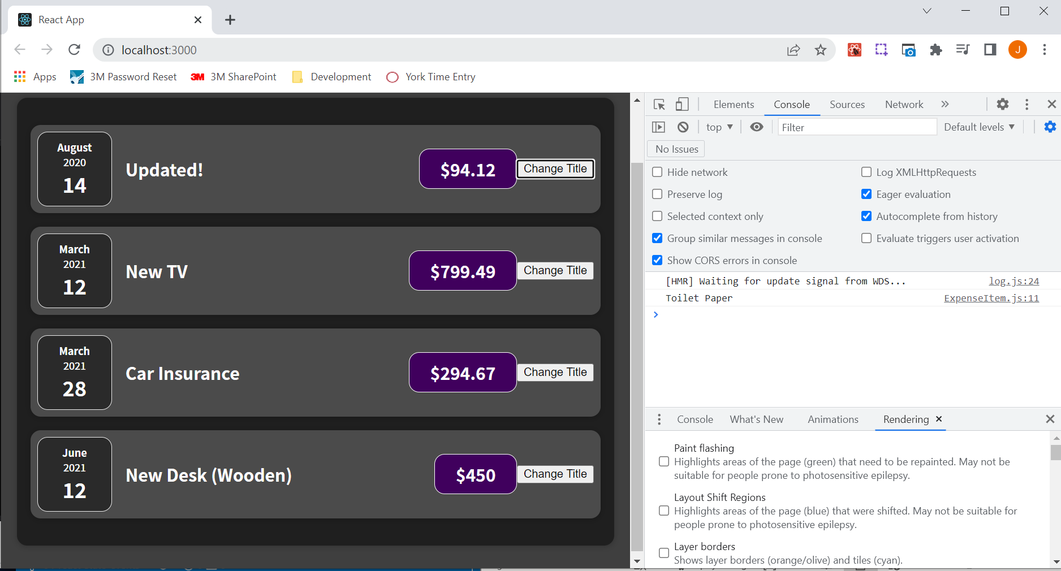

The console.log(title); statement still shows the title before it was updated. The reason for this is that calling this state updating function setTitle('Updated!'); actually doesn't change the value right away, but instead schedules this state update. So in the very next line thereafter, this new value isn't available yet. That's why we see the old value being logged even though we updated it before logging it out to the console. But you do see that eventually the component ExpenseItem is called again and is evaluated again, and then we see our updated value on the screen. That's how React state works. This is another key concept in React. If you have data which might change and where changes to that data should be reflected in the user interface, then you need state because regular variables will not do the trick. With state you can set and change values, and when they do change, React will re-evaluate the component in which the state was registered, and only that component, by the way, not any other components, just this component in which the state was registered.

In the next video we will take a closer look at the state, why we use const, and how this all works in detail.

### 50. A Closer Look at the "useState" Hook

State is a key concept in React. There are a couple of things to clarify regarding useState and why we use a const here.

|  |
| --- |
| src/components/Expenses/ExpenseItem.js |
| import React, { useState } from "react";  import ExpenseDate from "./ExpenseDate";  import Card from "../UI/Card";  import "./ExpenseItem.css";  const ExpenseItem = (props) => {  **const** [title, setTitle] = useState(props.title);  const clickHandler = () => {  setTitle("Updated!");  console.log(title);  };  return (  <Card className="expense-item">  <ExpenseDate date={props.date} />  <div className="expense-item__description">  <h2>{title}</h2>  <div className="expense-item__price">${props.amount}</div>  </div>  <button onClick={clickHandler}>Change Title</button>  </Card>  );  };  export default ExpenseItem; |

The function useState registers some State, so some value as a State for the component in which it is being called. As shown below useState is called in the ExpenseItem component function.

|  |
| --- |
| src/components/Expenses/ExpenseItem.js |
| import React, { useState } from "react";  import ExpenseDate from "./ExpenseDate";  import Card from "../UI/Card";  import "./ExpenseItem.css";  const ExpenseItem = (props) => {  const [title, setTitle] = **useState(props.title);**  const clickHandler = () => {  setTitle("Updated!");  console.log(title);  };  return (  <Card className="expense-item">  <ExpenseDate date={props.date} />  <div className="expense-item__description">  <h2>{title}</h2>  <div className="expense-item__price">${props.amount}</div>  </div>  <button onClick={clickHandler}>Change Title</button>  </Card>  );  };  export default ExpenseItem; |

More specifically, useState registers some State for a specific component instance. For example, the ExpenseItem component is being used four times within the Expenses component function. In "Expenses.js" we have four ExpenseItems. Every item receives its own separate State which is detached from the other States.

|  |
| --- |
| src/components/Expenses/Expenses.js |
| import React from "react"; // Technically we don't need this import but this is how it was done in the past.  import ExpenseItem from "./ExpenseItem";  import Card from "../UI/Card";  import "./Expenses.css";  const Expenses = (props) => {  return (  <Card className="expenses">  <ExpenseItem  title={props.expenses[0].title}  amount={props.expenses[0].amount}  date={props.expenses[0].date}  />  <ExpenseItem  title={props.expenses[1].title}  amount={props.expenses[1].amount}  date={props.expenses[1].date}  />  <ExpenseItem  title={props.expenses[2].title}  amount={props.expenses[2].amount}  date={props.expenses[2].date}  />  <ExpenseItem  title={props.expenses[3].title}  amount={props.expenses[3].amount}  date={props.expenses[3].date}  />  </Card>  );  };  export default Expenses; |

We have one ExpenseItem definition as shown in the bolded part of the below code snippet:

|  |
| --- |
| src/components/Expenses/ExpenseItem.js |
| import React, { useState } from "react";  import ExpenseDate from "./ExpenseDate";  import Card from "../UI/Card";  import "./ExpenseItem.css";  const **ExpenseItem** = (props) => {  const [title, setTitle] = useState(props.title);  const clickHandler = () => {  setTitle("Updated!");  console.log(title);  };  return (  <Card className="expense-item">  <ExpenseDate date={props.date} />  <div className="expense-item__description">  <h2>{title}</h2>  <div className="expense-item__price">${props.amount}</div>  </div>  <button onClick={clickHandler}>Change Title</button>  </Card>  );  };  export default ExpenseItem; |

but then the ExpenseItem function is basically called four times as shown in the below code snippet:

|  |
| --- |
| src/components/Expenses/Expenses.js |
| import React from "react"; // Technically we don't need this import but this is how it was done in the past.  import ExpenseItem from "./ExpenseItem";  import Card from "../UI/Card";  import "./Expenses.css";  const Expenses = (props) => {  return (  <Card className="expenses">  **<ExpenseItem**  **title={props.expenses[0].title}**  **amount={props.expenses[0].amount}**  **date={props.expenses[0].date}**  **/>**  **<ExpenseItem**  **title={props.expenses[1].title}**  **amount={props.expenses[1].amount}**  **date={props.expenses[1].date}**  **/>**  **<ExpenseItem**  **title={props.expenses[2].title}**  **amount={props.expenses[2].amount}**  **date={props.expenses[2].date}**  **/>**  **<ExpenseItem**  **title={props.expenses[3].title}**  **amount={props.expenses[3].amount}**  **date={props.expenses[3].date}**  **/>**  </Card>  );  };  export default Expenses; |

Every time it is called, a new separate State is created of course in the same way but managed independently by React. So if we change the title in the first ExpenseItem, the other ones are not affected because they have their own State.

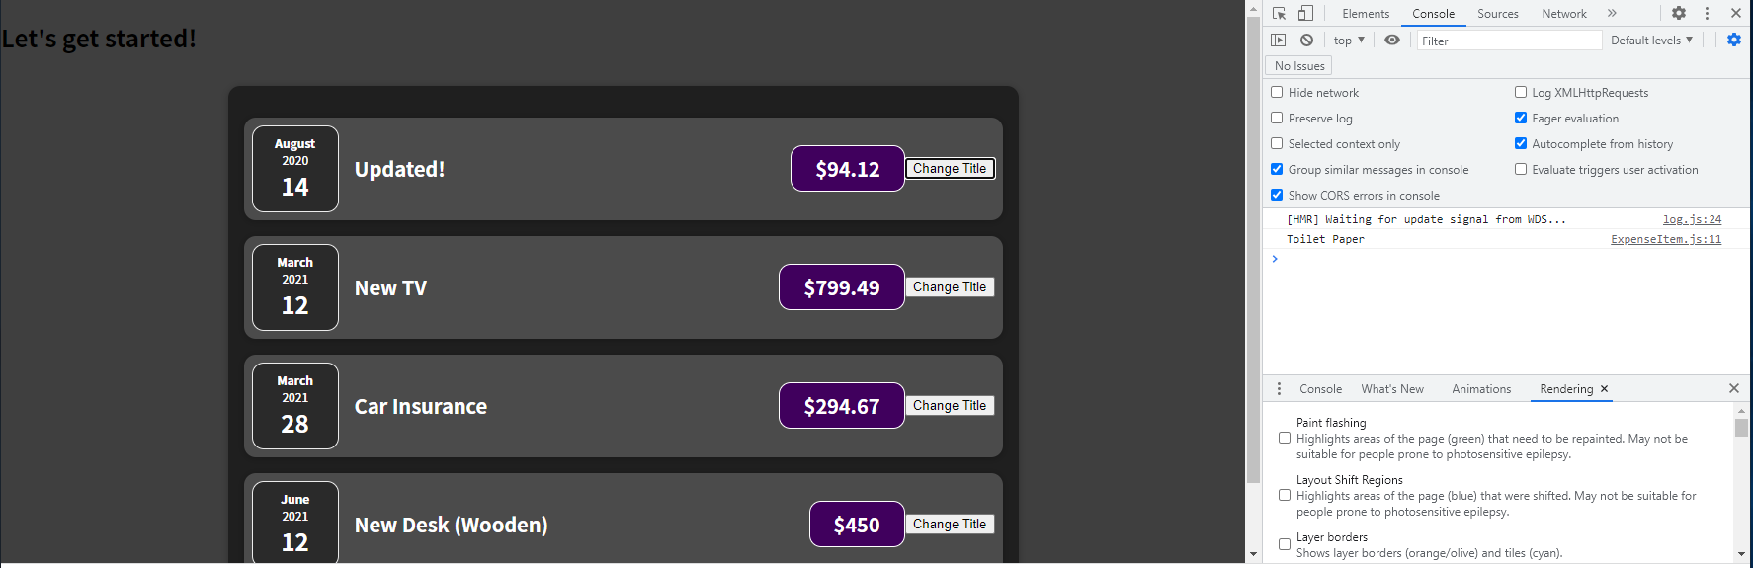

It's on a per component instance basis. So we have separate States, even if we create a component more than once. And that's of course crucial because it would be a rather undesired behavior if we change something in one item and all the other items are updated as well. Now, in addition, whenever state changes, because we click a button in this case, it's only this component function and only that specific instance where the component is being used where React will re-evaluate it.

You can actually prove this idea by adding console.log('ExpenseItem evaluated by React'); This will be called whenever the ExpenseItem component function is being executed.

|  |
| --- |
| src/components/Expenses/ExpenseItem.js |
| import React, { useState } from "react";  import ExpenseDate from "./ExpenseDate";  import Card from "../UI/Card";  import "./ExpenseItem.css";  const ExpenseItem = (props) => {  const [title, setTitle] = useState(props.title);  **console.log('ExpenseItem evaluated by React');**  const clickHandler = () => {  setTitle("Updated!");  console.log(title);  };  return (  <Card className="expense-item">  <ExpenseDate date={props.date} />  <div className="expense-item__description">  <h2>{title}</h2>  <div className="expense-item__price">${props.amount}</div>  </div>  <button onClick={clickHandler}>Change Title</button>  </Card>  );  };  export default ExpenseItem; |

If we save and reload the page, we see that ExpenseItem is being called 4 times, which makes sense because we're using ExpenseItem four times in the Expenses component function. So four separate instances of the ExpenseItem component are being created.

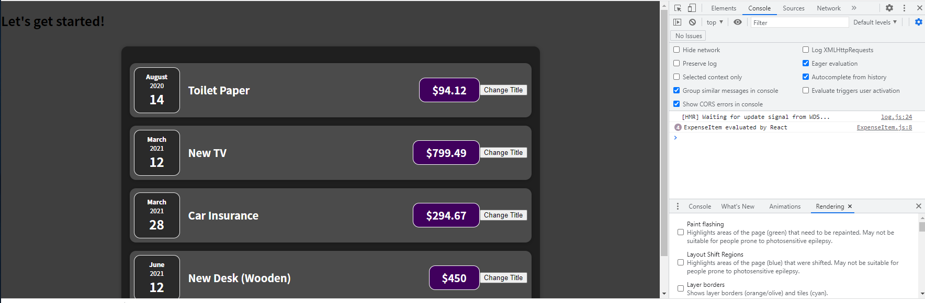

If we click on "Change Title" on one of the items, we see it's only printed once, which is basically happening because only that specific instance is being updated and therefore being re-evaluated, and the other instances are not affected by that state change. State is separated on a per component instance basis.

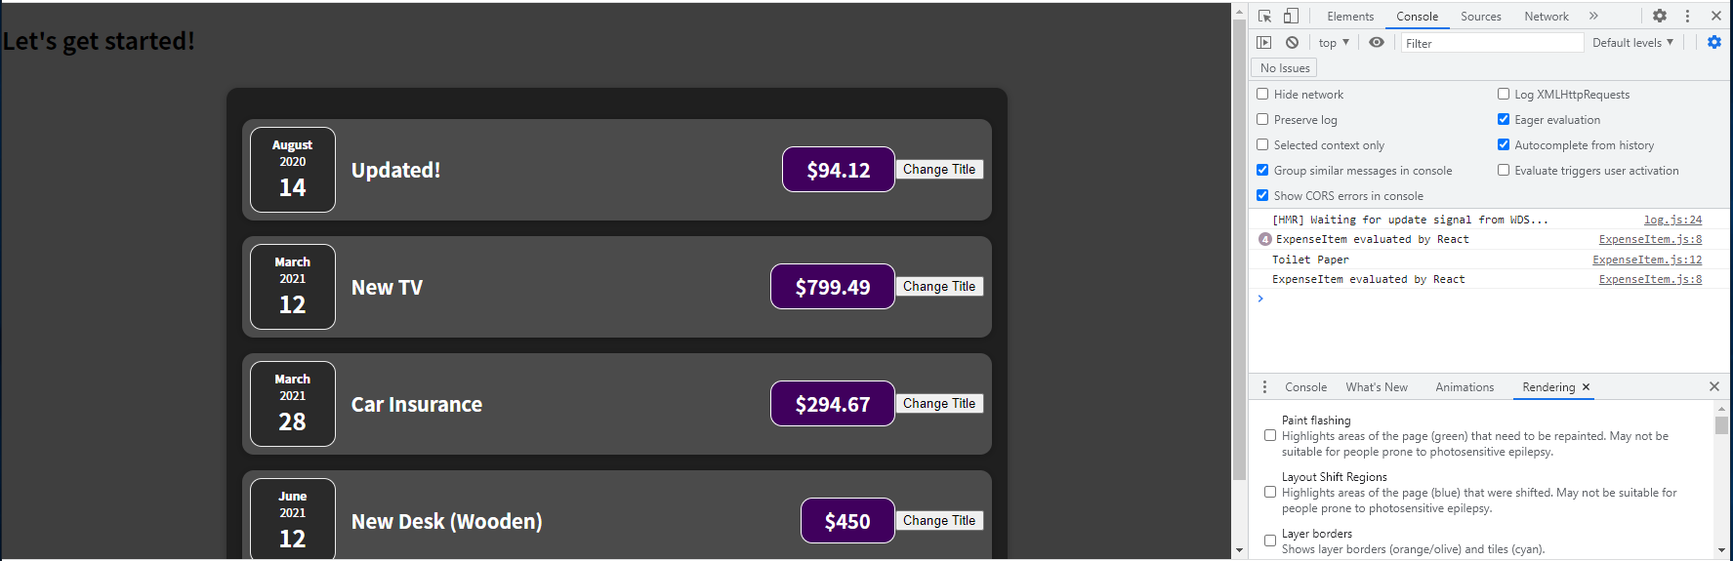

For variable declaration in the array destructuring, why is const used when we do eventually assign a new value? Keep in mind that we're not assigning a value with the equals sign.

|  |
| --- |
| src/components/Expenses/ExpenseItem.js |
| import React, { useState } from "react";  import ExpenseDate from "./ExpenseDate";  import Card from "../UI/Card";  import "./ExpenseItem.css";  const ExpenseItem = (props) => {  **const** [title, setTitle] = useState(props.title);  console.log('ExpenseItem evaluated by React');  const clickHandler = () => {  setTitle("Updated!");  console.log(title);  };  return (  <Card className="expense-item">  <ExpenseDate date={props.date} />  <div className="expense-item__description">  <h2>{title}</h2>  <div className="expense-item__price">${props.amount}</div>  </div>  <button onClick={clickHandler}>Change Title</button>  </Card>  );  };  export default ExpenseItem; |

We would get an error if we tried to assign a value to the title with an equals sign as is bolded in the below code snippet:

|  |
| --- |
| src/components/Expenses/ExpenseItem.js |
| import React, { useState } from "react";  import ExpenseDate from "./ExpenseDate";  import Card from "../UI/Card";  import "./ExpenseItem.css";  const ExpenseItem = (props) => {  const [title, setTitle] = useState(props.title);  console.log('ExpenseItem evaluated by React');  const clickHandler = () => {  setTitle("Updated!");  **title = "Updated!"; Error would occur**  console.log(title);  };  return (  <Card className="expense-item">  <ExpenseDate date={props.date} />  <div className="expense-item__description">  <h2>{title}</h2>  <div className="expense-item__price">${props.amount}</div>  </div>  <button onClick={clickHandler}>Change Title</button>  </Card>  );  };  export default ExpenseItem; |

The line bolded in the above code snippet is NOT how we assign a new value when we update a State. Instead, we call the state updating function setTitle as shown bolded in the following code snippet, and the concrete value is simply managed somewhere else by React.

|  |
| --- |
| src/components/Expenses/ExpenseItem.js |
| import React, { useState } from "react";  import ExpenseDate from "./ExpenseDate";  import Card from "../UI/Card";  import "./ExpenseItem.css";  const ExpenseItem = (props) => {  const [title, setTitle] = useState(props.title);  console.log('ExpenseItem evaluated by React');  const clickHandler = () => {  **setTitle("Updated!");**  console.log(title);  };  return (  <Card className="expense-item">  <ExpenseDate date={props.date} />  <div className="expense-item__description">  <h2>{title}</h2>  <div className="expense-item__price">${props.amount}</div>  </div>  <button onClick={clickHandler}>Change Title</button>  </Card>  );  };  export default ExpenseItem; |

By calling useState, we tell React that it should manage some value for us. We never see that variable itself.

|  |
| --- |
| src/components/Expenses/ExpenseItem.js |
| import React, { useState } from "react";  import ExpenseDate from "./ExpenseDate";  import Card from "../UI/Card";  import "./ExpenseItem.css";  const ExpenseItem = (props) => {  const [title, setTitle] = **useState(props.title);**  console.log('ExpenseItem evaluated by React');  const clickHandler = () => {  setTitle("Updated!");  console.log(title);  };  return (  <Card className="expense-item">  <ExpenseDate date={props.date} />  <div className="expense-item__description">  <h2>{title}</h2>  <div className="expense-item__price">${props.amount}</div>  </div>  <button onClick={clickHandler}>Change Title</button>  </Card>  );  };  export default ExpenseItem; |

So therefore, we just call the function setTitle, and we never assign a new value to the title with the equals operator.

|  |
| --- |
| src/components/Expenses/ExpenseItem.js |
| import React, { useState } from "react";  import ExpenseDate from "./ExpenseDate";  import Card from "../UI/Card";  import "./ExpenseItem.css";  const ExpenseItem = (props) => {  const [title, setTitle] = useState(props.title);  console.log('ExpenseItem evaluated by React');  const clickHandler = () => {  setTitle("Updated!");  console.log(title);  };  return (  <Card className="expense-item">  <ExpenseDate date={props.date} />  <div className="expense-item__description">  <h2>{title}</h2>  <div className="expense-item__price">${props.amount}</div>  </div>  <button onClick={clickHandler}>Change Title</button>  </Card>  );  };  export default ExpenseItem; |

And therefore, using const is just fine.

|  |
| --- |
| src/components/Expenses/ExpenseItem.js |
| import React, { useState } from "react";  import ExpenseDate from "./ExpenseDate";  import Card from "../UI/Card";  import "./ExpenseItem.css";  const ExpenseItem = (props) => {  **const** [title, setTitle] = useState(props.title);  console.log('ExpenseItem evaluated by React');  const clickHandler = () => {  setTitle("Updated!");  console.log(title);  };  return (  <Card className="expense-item">  <ExpenseDate date={props.date} />  <div className="expense-item__description">  <h2>{title}</h2>  <div className="expense-item__price">${props.amount}</div>  </div>  <button onClick={clickHandler}>Change Title</button>  </Card>  );  };  export default ExpenseItem; |

How do we get the latest title value then, though? Well, keep in mind that the component function is re-executed when the State is updated.

|  |
| --- |
| src/components/Expenses/ExpenseItem.js |
| import React, { useState } from "react";  import ExpenseDate from "./ExpenseDate";  import Card from "../UI/Card";  import "./ExpenseItem.css";  const ExpenseItem = (props) => {  const [**title**, setTitle] = useState(props.title);  console.log('ExpenseItem evaluated by React');  const clickHandler = () => {  setTitle("Updated!");  console.log(title);  };  return (  <Card className="expense-item">  <ExpenseDate date={props.date} />  <div className="expense-item__description">  <h2>{title}</h2>  <div className="expense-item__price">${props.amount}</div>  </div>  <button onClick={clickHandler}>Change Title</button>  </Card>  );  };  export default ExpenseItem; |

And therefore this line of code, const [title, setTitle] = useState(props.title);, is also executed again whenever the component function is executed again.

|  |
| --- |
| src/components/Expenses/ExpenseItem.js |
| import React, { useState } from "react";  import ExpenseDate from "./ExpenseDate";  import Card from "../UI/Card";  import "./ExpenseItem.css";  const ExpenseItem = (props) => {  const [title, setTitle] = useState(props.title);  console.log('ExpenseItem evaluated by React');  const clickHandler = () => {  setTitle("Updated!");  console.log(title);  };  return (  <Card className="expense-item">  <ExpenseDate date={props.date} />  <div className="expense-item__description">  <h2>{title}</h2>  <div className="expense-item__price">${props.amount}</div>  </div>  <button onClick={clickHandler}>Change Title</button>  </Card>  );  };  export default ExpenseItem; |

So if we called setTitle and we assign a new title,

|  |
| --- |
| src/components/Expenses/ExpenseItem.js |
| import React, { useState } from "react";  import ExpenseDate from "./ExpenseDate";  import Card from "../UI/Card";  import "./ExpenseItem.css";  const ExpenseItem = (props) => {  const [title, setTitle] = useState(props.title);  console.log('ExpenseItem evaluated by React');  const clickHandler = () => {  setTitle("Updated!");  console.log(title);  };  return (  <Card className="expense-item">  <ExpenseDate date={props.date} />  <div className="expense-item__description">  <h2>{title}</h2>  <div className="expense-item__price">${props.amount}</div>  </div>  <button onClick={clickHandler}>Change Title</button>  </Card>  );  };  export default ExpenseItem; |

That leads to this component being called again,

|  |
| --- |
| src/components/Expenses/ExpenseItem.js |
| import React, { useState } from "react";  import ExpenseDate from "./ExpenseDate";  import Card from "../UI/Card";  import "./ExpenseItem.css";  const ExpenseItem = (props) => {  const [title, setTitle] = useState(props.title);  console.log('ExpenseItem evaluated by React');  const clickHandler = () => {  setTitle("Updated!");  console.log(title);  };  return (  <Card className="expense-item">  <ExpenseDate date={props.date} />  <div className="expense-item__description">  <h2>{title}</h2>  <div className="expense-item__price">${props.amount}</div>  </div>  <button onClick={clickHandler}>Change Title</button>  </Card>  );  };  export default ExpenseItem; |

and therefore, this new title, this updated title is fetched from React, which manages the State for us.

|  |
| --- |
| src/components/Expenses/ExpenseItem.js |
| import React, { useState } from "react";  import ExpenseDate from "./ExpenseDate";  import Card from "../UI/Card";  import "./ExpenseItem.css";  const ExpenseItem = (props) => {  const [**title**, setTitle] = useState(props.title);  console.log('ExpenseItem evaluated by React');  const clickHandler = () => {  setTitle("Updated!");  console.log(title);  };  return (  <Card className="expense-item">  <ExpenseDate date={props.date} />  <div className="expense-item__description">  <h2>{title}</h2>  <div className="expense-item__price">${props.amount}</div>  </div>  <button onClick={clickHandler}>Change Title</button>  </Card>  );  };  export default ExpenseItem; |

Basically, we go to React and say, "Hey please give me that latest title State which I told you to manage for me." And React provides us this latest State in this array, which useState always returns.

|  |
| --- |
| src/components/Expenses/ExpenseItem.js |
| import React, { useState } from "react";  import ExpenseDate from "./ExpenseDate";  import Card from "../UI/Card";  import "./ExpenseItem.css";  const ExpenseItem = (props) => {  const **[title, setTitle]** = useState(props.title);  console.log('ExpenseItem evaluated by React');  const clickHandler = () => {  setTitle("Updated!");  console.log(title);  };  return (  <Card className="expense-item">  <ExpenseDate date={props.date} />  <div className="expense-item__description">  <h2>{title}</h2>  <div className="expense-item__price">${props.amount}</div>  </div>  <button onClick={clickHandler}>Change Title</button>  </Card>  );  };  export default ExpenseItem; |

So we always get a brand new snapshot of that State when this component function re-executes. That's how this works under the hood.

You might be wondering if that means we always overwrite any State changes with props.title again. And here, the special thing is that React keeps track of

|  |
| --- |
| src/components/Expenses/ExpenseItem.js |
| import React, { useState } from "react";  import ExpenseDate from "./ExpenseDate";  import Card from "../UI/Card";  import "./ExpenseItem.css";  const ExpenseItem = (props) => {  const [title, setTitle] = useState(**props.title**);  console.log('ExpenseItem evaluated by React');  const clickHandler = () => {  setTitle("Updated!");  console.log(title);  };  return (  <Card className="expense-item">  <ExpenseDate date={props.date} />  <div className="expense-item__description">  <h2>{title}</h2>  <div className="expense-item__price">${props.amount}</div>  </div>  <button onClick={clickHandler}>Change Title</button>  </Card>  );  };  export default ExpenseItem; |

when we call useState in a given component instance for the first time. And when we call it for the first time ever, it'll take that argument as an initial value. But if a component is then re-executed, because of

|  |
| --- |
| src/components/Expenses/ExpenseItem.js |
| import React, { useState } from "react";  import ExpenseDate from "./ExpenseDate";  import Card from "../UI/Card";  import "./ExpenseItem.css";  const ExpenseItem = (props) => {  const [title, setTitle] = **useState(props.title);**  console.log('ExpenseItem evaluated by React');  const clickHandler = () => {  setTitle("Updated!");  console.log(title);  };  return (  <Card className="expense-item">  <ExpenseDate date={props.date} />  <div className="expense-item__description">  <h2>{title}</h2>  <div className="expense-item__price">${props.amount}</div>  </div>  <button onClick={clickHandler}>Change Title</button>  </Card>  );  };  export default ExpenseItem; |

such a State change, for example, React will not reinitialize the State. Instead, it will detect that this State had been initialized in the past, and it will just grab the latest State, which is based on some State update, for example, and give us that State instead.

|  |
| --- |
| src/components/Expenses/ExpenseItem.js |
| import React, { useState } from "react";  import ExpenseDate from "./ExpenseDate";  import Card from "../UI/Card";  import "./ExpenseItem.css";  const ExpenseItem = (props) => {  const [title, setTitle] = useState(props.title);  console.log('ExpenseItem evaluated by React');  const clickHandler = () => {  **setTitle("Updated!");**  console.log(title);  };  return (  <Card className="expense-item">  <ExpenseDate date={props.date} />  <div className="expense-item__description">  <h2>{title}</h2>  <div className="expense-item__price">${props.amount}</div>  </div>  <button onClick={clickHandler}>Change Title</button>  </Card>  );  };  export default ExpenseItem; |

So this initial value is really only considered

|  |
| --- |
| src/components/Expenses/ExpenseItem.js |
| import React, { useState } from "react";  import ExpenseDate from "./ExpenseDate";  import Card from "../UI/Card";  import "./ExpenseItem.css";  const ExpenseItem = (props) => {  const [title, setTitle] = useState(**props.title**);  console.log('ExpenseItem evaluated by React');  const clickHandler = () => {  setTitle("Updated!");  console.log(title);  };  return (  <Card className="expense-item">  <ExpenseDate date={props.date} />  <div className="expense-item__description">  <h2>{title}</h2>  <div className="expense-item__price">${props.amount}</div>  </div>  <button onClick={clickHandler}>Change Title</button>  </Card>  );  };  export default ExpenseItem; |

when this component function is being executed for the first time, for a given component instance.

|  |
| --- |
| src/components/Expenses/ExpenseItem.js |
| import React, { useState } from "react";  import ExpenseDate from "./ExpenseDate";  import Card from "../UI/Card";  import "./ExpenseItem.css";  **const ExpenseItem = (props) => {**  **const [title, setTitle] = useState(props.title);**  **console.log('ExpenseItem evaluated by React');**  **const clickHandler = () => {**  **setTitle("Updated!");**  **console.log(title);**  **};**  **return (**  **<Card className="expense-item">**  **<ExpenseDate date={props.date} />**  **<div className="expense-item__description">**  **<h2>{title}</h2>**  **<div className="expense-item__price">${props.amount}</div>**  **</div>**  **<button onClick={clickHandler}>Change Title</button>**  **</Card>**  **);**  **};**  export default ExpenseItem; |

It is important to understand how State works under the hood because if you don't fully understand that, then you will run into problems in more complex React applications where suddenly some value isn't updated as you expected it to be.

In a nutshell, to use state you just register State with useState:

|  |
| --- |
| src/components/Expenses/ExpenseItem.js |
| import React, { useState } from "react";  import ExpenseDate from "./ExpenseDate";  import Card from "../UI/Card";  import "./ExpenseItem.css";  const ExpenseItem = (props) => {  const [title, setTitle] = **useState(props.title);**  console.log('ExpenseItem evaluated by React');  const clickHandler = () => {  setTitle("Updated!");  console.log(title);  };  return (  <Card className="expense-item">  <ExpenseDate date={props.date} />  <div className="expense-item__description">  <h2>{title}</h2>  <div className="expense-item__price">${props.amount}</div>  </div>  <button onClick={clickHandler}>Change Title</button>  </Card>  );  };  export default ExpenseItem; |

you always get back two values:

|  |
| --- |
| src/components/Expenses/ExpenseItem.js |
| import React, { useState } from "react";  import ExpenseDate from "./ExpenseDate";  import Card from "../UI/Card";  import "./ExpenseItem.css";  const ExpenseItem = (props) => {  const **[title, setTitle]** = useState(props.title);  console.log('ExpenseItem evaluated by React');  const clickHandler = () => {  setTitle("Updated!");  console.log(title);  };  return (  <Card className="expense-item">  <ExpenseDate date={props.date} />  <div className="expense-item__description">  <h2>{title}</h2>  <div className="expense-item__price">${props.amount}</div>  </div>  <button onClick={clickHandler}>Change Title</button>  </Card>  );  };  export default ExpenseItem; |

The value itself

|  |
| --- |
| src/components/Expenses/ExpenseItem.js |
| import React, { useState } from "react";  import ExpenseDate from "./ExpenseDate";  import Card from "../UI/Card";  import "./ExpenseItem.css";  const ExpenseItem = (props) => {  const [**title**, setTitle] = useState(props.title);  console.log('ExpenseItem evaluated by React');  const clickHandler = () => {  setTitle("Updated!");  console.log(title);  };  return (  <Card className="expense-item">  <ExpenseDate date={props.date} />  <div className="expense-item__description">  <h2>{title}</h2>  <div className="expense-item__price">${props.amount}</div>  </div>  <button onClick={clickHandler}>Change Title</button>  </Card>  );  };  export default ExpenseItem; |

and the updating function

|  |
| --- |
| src/components/Expenses/ExpenseItem.js |
| import React, { useState } from "react";  import ExpenseDate from "./ExpenseDate";  import Card from "../UI/Card";  import "./ExpenseItem.css";  const ExpenseItem = (props) => {  const [title, **setTitle**] = useState(props.title);  console.log('ExpenseItem evaluated by React');  const clickHandler = () => {  setTitle("Updated!");  console.log(title);  };  return (  <Card className="expense-item">  <ExpenseDate date={props.date} />  <div className="expense-item__description">  <h2>{title}</h2>  <div className="expense-item__price">${props.amount}</div>  </div>  <button onClick={clickHandler}>Change Title</button>  </Card>  );  };  export default ExpenseItem; |

You call the updating function whenever the State should change, and you use that

|  |
| --- |
| src/components/Expenses/ExpenseItem.js |
| import React, { useState } from "react";  import ExpenseDate from "./ExpenseDate";  import Card from "../UI/Card";  import "./ExpenseItem.css";  const ExpenseItem = (props) => {  const [title, setTitle] = useState(props.title);  console.log('ExpenseItem evaluated by React');  const clickHandler = () => {  **setTitle("Updated!");**  console.log(title);  };  return (  <Card className="expense-item">  <ExpenseDate date={props.date} />  <div className="expense-item__description">  <h2>{title}</h2>  <div className="expense-item__price">${props.amount}</div>  </div>  <button onClick={clickHandler}>Change Title</button>  </Card>  );  };  export default ExpenseItem; |

first element whenever you want to use

|  |
| --- |
| src/components/Expenses/ExpenseItem.js |
| import React, { useState } from "react";  import ExpenseDate from "./ExpenseDate";  import Card from "../UI/Card";  import "./ExpenseItem.css";  const ExpenseItem = (props) => {  const [**title**, setTitle] = useState(props.title);  console.log('ExpenseItem evaluated by React');  const clickHandler = () => {  setTitle("Updated!");  console.log(title);  };  return (  <Card className="expense-item">  <ExpenseDate date={props.date} />  <div className="expense-item__description">  <h2>{title}</h2>  <div className="expense-item__price">${props.amount}</div>  </div>  <button onClick={clickHandler}>Change Title</button>  </Card>  );  };  export default ExpenseItem; |

the State value, like here for outputting it in the JSX code. And React will do the rest and it will re-execute the component function and re-evaluate the JSX code whenever the State changes.

State is an important concept because it's State which adds reactivity to our application. Without State, our user interface would never change. But with State and with listening to events, we can make sure that we can react to user input and that such input can result in a visible change on our screen. So State is a super important concept and of course being able to listen to user events is also important as you can tell.

### 51. State can be updated in many ways!

Thus far, we update our state **upon user events** (e.g. upon a click).

That's very common but not required for state updates! **You can update states for whatever reason you may have.**

Later in this course, we'll see Http requests that complete (where we then want to update the state based on the Http response we got back) but you could also be updating state because a time (set with setTimeout()) expired for example.

### 52. Adding Form Inputs

One important piece is missing, for example, the capability to gather user input so that users can add their own expenses. That sounds fairly important for an expense tracker, but up to this point, it's not possible, so that's what we'll work on next.

We'll add a new category of components because the components that we have so far are about outputting expenses as well as about showing the expenses. We now want to gather user input, and therefore, we'll add a new sub-folder in the components folder and name it "NewExpense" because ultimately that's what the components in this folder will relate to. Within the "NewExpense" folder, we can create a file called "NewExpense.js", which will hold the new expense component.

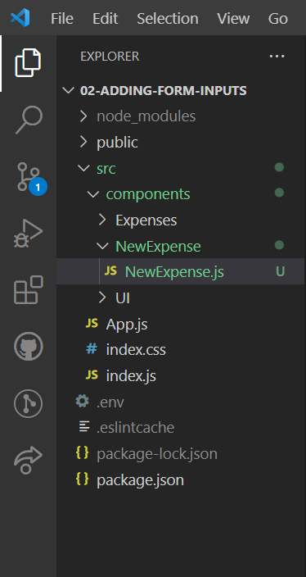

Inside of the new expense component, we want to render a form where users can enter their expense data. We start by setting up our basic NewExpense component and it's export default NewExpense to make it available,

|  |
| --- |
| src/components/NewExpense/NewExpense.js |
| import React from 'react';  const NewExpense = () => {};  export default NewExpense; |

and we can import React from 'react'; You technically don’t need to add this import, but we will still add it here because you will see it in many react projects as well as to make it clear that under the hood, JSX uses this react library.

|  |
| --- |
| src/components/NewExpense/NewExpense.js |
| import React from **'react'**;  const NewExpense = () => {};  export default NewExpense; |

The goal with this component is to return a form for our inputs. We first off return a div, and then inside of that div, we return a form.

|  |
| --- |
| src/components/NewExpense/NewExpense.js |
| import React from 'react';  const NewExpense = () => {  **return (**  **<div>**  **<form></form>**  **</div>**  **)**  };  export default NewExpense; |

Inside of the "NewExpense" folder we create a file called "NewExpense.css" where we add our styling. We then import './newExpense.css';

|  |
| --- |
| src/components/NewExpense/NewExpense.js |
| import React from 'react';  **import './NewExpense.css';**  const NewExpense = () => {  return (  <div>  <form></form>  </div>  )  };  export default NewExpense; |

We now add className="new-expense" to the outermost div.

|  |
| --- |
| src/components/NewExpense/NewExpense.js |
| import React from 'react';  import './NewExpense.css';  const NewExpense = () => {  return (  <div **className="new-expense"**>  <form></form>  </div>  )  };  export default NewExpense; |

We will put the form into a separate component so that the form logic lives in its own component. We create a file called "ExpenseForm.js" and in there we can create a component function called ExpenseForm and also export default ExpenseForm; as well as adding import React from 'react'; We can also create a file called "ExpenseForm.css" where we add our styling. We import './ExpenseForm.css'; at near the top of the "ExpenseForm.js" file.

|  |
| --- |
| src/components/NewExpense/ExpenseForm.js |
| import React from 'react';  import './ExpenseForm.css';  const ExpenseForm = () => {}  export default ExpenseForm; |

In the ExpenseForm component, we will return this form element and in there will structure this form.

|  |
| --- |
| src/components/NewExpense/ExpenseForm.js |
| import React from 'react';  import './ExpenseForm.css';  const ExpenseForm = () => {  **return (**  **<form></form>**  **)**  }  export default ExpenseForm; |

We want users to be able to add a title, pick a date from a date picker, and enter the amount. We'll need three input fields. We create a div to hold all inputs where the div has a className of "new-expense__controls"

|  |
| --- |
| src/components/NewExpense/ExpenseForm.js |
| import React from 'react';  import './ExpenseForm.css';  const ExpenseForm = () => {  return (  <form>  **<div className="new-expense__controls">**    **</div>**  </form>  )  }  export default ExpenseForm; |

For styling reasons, we will wrap each input in a div where the div has a className of "new-expense__control".

|  |
| --- |
| src/components/NewExpense/ExpenseForm.js |
| import React from 'react';  import './ExpenseForm.css';  const ExpenseForm = () => {  return (  <form>  <div className="new-expense__controls">  **<div className="new-expense__control">**    **</div>**  </div>  </form>  )  }  export default ExpenseForm; |

Within the div bolded in the above code-snippet, we can now set up a label and then add an input setting the type to text and making the input self-closing because the input does not have anything between the opening and closing tags as is the case with regular HTML.

|  |
| --- |
| src/components/NewExpense/ExpenseForm.js |
| import React from 'react';  import './ExpenseForm.css';  const ExpenseForm = () => {  return (  <form>  <div className="new-expense__controls">  <div className="new-expense__control">  **<label>Title</label>**  **<input type="text"/>**  </div>  </div>  </form>  )  }  export default ExpenseForm; |

We can then copy and paste the div with the className of "new-expense__control" as well as the label and input elements within it in order to

|  |
| --- |
| src/components/NewExpense/ExpenseForm.js |
| import React from "react";  import "./ExpenseForm.css";  const ExpenseForm = () => {  return (  <form>  <div className="new-expense__controls">  <div className="new-expense__control">  <label>Title</label>  <input type="text" />  </div>  **<div className="new-expense__control">**  **<label>Title</label>**  **<input type="text" />**  **</div>**  **<div className="new-expense__control">**  **<label>Title</label>**  **<input type="text" />**  **</div>**  </div>  </form>  );  };  export default ExpenseForm; |

have inputs for the Amount and Date. (For the "Amount" input, min and step are just default HTML attributes which control how the input element will be used. For the "Date" input, we can set the type to date, which will then automatically give us a date picker. We also set the min and max attributes on the date. We are setting the specific min and max dates because later we will add a filter where we only provide the years 2019 thru 2022 for filtering).

|  |
| --- |
| src/components/NewExpense/ExpenseForm.js |
| import React from "react";  import "./ExpenseForm.css";  const ExpenseForm = () => {  return (  <form>  <div className="new-expense__controls">  <div className="new-expense__control">  <label>Title</label>  <input type="text" />  </div>  **<div className="new-expense__control">**  **<label>Amount</label>**  **<input type="number" min="0.01" step="0.01"/>**  **</div>**  **<div className="new-expense__control">**  **<label>Date</label>**  **<input type="date" min="2019-01-01" max="2022-12-31"/>**  **</div>**  </div>  </form>  );  };  export default ExpenseForm; |

Now that we have the inputs, we're also going to need a button to submit the form. Therefore, right before the form closes, we can add a new div and add className="new-expense__actions".

|  |
| --- |
| src/components/NewExpense/ExpenseForm.js |
| import React from "react";  import "./ExpenseForm.css";  const ExpenseForm = () => {  return (  <form>  <div className="new-expense__controls">  <div className="new-expense__control">  <label>Title</label>  <input type="text" />  </div>  <div className="new-expense__control">  <label>Amount</label>  <input type="number" min="0.01" step="0.01"/>  </div>  <div className="new-expense__control">  <label>Date</label>  <input type="date" min="2019-01-01" max="2022-12-31"/>  </div>  </div>  **<div className="new-expense__actions">**    **</div>**  </form>  );  };  export default ExpenseForm; |

Within the div with className="new-expense__actions", we can add a button element with the text "Add Expense" and set the type to submit, so that when this button is pressed, since it is inside of the form, the form will be submitted.

|  |
| --- |
| src/components/NewExpense/ExpenseForm.js |
| import React from "react";  import "./ExpenseForm.css";  const ExpenseForm = () => {  return (  <form>  <div className="new-expense__controls">  <div className="new-expense__control">  <label>Title</label>  <input type="text" />  </div>  <div className="new-expense__control">  <label>Amount</label>  <input type="number" min="0.01" step="0.01"/>  </div>  <div className="new-expense__control">  <label>Date</label>  <input type="date" min="2019-01-01" max="2022-12-31"/>  </div>  </div>  <div className="new-expense__actions">  **<button type="submit">Add Expense</button>**  </div>  </form>  );  };  export default ExpenseForm; |

We can now import ExpenseForm in the file "NewExpense.js", so that we can access the ExpenseForm component within "NewExpense.js".

|  |
| --- |
| src/components/NewExpense/NewExpense.js |
| import React from 'react';  import ExpenseForm from './ExpenseForm';  **import './NewExpense.css';**  const NewExpense = () => {  return (  <div className="new-expense">  <form></form>  </div>  )  };  export default NewExpense; |

We add the ExpenseForm component as an HTML element in our NewExpense function body so that the NewExpense component will render the ExpenseForm component.

|  |
| --- |
| src/components/NewExpense/NewExpense.js |
| import React from 'react';  import ExpenseForm from './ExpenseForm';  import './NewExpense.css';  const NewExpense = () => {  return (  <div className="new-expense">  **<ExpenseForm />**  </div>  )  };  export default NewExpense; |

Now we want to render the NewExpense component in the "App.js" file because we are combining all these components in that file.

We add import NewExpense from "./components/NewExpense/NewExpense" near the top of the "App.js" file.

|  |
| --- |
| src/App.js |
| import React from "react";  **import NewExpense from "./components/NewExpense/NewExpense"**  import Expenses from "./components/Expenses/Expenses";  const App = () => {  const expenses = [  {  id: "e1",  title: "Toilet Paper",  amount: 94.12,  date: new Date(2020, 7, 14),  },  { id: "e2", title: "New TV", amount: 799.49, date: new Date(2021, 2, 12) },  {  id: "e3",  title: "Car Insurance",  amount: 294.67,  date: new Date(2021, 2, 28),  },  {  id: "e4",  title: "New Desk (Wooden)",  amount: 450,  date: new Date(2021, 5, 12),  },  ];  return (  <div>  <h2>Let's get started!</h2>  <Expenses expenses={expenses} />  </div>  );  };  export default App; |

Instead of the dummy h2 tag

|  |
| --- |
| src/App.js |
| import React from "react";  import NewExpense from "./components/NewExpense/NewExpense"  import Expenses from "./components/Expenses/Expenses";  const App = () => {  const expenses = [  {  id: "e1",  title: "Toilet Paper",  amount: 94.12,  date: new Date(2020, 7, 14),  },  { id: "e2", title: "New TV", amount: 799.49, date: new Date(2021, 2, 12) },  {  id: "e3",  title: "Car Insurance",  amount: 294.67,  date: new Date(2021, 2, 28),  },  {  id: "e4",  title: "New Desk (Wooden)",  amount: 450,  date: new Date(2021, 5, 12),  },  ];  return (  <div>  ~~<h2>Let's get started!</h2>~~ // will be replaced  <Expenses expenses={expenses} />  </div>  );  };  export default App; |

we now render the NewExpense component.

|  |
| --- |
| src/App.js |
| import React from "react";  import NewExpense from "./components/NewExpense/NewExpense"  import Expenses from "./components/Expenses/Expenses";  const App = () => {  const expenses = [  {  id: "e1",  title: "Toilet Paper",  amount: 94.12,  date: new Date(2020, 7, 14),  },  { id: "e2", title: "New TV", amount: 799.49, date: new Date(2021, 2, 12) },  {  id: "e3",  title: "Car Insurance",  amount: 294.67,  date: new Date(2021, 2, 28),  },  {  id: "e4",  title: "New Desk (Wooden)",  amount: 450,  date: new Date(2021, 5, 12),  },  ];  return (  <div>  <New Expense />  <Expenses expenses={expenses} />  </div>  );  };  export default App; |

When we save and reload in the browser we get the following output where we can see the expense form, which is what we expect to see.

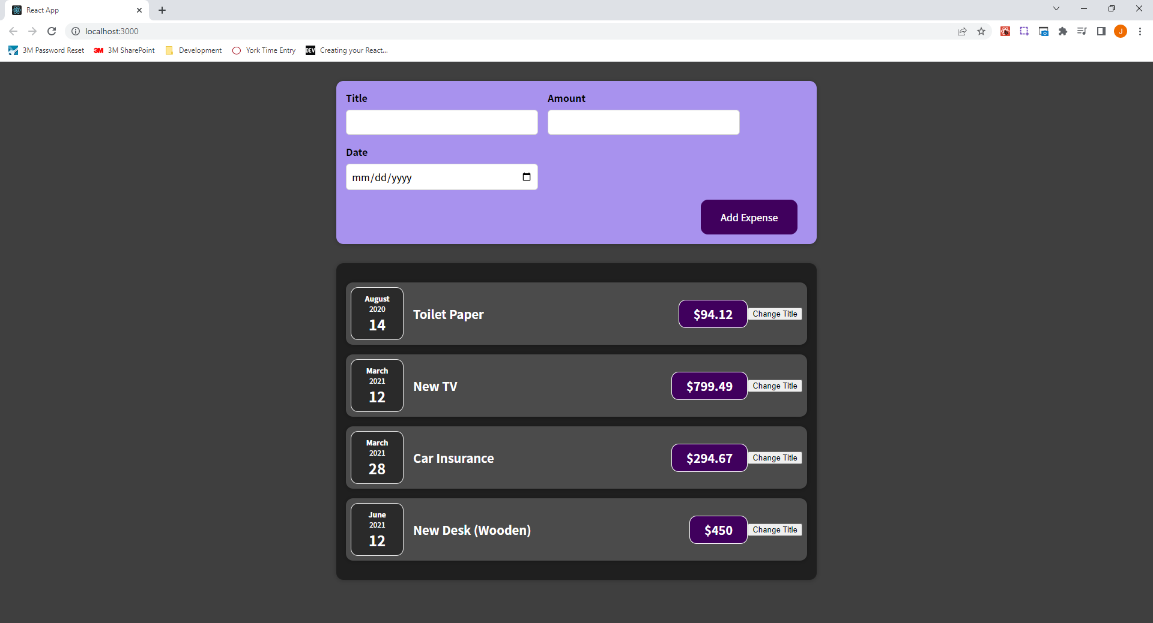

### 53. Listening to User Input